Work for home 8/6/20 – 12/6/20
Hello girls!
I hope you all enjoyed the weekend. We are coming close to the end of the school year now, and the end of primary school for you all! Well done on all of your hard work so far, and remember that you only have a few weeks of work left before you can relax for the summer!
Spellings
My Spelling Workbook – Unit 16 pages 64, 64 (vacant – embarrass)
Dictation –
- Snuff
- Stuff
- Back
- Black
- Crack
- Hack
- Jealous
- Marvellous
- Enormous
- Picture
- Occurred

- Dictionary definitions
- Scrabble
- Rhyming words
- Wordsearch
Seanfhocail na seachtaine
“Bíonn an fhírinne searbh” The truth is often bitter. What do you think this means? Tarraing pictiúr den sheanfhocail sin i do chóipleabhar.

Monday:
- Word of the day – Protest
- Number of the day – 400,000
- English – ‘Inside Out and Back Again’ read pages 37-43. The writing on page 43 is laid out differently to other pages, why do you think it is laid out this way? Do you have any predictions for what will happen after page 43?
- Maths – Busy at Maths page 109. Bar charts are used to represent information, in this case the information is about the amount of tickets and food sold in a cinema in one week. By completing questions 1 and 2, you will practise completing a bar chart and reading the information shown on them.
- Gaeilge – Toraíocht taisce arís! Faigh 10 rudaí i do theach le ‘b’ mar an chéad fuaim (first sound)! Mar shampla, bord, bábóg, bosca.
- Music – I’ve looked through all of your suggestions for graduation songs. Well done, you all chose really lovely songs! I think the one that we will go for is ‘Count on Me’ by Bruno Mars. This is a really lovely song about friendship and looking after each other. I’ve linked the lyrics to the song here so that you can have a listen and see what you think. https://www.youtube.com/watch?v=Msl2fl3h59I
Tuesday:
- Word of the day – Inequality
- Number of the day – 750,000.75
- English – I’m hoping to make something for your graduation including photographs of your time in school. With your parent’s permission, have a look for some pictures of your experience in primary school (e.g. first day of primary school, communion, school tours, sports days). If you have permission, you could write a short caption for each photograph and send it on to me to be included in your graduation.
- Maths – Busy at Maths page 110. Complete questions 1 and 2. Which type of graph do you think is easier to read, a bar line graph or a trend graph? Why?
- Gaeilge –
- PE – https://www.youtube.com/watch?v=hJbRpHZr_d0 This yoga video is specifically for helping your body to manage stress and anxiety. Find a quiet space and take some time to exercise and relax.

Wednesday:
- Word of the day – Peaceful
- Number of the day – 82,462 ¹²/₁₆
- English – ‘Inside Out and Back Again’ pages 44-51. Há’s family have a discussion about leaving Vietnam. The family seems to be divided whether to stay or go. If you were a part of this family, what side would you be on? Why?
- Maths – Busy at Maths page 111. Complete question 2 in your maths copy. Remember that the average is calculated by adding together the value for each item, then dividing the total by the number of items that were added.
- Gaeilge – Imir ‘Deir Ó Ghrádaigh’ le do chlann.
- Art – You may have seen some Kindness Rocks while you’ve been out walking, these are rocks that have been painted with happy phrases or quotes that might cheer people up when they see them. If you’d like to make your own Kindness Rocks and put them out for people to see, take a photo and send it on to me! I’ve included some examples at the bottom of this document so you can see what these look like.

Thursday:
- Word of the day – Justice
- Number of the day – ⁶/₈ as many equivalent fractions as you can!
- English – ‘Inside Out and Back Again’ pages 52-63. On pages 57 and 58 the items packed by the family are listed. If you were to pack a bag to leave for a new country, what items would you bring and why?
- Maths – Mangahigh activities. Well done Hannah, Ema, Emma, Meg and Eili, that’s 5 people in our class that are in the top 10 for our school!
- Gaeilge – Scríobh do nuacht féin i do chóipleabhar Ghaeilge.

Friday:
- Word of the day – Resolution
- Number of the day – 3,080,000.02
- English – Spellings for me test. Well done to the girls working hard on this website, if anyone else needs their login details or to be moved up to more challenging spellings just send me an email!
- Maths – Busy at Maths page 112 question 1. Profit = the amount of money that the seller makes by selling an item – the difference between how much the item cost to buy and how much it sold for.

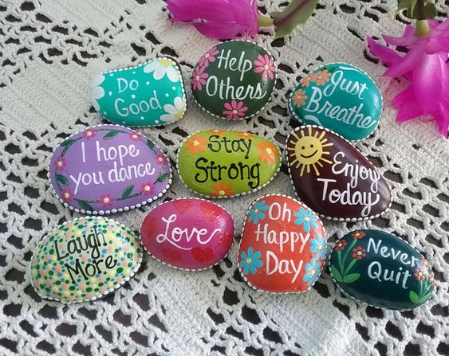
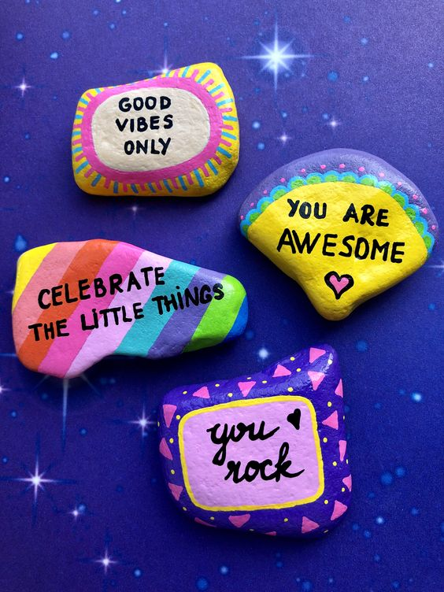
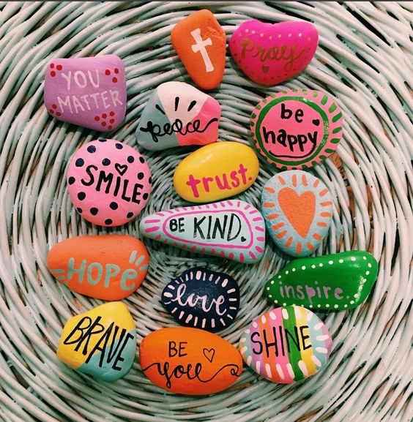
C F E R K B H B S I M C L D N B K E
V V F Y J A E L P T D L D Q I R M N
A F Y B J C C B L A C K T M U F Q O
F N I U V K U F X C E W X K B D R R
W A T M K L L X Z V R L T C L F T M
Q O D Q C W K P M G Q A A Z F S W O
V N M K R O E R D Z P C C U P R E U
K V U B Q X P R S Q G R T K A B Y S
M W G P C I D E U Y K S M O S S B U
B A C D H Y S K Y T Q C C J D H P R
G D R S U O L A E J C C T K Q J Z F
W R G V Z C V I H W U I Q X U Y Z J
F Q I M E Z F E O R A N P F F T R B
H Q A E T L B K R J I D E F F R S R
C W V Q Q M L E P H M W O U G H G C
O S L Q G G D O A K G Y T N E K I G
G X F X Q U I C U H G Y E S X A R Y
B X P W O Q K S Y S L A W Q A L K Z

BACK
BLACK
CRACK
ENORMOUS
HACK
JEALOUS
MARVELLOUS
OCCURRED
PICTURE
SNUFF
STUFF

