School Closure Work 30th-3rd March
Hi Girls,
I hope everyone is well and is staying safe at home. Here is some work to keep you busy for this week.
English and Maths is broken up into days so that it is easier for you to follow. You will find some more activities at the bottom of this page and you can choose when to do these.
Remember there is no pressure to get all of this done, only do what you can and don’t be worrying about any of it.
I hope you all have a lovely Easter and don’t eat too much chocolate. Remember to keep trying to get a bit of fresh air every day and a bit of exercise. (a fun way to do this during Easter is to do an Easter hunt in your garden or around your house, I know I’ll be doing one with my sisters

Looking forward to seeing you all soon,
Keep safe,
Ms Carr :)
Monday
Numeracy
- Continue with your counting activities. Try do at least 15 minutes of oral counting everyday.
- 2D shapes : Square, circle, triangle, rectangle, semi-circle. Cut out lots of 2D shapes from paper/cardboard etc. Use these shapes to make a teddy/car/monster or maybe an Easter bunny. Stick your design onto an A4 background of paper/card.
- Number of the day, write 5 facts about the number: 22
- Visit the topmarks.co.uk website and mangahigh for maths games and activities. Select your age and subject maths.
Literacy
- Continue Paired Reading
- Spellings: pg 50
Take three spelling every night to focus on. Use our look, say , cover , write and check method when learning your spellings. Try put your spellings into a sentence (either written or orally)
Complete exercises on page 50.
- Listen to this Audio Book, ‘Mr Stink’ by David Walliams, After click on the Activities tab at the top of the web page and choose an activity to complete, your choice.
https://www.worldofdavidwalliams.com/mr-stink-by-david-walliams-read-by-david-wallims-and-matt-lucas-audiobook-extract/ https://rainbow.cjfallon.ie/#/units/second/1

- Handwriting Book- Page 43. Do your best and most careful work!

Tuesday
Numeracy
- Counting activities
- 2D shapes: revise all your 2D shapes today. Look for 2D shapes in your house and list as many as you can find. (Have a shape hunt)
- Busy At maths page 33
- Number of the day, write 5 facts about the number: 48
Literacy
- Continue Paired Reading
- Spellings.
- Grammer book spelling exercises page 51.
- Free-writing- any topic you want. Example, write a recipie, story, recount, report, diary entry, shopping list.

Wednesday
Numeracy
- Counting activities
- Busy At maths page 57 (try your best to do these word problems, if they are too tricky don’t worry about it )
- Number of the day, write 5 facts about the number: 98
- Addition: 40 + 27 =
Practice using your addition strategies to get the answer to this sum. Remember to use your empty number line to help you get your answers.
(The girls will be used to doing these types of sums so they should know what to do, let them try and come up with as many different strategies as they can to get the answer to the sum)
- Mangahigh or Topmarks, maths games online.
Literacy
- Continue Paired Reading
- Spellings
- Make a story picture book of ‘the three little pigs’. Write 3 or 4 sentences on each page with a corresponding illustration. Focus on using the tricky words below when writing your story. (this can be made on pages of paper and then stick/staple them all together)
- I, the , he, she, me, no, so , one , give, what , where, any, before, we , was, be , to, do, by, only, old, little, when , who, many, myself, are, all, you, your, come, some, like, have, live, down, why, which, more, other, were, said, here, there , they, go.
- Read your ‘The little pigs’ story to someone at home. Remember to read with expression , good use of pace and appropriate pausing after comas, full stops etc.
- Handwriting Book- Page 45. Do your best careful work!

Thursday
Numeracy
- Counting activities
- Practice counting to 100 and create our own 100 square.
- Busy At maths page 58 Help Mikey monkey!
- Number of the day, write 5 facts about the number: 83
- Addition: 30 + 29 = (again use our addition strategies to get your answer)
- Topmarks Website- choice of game
Literacy
- Continue Paired Reading
- Spellings
- Easter: make a spider web on Easter. Write down as many words as you can that are to do with Easter. (you will use these words to help you write your poem tomorrow)
- Procedural writing: create a recipe for making chocolate Easter nests. I will give you the list of equipment and ingredients and I want you to try and create the steps to follow to make them. (e.g. First break up the chocolate and put it into the bowl) If you are unsure of what to do think back to the time we made jelly and the steps we took
- Equipment: bowl, wooden spoon, bun cases, bun case tray, hob, fridge.
- Ingredients: Cooking chocolate, rice crispies, and chocolate eggs.
- Maybe if you are lucky someone at home might try out your recipe with you and you could enjoy making some chocolate Easter nests together.

Friday
Numeracy
- Number of the day, write 5 facts about the number: 71
- Game following this link
https://www.topmarks.co.uk/learning-to-count/blast-off
- Measures: Oral questions relating to the calendar (birthdays/days/dates/seasons etc.)and the clock (1 hour/half hour)
- Clock Diary-Write down what time you got up, ate your breakfast, had your dinner, went to bed, feel free to add more activities to your clock diary.
Literacy
- Continue Paired Reading
- Spelling test. Ask someone at home to test you on your spellings. Try your best
- Easter: Make up a poem all about Easter. (use your words from yesterday to help you write your poem)
Choose the day you want to complete the below activities.
Gaeilge
Bua na cainte: pg 93
An Cháisc- Easter
Art
- Draw/Sketch an Easter Bunny in your free-Drawing copy.
- http://www.iamanartist.ie/drawing/ Watch relevant videos on this website and with attention to line draw your house or an imaginary house.
- Easter art ideas:
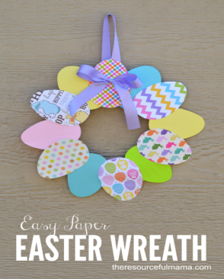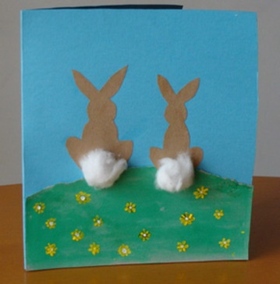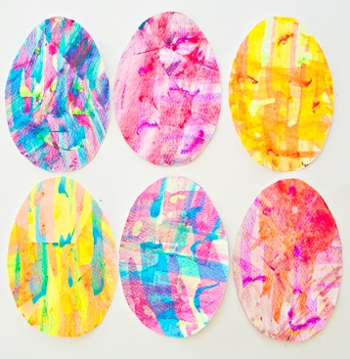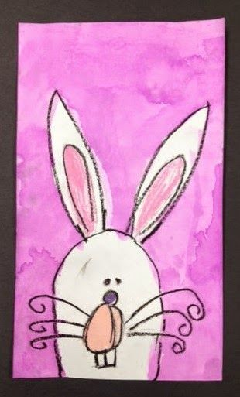
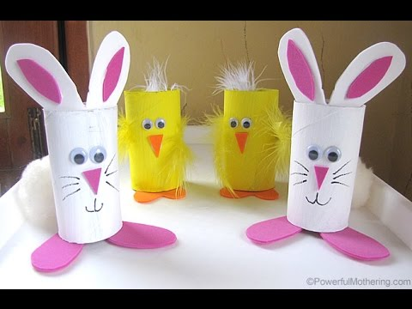

PE- Everyday, Get Active!
Joe Wicks PE lessons on Youtube Daily ay 9:00am.
Active Break’s https://www.gonoodle.com/
RTE Junior has ten minute exercise videos that the girls can follow https://rtejr.rte.ie/10at10/
Keep an eye on the active school section for some more ideas!
Music
Youtube: Music with Myleene Klass. 1pm each day on her channel.
Optional Projects: SESE
Spring
Draw two detailed and interesting pictures of Spring on an A4 white page. Spring on the farm/spring all around us etc. Label using as many words as possible – daffodils, tulips, crocus, buds on trees, lambs, nests, chicks, frogspawn, tadpoles etc.
Stick the finished picture in a card/cardboard. Use the pictures to make 2 jigsaws.
Cut the pictures into 16/32 pieces and place into freezer bags (sip lock if possible to keep all the pieces safe). We will enjoy making all these jigsaws when we get back to school

Some good free websites/free trials:
sir linkalot- Spelling Practice
Storytimefromspace.com- Story Time
The maths factor.com- Maths Lessons
Science kids.co.nz –Project section has some good activities
Nasa.gov – Kids Science section
National Geographic Kids –SESE Activities and Lessons
BBCgoodfood- has a kids baking section

