Monday
Numeracy
- This week we will look at the 100 square
- Here are some videos to help remind you about the 100 square.
https://www.youtube.com/watch?v=RWg5yCu4V8A
https://www.youtube.com/watch?v=fydOb5NMYKQ
https://www.youtube.com/watch?v=Fihw_ZqvgSk
https://www.youtube.com/watch?v=-defmZFRpMs
- I have attached a number square template for you to fill in, if you can’t print it off, use some paper, a ruler and some pencils or markers to make your very own. You can look at the 100 square on page 37 in busy at maths if you are stuck or the completed 100 square attached.
- Mangahigh or Topmarks, maths games online.
https://www.topmarks.co.uk/Search.aspx?q=100+square+splat
Follow this link or search top marks 100 square splat!
Literacy
- Continue Spellings and raz kids.
- Wolves, Trains and Dolphins- Remember we read about Bottlenose Dolphins, this year. Reread page 86 to remind yourself. This time underline all the plural words you see in the piece.
Clue: Plural means more than one, example: Dolphins (the ‘s’ lets us know it is more than one/ plural)
- Novel: This week we are going to start reading our second book together ‘Darcy Dolphin is a little bit magic’
- Before we start reading I want you to look at the front cover and the blurb, can you make a prediction as to what the book will be about?
- Do you think Darcy is a good name for a Dolphin?
- If you had a Dolphin what would you call it?
- Have you ever seen a Dolphin?
- Can you find the name of the famous Dolphin that can be seen in Dingle, Co. Kerry?

Tuesday
Numeracy
- Busy at maths interactive.
- Use your 100 square to complete page 37 in busy at maths
- Make sure to start at the number given and count on or back depending if the questions asks for more or less.
- Mangahigh or Top marks, maths games online.
https://www.topmarks.co.uk/Search.aspx?q=100+square+splat
Follow this link or search top marks 100 square splat!

Literacy
- Continue raz kids and spelling for me.
- Novel: Novel: Read page 5-24
- Darcy had lots of ideas to welcome the new students, can you think of ideas you would use?
- What is plankton? Look it up if you’re not sure!
- Why was Darcy afraid of Miss Angler?
- Do you think Coral was shy?
- Do you think ‘Clam up’ would be a fun game?
- On page 23, we find the meaning of the word ‘persevere’. Can you put the word into a sentence of your own?
- Wolves’ trains and Dolphins. We started the questions on page 87 in school, make sure you have finished them all. If you have, you can write 5 facts about Bottlenose Dolphins.
Wednesday
Numeracy
- Search ‘Caterpillar ordering and sequencing’ activity on top marks or click the link below.
https://www.topmarks.co.uk/ordering-and-sequencing/caterpillar-ordering
- Busy at maths interactive
- Busy at maths Page 38, fill in the missing numbers using your 100 square.
Literacy
- Continue raz kids and spelling for me.
- Handwriting Book- Page 40. Do your best careful work!
- Novel: read page 24-35
Darcy wrote a letter to his parents to warn them about Coral. Can you write a letter to a loved one telling them some of the things you’ve been up to this week.
- Wolves, trains and dolphins page 88

Thursday
Numeracy
- I have attached a missing number activity sheet for you to complete. Don’t worry about printing it out, you can look at it on your screen and write your answers in your copy or on a sheet.
- Ask someone out call out a number for you between 1 and 100, find it on your number square.
- Add on 6.
- Take away 4.
- Jump on 10.
What number did you land on?
Literacy
- Continue raz kids and spelling for me.
- Novel: read page 36-49
- Why Darcy think Coral was a zombie crab, what evidence did he find?
- Word of the day ‘Showdown’ can you put this word into a sentence?
- Why did Darcy feel bad?
- Wolves, trains and dolphins page 89. You can use an online dictionary id you don’t have one at home. You might already know the meaning of some of the words.
Friday
Numeracy
- Mangahigh or Topmarks, maths games online.
- Using your 100 square complete the following questions:
- 10 more than 20 is?
- 5 more than 12 is?
- 10 less that 70 is?
- 3 more than 90 is?
Literacy
- Continue raz kids and spelling for me.
- Wolves, trains and Dolphins page 90. Groups of things have special words
Example: a deck of cards, a pack of wolves, a school of fish. See if you can figure out which words are associated with the groups on this page.
- Novel: read page 52- 53
- Darcy loved show and tell, can you think of one thing you would bring for show and tell?
- Word of the day ‘eccentric’, can you put this word into a sentence of your own?
- On page 63, we learn the meaning of the word ‘deflated’ can you put this word into a sentence of your own?

Choose the day you want to complete the below activities.
Gaeilge
- Bua na Cainte page 127
- Learn the colours as gaeilge.
- Practise spelling.
- Scríobh na habairtí (Bottom of the page, if stuck use the format below and fill in the blanks with the correct colour)
- Tá gúna dearg ort.
- Tá hata _____ ort.
- Tá bróga _____ ort.

Watch an episode of ‘ár mbia, ár slí’ on rte player (link below) to see some children cook/bake as gaeilge.
Why not try one of the recipes and send me a picture of the finished product!

https://www.rte.ie/player/series/ar-mbia-ar-sli/SI0000006050?epguid=IP000065298
Art

Create a seaside themed picture. Take a look at the pictures below for some inspiration.

Sketch your piece in your free drawing copy before you complete it.

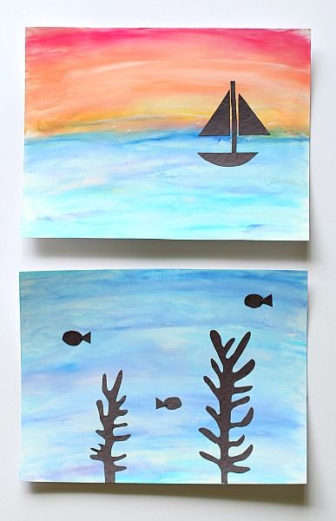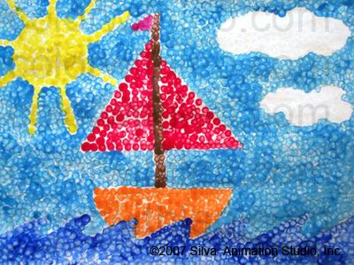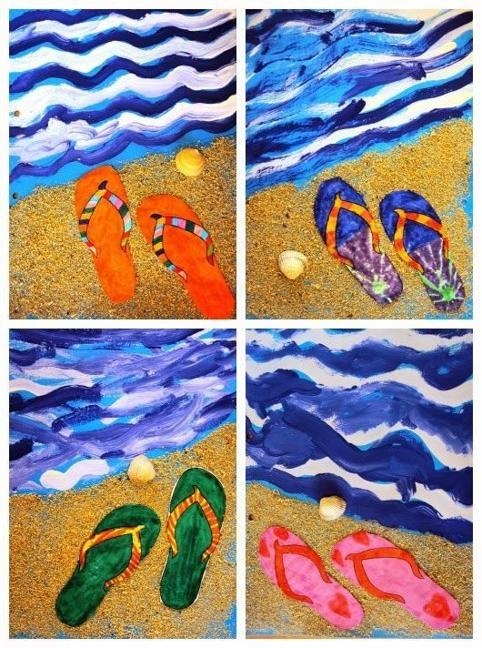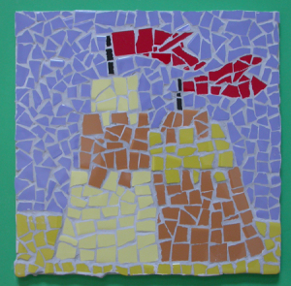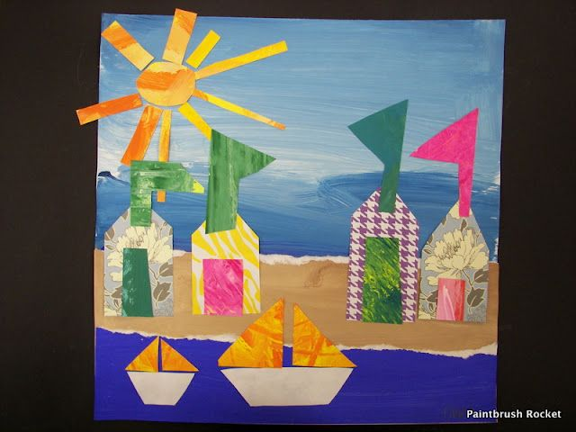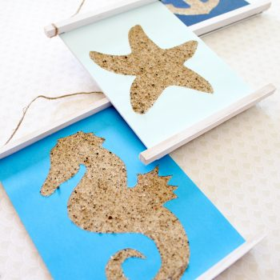
PE- Everyday, Get Active!
Complete your Daily Mile each day and don’t forget to send me your total on Friday!!
Joe Wicks PE lessons on YouTube Daily at 9:00am
Follow your active Homework journal.
Take a look at the active school section on the website for some more active ideas!
Music
YouTube: Music with Myleene Klass. 1pm each day on her channel.
Our next sing-along song on dabledoo music is ‘Wouldn’t it be nice’ by The Beach Boys
Check out the link below and practise singing along!
https://www.youtube.com/watch?time_continue=4&v=3y44BJgkdZs&feature=emb_title

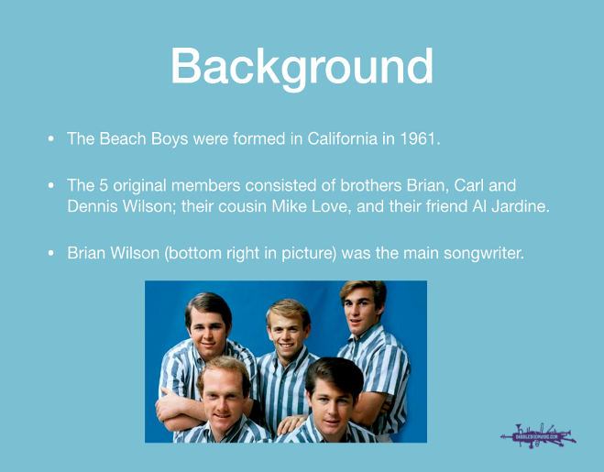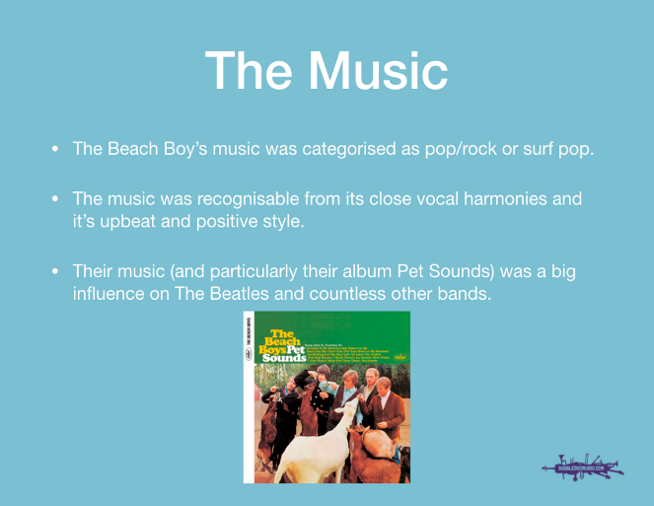

If you have collected your books you should have your recorder at home with you. I have attached pictures of some of the pages for you to practice.
RTE School Hub
You can tune in to watch RTE school hub on RTE TV at 11am each day.
Optional Projects: SESE
Write a list of 5 safety Rules you should follow at the seaside.
Decorate your list and don’t forget to write your title.
Baking ideas
Banana Pancakes

Ingredients
- 350g self-raising flour
- 1 tsp baking powder
- 2 very ripe bananas
- 2 medium eggs
- 1 tsp vanilla extract
- 250ml whole milk
- Butter for frying

To serve
- bananas, sliced
- maple syrup optional

Method
- 1. Sieve the flour, baking powder and a generous pinch of salt into a large bowl.
- 2. In a separate mixing bowl, mash the very ripe bananas with a fork until smooth, then whisk in the eggs, vanilla extract and milk.
- 3. Make a well in the centre of the dry ingredients, tip in the wet ingredients and swiftly whisk together to create a smooth, silky batter.
- 4. Heat a little knob of butter in a large non-stick pan over a medium heat. Add 2-3 tbsp of the batter to the pan and cook for several minutes, or until small bubbles start appearing on the surface. Flip the pancake over and cook for 1-2 mins on the other side.
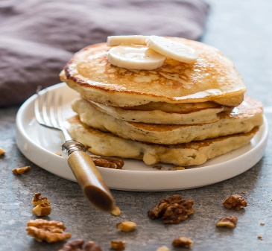
- 5. Repeat with the remaining batter, keeping the pancakes warm in a low oven.
- 6. Stack the pancakes on plates and top with the banana slices and maple syrup!

