Monday
Numeracy
- Busy At maths interactive.
- Busy At maths page 123
- Using your white board add 33+46
- Mangahigh or Topmarks, maths games online.
Literacy
- Continue Spellings and raz kids.
- Wolves, Trains and Dolphins page 75
Working on Prepositions: Prepositions are words that make links between words
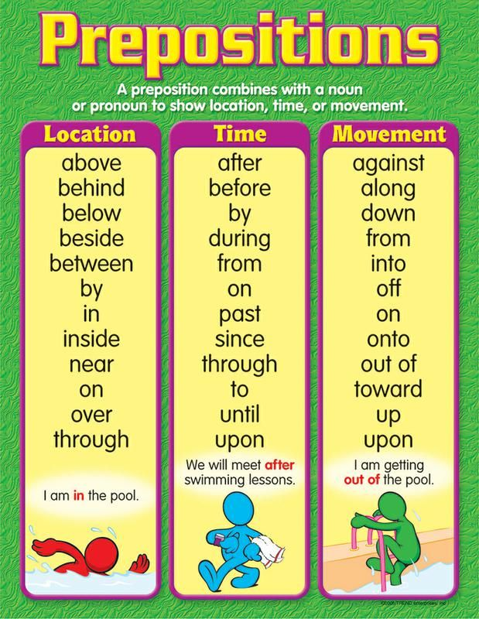
- Novel: read chapter 8 page 71-84.
- Find the word translucent on page 77. We looked at this word when we learnt about light, can you remember what it means?
  - If not look it up!
- Charlie puts frog-spawn in the bath at the park. Can you create a poster that teaches people about the life cycle of a frog?

Tuesday
Numeracy
- Number of the day, write 5 facts about the number: 415
- Mangahigh or Topmarks, maths games online.
- Revision: List as many 3D shapes as you can. See PowerPoint attached and shape hunt worksheet. Remember when using tally marks IIII and strikethrough for 5. Like so:
1 2 3 4 5
Literacy
- Continue raz kids and spelling for me.
- Handwriting Book- Page 38. Do your best careful work!
- Novel: ‘Hundred Mile An Hour Dog’- read chapter 9
- At the end of Chapter Nine, Sergeant Smugg threatens to have Streaker put down. Write a persuasive letter to him that encourages him to change his mind.
Wednesday
Numeracy
- Even numbers can be put in groups of two.
- Odd numbers will have one left over when you try to put them in groups of two.
- Complete Busy at maths page 33
- Number of the day, write 5 facts about the number: 962
- Mangahigh or Topmarks, maths games online.
- Suggestion for topmarks: coconut odd and oven and the daily ten for some revision.
https://www.topmarks.co.uk/learning-to-count/coconut-odd-or-even

Literacy
- Continue raz kids and spelling for me.
- Novel: ‘Hundred Mile An Hour Dog’- read chapter 10
Questions:
- At the beginning of this chapter, why was Trevor worried about Streaker?
- In this chapter, Trevor decides he will make a dog exercising machine, Design your own dog-exercising machine.
- What hobbies did Trevor’s parents have? (clue: page 98)
- Wolves, trains and dolphins page 76 Proofread the piece and correct the mistakes you see. Come up with some pet names!

Thursday
Numeracy
- Complete Busy at maths page 34
- Number of the day, write 5 facts about the number: 75
- Mangahigh or Topmarks, maths games online.
- Suggestion for topmarks: coconut odd and oven and the daily ten for some revision.

Literacy
- Continue raz kids and spelling for me.
- Novel: ‘Hundred Mile An Hour Dog’- read chapter 11
Questions:
  - How did Tina act as a good friend?
  - What was mom most annoyed about?
- Wolves, trains and dolphins page 77. Fill in the blanks and make words with the given letters.

Friday
Numeracy
- Complete Busy at maths page 35 & 36
- Mangahigh or Topmarks, maths games online.
Literacy
- Continue raz kids and spelling for me.
- Novel: ‘Hundred Mile An Hour Dog’- read chapter 12
Choose Task 1 or 2:
- Write your own story about a different ‘Hundred-Mile-An-Hour’ animal. This could be a pet, a wild animal or an endangered species.
or
- At the back of the book, there is a page with 14 1/2 things that you didn’t know about Jeremy Strong. Could you make a similar page about yourself?
- Wolves, trains and dolphins page 78. Add the words that spring to your mind to create a poem of your own!

Choose the day you want to complete the below activities.
Gaeilge
- Bua na Cainte page 126
Éadaí-clothes
Hata- hat
Cóta- coat
Gúna- dress
Stocaí- socks
Bróga- shoes
Bríste- trousers
Léine- shirt
Litrigh- spell
Scríobh na habairtí- write the sentences

Watch an episode of ‘ár mbia, ár slí’ on rte player (link below) to see some children cook/bake as gaeilge.

https://www.rte.ie/player/series/ar-mbia-ar-sli/SI0000006050?epguid=IP000065298
Art

If you learn how to draw a tropical fish, you can start to appreciate just how many different kinds of fish there are swimming around in the ocean right now.

See drawing tutorial in the document attached or try draw your own!
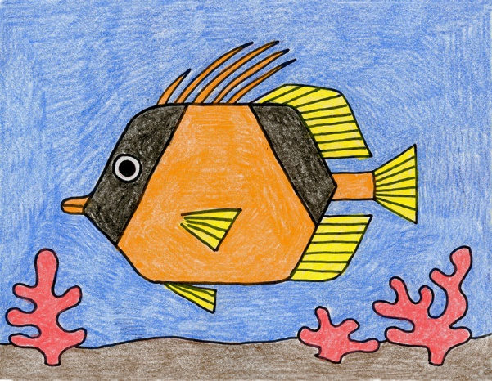
PE- Everyday, Get Active!
Complete your Daily Mile each day and don’t forget to send me your total on Friday!!
Joe Wicks PE lessons on YouTube Daily at 9:00am
Follow your active Homework journal.
Take a look at the active school section on the website for some more active ideas!
Music
YouTube: Music with Myleene Klass. 1pm each day on her channel.
Our next sing-along song on dabledoo music is ‘Bastille-Pompeii’
Check out the link below and practise singing along!
https://www.youtube.com/watch?v=F90Cw4l-8NY
RTE School Hub
You can tune in to watch RTE school hub on RTE TV at 11am each day.
Optional Projects: SESE
Complete a project based on The Ocean your artwork will be nice to link with this project.
https://kids.britannica.com/kids/article/ocean/346185
https://kids.nationalgeographic.com/explore/nature/habitats/ocean/
https://www.natgeokids.com/ie/discover/geography/general-geography/ocean-facts/

