Wednesday
Numeracy
- Busy at maths interactive.
- Practise skip counting in 2’s, 3’s, 4’s and 5’s. Complete page 140.
- Mangahigh or Topmarks, maths addition games online.
Literacy
- Continue Spellings and raz kids.
- Wolves, Trains and Dolphins- Read ‘Big Ted’s Barbecue’ on page 61. Remember read the story 3 times to make sure you understand it.
Draw all of the things Ted put on the Barbecue. Answer the questions on page 62 using full sentences.
- Novel: Darcy Dolphin is a little bit magic. Read page 64-84 and write a short summary about what happened.
Put the word ‘Truce’ into a sentence of your own.
Thursday
Numeracy
- Busy at maths interactive.
- Use your number square from last week to help you with the questions on page 141.
- Mangahigh or Top marks, maths games online.

Literacy
- Continue raz kids and spelling for me.
- Wolves, trains and Dolphin’s page 63.
Question 4: Complete the word search.
Question 5: Choose the correct spelling ‘meat’ or ‘meet’. This picture might help you remember the correct one!
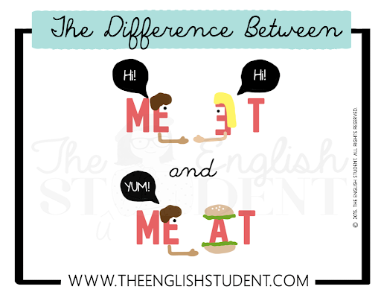
- Novel: Read page 85- 98
How did dad try to cheer Coral up?
What was Darcy’s favourite shop called?
Can you remember a time when you were reunited with someone or something?
Friday
Numeracy
- Busy at maths interactive
- Busy at maths Page 142
- Use your whiteboard to add 46+33=
Explain the strategy you used to your parent or sibling!
Literacy
- Continue raz kids and spelling for me.
- Novel: Predict what will happen in week 3.
Write down your prediction and check back later to see if you’re correct!
Read page 100-120.
On page 112 and 113, Coral and Darcy write lists of what they are good at. Write a list of things that you are good at!
- Wolves, trains and dolphins page 64

Choose the day you want to complete the below activities.
Gaeilge
- Bua na Cainte page 128
- Read the sentences.
- Scríobh na habairtí: Look at the picture and copy the correct sentence.
Art
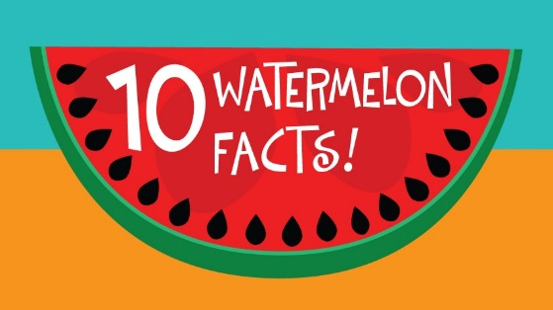
- Wild watermelons originated in southern Africa.
- The watermelon can be classed as both a fruit and a vegetable.
- It is a fruit because it grows from a seed, has a sweet refreshing flavour, and is loosely considered a type of melon (although it is actually a type of berry called a pepo).
- It is a vegetable because it is a member of the same family as the cucumber, pumpkin and squash. It is also harvested and cleared from fields like other vine growing vegetables.
- By weight, a watermelon contains about 6% sugar and 92% water.
- The high water and electrolyte content of watermelons make them ideal as a refreshing summer thrust quenchers. They keeps us hydrated, our skin fresh, and can clean the kidneys of toxins.
- Nutritionally, watermelons contain high levels of vitamin B6 (which increases brain power), vitamin A (good for eye sight), potassium (which helps in curing heart disease and keeping the heart healthy). The watermelon also contains Vitamin B1, C and manganese which protect against infections.
- China is the world's largest producer of watermelons.
- There are more than 1200 varieties of watermelon that come in various weights, shapes, sizes and red, orange, yellow or white in colour.
- As of 2013, the Guinness World Record for heaviest watermelon is for one grown by Lloyd Bright in Arkansas, USA. The watermelon weighed in at 121.93 kg

This week we are going to try some Watermelon art! Take a took at the video below and follow the steps. Pause it as you go if its easier. Or if you have one at home why not cut a slice and draw it from observation! You can use whatever you like, as always it’s a good idea to stetch your piece with a pencil first!

https://www.youtube.com/watch?v=Q9xiKe5JZp8

Some inspiration:

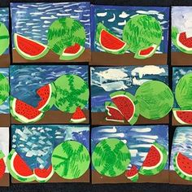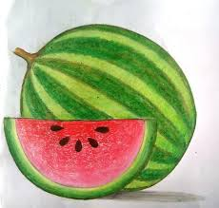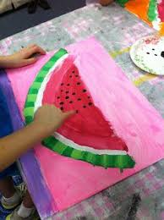
PE- Everyday, Get Active!
Complete your Daily Mile each day and don’t forget to send me your total on Friday!!
Joe Wicks PE lessons on YouTube Daily at 9:00am
Follow your active Homework journal.
Take a look at the active school section on the website for some more active ideas!
Music
YouTube: Music with Myleene Klas. Check out her YouTube channel this week.
RTE School Hub
You can tune in to watch RTE school hub on RTE TV at 11am each day.
SESE
You will find a summer picture with questions attached linked on the page below where you found the work. Ask an adult to ask you the questions and answer them using the picture to help you.
Recipe: Watermelon Juice
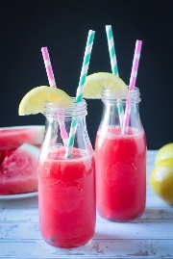
You will need a blender, a sieve and a watermelon.
You will need to ask for help from an adult when using the blender and knife.
Ingredients: Watermelon
Method:
- Chop your watermelon and add it to your blender.
- Once blended pour it through a sieve to get rid of any excess chunks.
- Pour and serve in your favourite glass!

