Science Experiments

RAINBOW IN A JAR
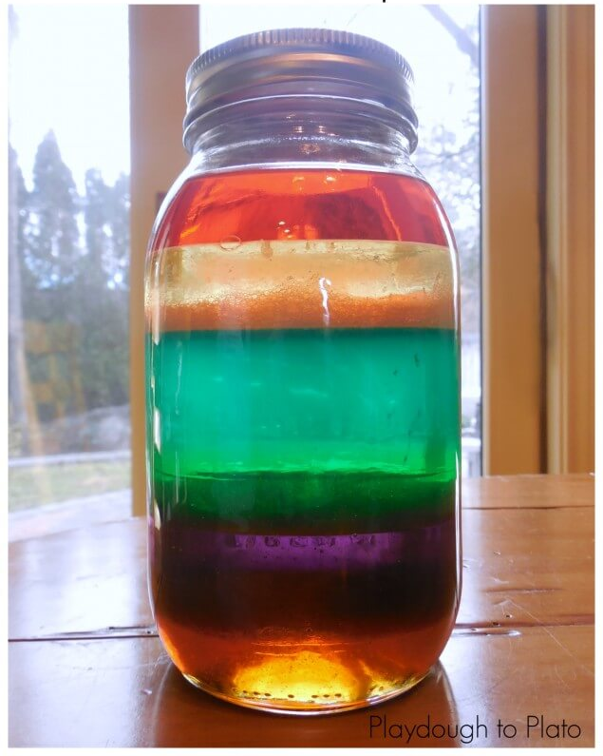

You will need:
- A tall, see-through container (Jar, bottle)  - Honey  - Corn syrup  - Milk | - Dish soap (washing-up liquid)  - Olive oil  - Water  - Food colouring  - Maple syrup

Method:
- Before you begin, you don’t need all ingredients mentioned above.
- Pour honey into the middle of the container, not touching sides.
- Next, colour the corn syrup using food colouring. Then add to middle of container not touching the sides.
- Pour in the dish soap (should be already coloured, colour if not)
- Colour the regular water and pour into the middle of container not touching sides.
- Using the olive oil, pour a thick layer on top, make sure it is in the middle.
- Gently lift up your container, hold it against the light and admire your creation.
For best results, use bright food colouring!
Check out: https://www.rte.ie/learn/2020/0407/1129075-suite-science-stacking-liquids-3rd-6th-class/ if you need some help or if you don’t have the materials needed, watch it instead.

LAVA LAMP
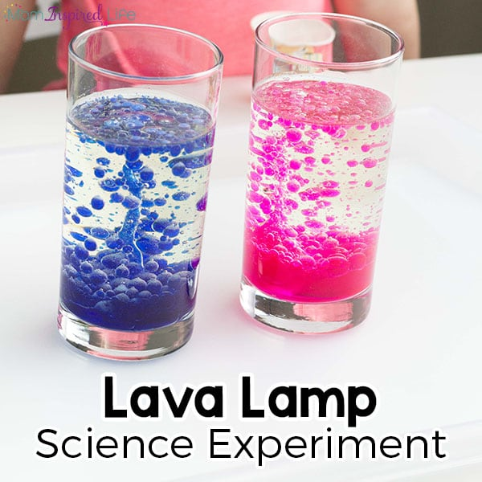

What do I need?
- Vegetable oil
- Water
- Food colouring – any colour
- Alka Seltzer tablets
What do I do?
- To begin, colour about 1/2 cup of water with food colouring.
- Take the Alka Seltzer tablets and break them into 2 or 3 pieces. Place them in a small cup or container.
- Fill a glass about 3/4 full with vegetable oil. Then pour in the coloured water until the liquid in the cup is about 1-2 inches from the top.
- You don’t want it to overflow! Well, unless you want to turn it into an eruption experiment too. For this reason and quick clean-up, I like to do this on a tray.
Check out: https://kids.nationalgeographic.com/explore/science/make-a-groovy-lava-lamp/ if you want to follow a different method or you would like pictures to aid you along the way.
Have Fun

