School Closure Work 8th-12th of June
Daily Activities
- Aistear- Fairytales
- Counting activities
- Sounds, tricky words and handwriting
- PE- try to do 60 minutes each day- there are lots of ideas on the Active Home School Page. Why not try out the new Daily Mile (Home Edition) challenge this week?
- Reading each day- paired reading books, or a book from home
- Well Done to Brianna Lawless who won Last week’s Cooking Competition. She made a yummy shepherd’s pie. If you want to be in with a chance of winning next week just send on your pictures of what you cooked or baked to msquigg.stjohnofgodartane@gmail.com Keep an eye out of Ms Quigg’s Cookery Page for new recipes posted weekly!
- Gaeilge- https://www.cula4.com/en/shows/
Monday
Numeracy
- Continue to work on your counting activities. Revise counting forward from 0-50 and backwards from 45-0. Please try spend around 15 minutes every day counting. You can use the Jack Hartmann Youtube videos to count and be active at the same time
- Let's see if you can remember your number stories. In your copy, try to write the story of 1,2,3. Which two numbers added together are equal to 3? You can use 3+ 0 = 3, 2 + 1 = 3.... see how many sums you can make for the story of 1,2,3. Remember to use one box for each number that you write, and give the + and = signs their own boxes in your Maths copy too!

Literacy
- Write 3-5 sentences of your news from the weekend and draw a picture to match. What did you play? What did you learn? What did you enjoy doing? Remember to use capital letters and full stops. Try and write at least 6 sentences. Today I want you to try and use these three words in your news :
- sunshine
- beautiful
- active

- Handwriting Book- Continue onto the next page in your handwriting book. Take your time and be careful.

P.E
- Cosmic Yoga: Complete ‘The very hungry caterpillar’ yoga video which is on the class page.

Tuesday
Numeracy
- Let's see if you can remember your number stories. In your Maths copy, try to write the story of 4,5,6. Which two numbers added together are equal to 6? You can use 6 + 0 = 6, 5 + 1 = 6.... see how many sums you can make for the story of 4, 5, 6. Remember to use one box for each number that you write, and give the + and = signs their own boxes in your Maths copy too!
Literacy/Visual Arts
- Listen to the story ‘The Huge Bag of Worries’. Draw some pictures of things that worry you in the worry bag and discuss them with your parents.
- With the help of your parents, create your very own worry monster.
SESE:
If you have a plastic bottle and some of the household items that are pictured below, see if you can make your own Maracas! You can use them to shake along to the beat of your favourite song!
Wednesday
Numeracy
- Let's see if you can remember your number stories. In your Maths copy, try to write the story of 7,8,9,10. Which two numbers added together are equal to 7, 8, 9, 10. You can use 5 + 3 = 8, or 4 + 4 = 8.... see how many sums you can make for the story of 8. Remember to use one box for each number that you write, and give the + and = signs their own boxes in your Maths copy too!

Literacy
- Revise the "ou" sound. Take a look at the following video clip https://www.youtube.com/watch?v=-qtCB7CYH3I
- Can you try and write some "ou" words on flashcards? How many "ou" words can you think of? You can use some of Geraldine's words from the video above.

Gaeilge:
- Listen to the story of "The Gingerbread Man" in Irish. Then take a page and draw three pictures - one from the beginning of the story, one from the middle and another from the end of the story. You can watch the video here: https://www.youtube.com/watch?v=9IqzHVa_yXM&app=desktop
- Complete page 36-40 of Bua na Cainte
Thursday
Numeracy
- 100 Square:
- Print off attached blank 100 square template, or create your own.
- Using the 100 square below, fill in your 100 square (Or you can try filling it in without the full 100 squares)
- Count by twos to 20 and underline/circle with a pencil are you go. Continue on for as far as you are able to.
- Rub out the previous pencil markings. Count by tens to 100 and underline/circle with pencil again.
- Rub out the previous pencil markings. Say and circle the following numbers: 3,7,10,12,15,19,20,24,25,28,30,31,33,36,40,42,44,47,50,53,55,58,60,
61,64,66,70,74,75,79,80,85,89,90,93,96,97,99,100
- Complete the other attached activities (Missing numbers and jigsaws)
Literacy
- Listen to the story ‘Don’t worry William’. Draw a picture of your favourite part of the story and discuss with your parents.
- Draw a picture/ write a list of all the things that make you happy and that you are thankful for! (family, friends, pets, nature, etc)

Science: Glitter Jar
- Follow the instructions on the sheet attached to make your own glitter jar. If you feel worried, give the jar a shake, watch the glitter swirl around, and then settle calmly at the bottom.

Friday
Numeracy
- Visit the website below to play some ‘Number’ activities. Complete the next 2 pages in your Planet Maths Book.
- https://www.splashlearn.com/

Literacy
- Phonics: revise the "er" sound. Take a look at the following video clip https://www.youtube.com/watch?v=KK8_kUg3454
- Now can you try and write some "er" words on flashcards? How many "er" words did you get? You can also use some of Geraldine's words from the video above.

SPHE:
- Take a moment to think about how you are feeling. What words describe how are you feeling? Draw a picture and talk to your parents about it.

SESE:
- You may have noticed lots of Busy Bees outside while we had sunny weather! Watch this video which is all about Bees and when you are finished, write down some of the facts you remember about bees. Try to sound out the words yourself but if you are having trouble with spelling, ask an adult to help you. https://www.youtube.com/watch?v=ta154f5Rp5Y
​

Choose the day you want to complete the below activities.
Gaeilge
This week I am giving you one phrase to work on along with some new vocabulary. Try and use them as much as you can throughout the two week. Make some labels with the new vocabulary and find them objects in the house.
Don’t be afraid to make mistakes

Question: Cén aois thú? What age are you?
Answer: Tá mé …….. d’aois. I am ……. Years old.

Aon bhliain d’aois – One year old
Dhá bhliain d’aois – two years old
Trí bliana d’aois – three years old
Ceithre bliana d’aois – four years old
Cúig bliana d’aois – five years old
Sé bliana d’aois – six years old
Seacht mbliana d’aois – seven years old
Ocht mbliana d’aois – eight years old

New vocabulary:
Coinneal candle
Cárta card
Leitís lettuce
Cáca cake
Cairéad carrot
Bord table
Daideo grandad
Carbhat tie
Bronntanas presents
Coinín rabbit
Balún balloon
Hata hat
Féasta party
Watch an episode of Tir na nog on rte junior. Listen out for an irish words you recognise. Oisín, Niamh and Fionn have fun through gaeilge.
https://www.rte.ie/player/series/tir-na-nog/SI0000006552?epguid=IP000064973
Art
- Draw/Sketch a bee in your free-Drawing copy.
- Follow this link to find a step by step drawing of a realistic bee: https://www.youtube.com/watch?v=Ho4aUHY6fss
- Other art ideas:
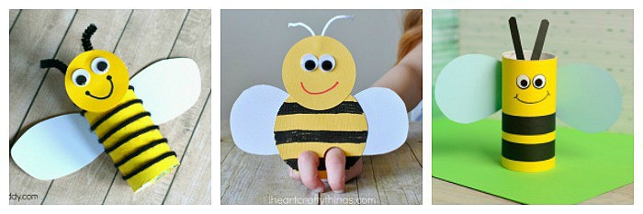
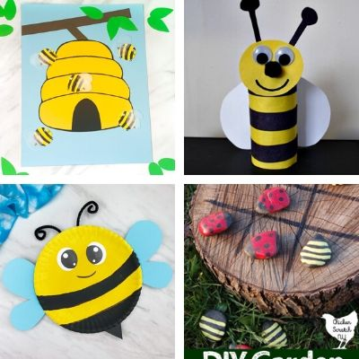

Recipe: Watermelon Juice
You will need a blender, a sieve and a watermelon.
You will need to ask for help from an adult when using the blender and knife.
Ingredients: Watermelon
Method:
- Chop your watermelon and add it to your blender.
- Once blended pour it through a sieve to get rid of any excess chunks.
- Pour and serve in your favourite glass!

