School Closure Work 27th – 1st May
Monday
Numeracy
- Continue to work on your counting activities. Please try spend around 15 minutes every day counting.
- Money: Draw 2 piggy bank templates. Draw a different set of coins in each piggy bank (not exceeding 20c). Write the correct amount under each one and to indicate which piggy bank contains the highest/lowest amount.
- Draw 2 piggy banks again. Write an amount (not exceeding 20c) under the first one. Ask your Child to draw a set of appropriate coins matching the amount in the piggy bank. Then ask them to draw a set of coins matching a higher/lower amount in the second piggy bank. Repeat the procedure using alternative amounts/sets of coins.
- Play shop: create your own shop in your house. Use different toys/books/clothes to sell in your shop. Give each item a price (20c or under).Pretend to be a customer and see how many items you can buy for 20c.
(if you don’t have any coins to play with create your own money using paper 1c, 2c, 5c, 10c,20c)
- Visit the topmarks.co.uk website and mangahigh for maths games and activities. Select your age and subject maths.
Literacy
- Raz Kidz: If you haven’t already joined Raz kids please do. It’s a great site with loads of books for you to read. You can listen to the story and then read it yourself and afterwards you can record yourself reading and listen back to yourself. There’s a few activities to complete too and you can collect lots of stars as prizes.
(email us for your password if you would like to use this site)
- Write 3-5 sentences of your news from the weekend and draw a picture to match. We can’t wait to hear all of your news soon.

P.E
- Ball games- Can you play football/basketball/tennis in your garden? Try go noodle/ Joe wicks activity each day.

Aistear
Tuesday
Numeracy
- 15 minutes counting activities
- Draw a selection of coins. Point to an item in the “shop” and invite your child to select an appropriate set of coins required to buy that particular item. Several alternatives may be suggested in order to develop the concept that identical sums of money may be made using various combinations of coins.
- Money: Have fun playing in your shop again.
- Practice using coins up to 20c. How many ways can you make 20c? Do some coin rubbings. (Place a coin under a piece of paper and rub over it using a crayon, an image of the coin should appear)
Literacy
- Continue reading your stories on Raz- kids
- Revise all of your sounds. This week focus on digraphs:
    - Click on https://slp.cjfallon.ie/
    - Select book B
    - Unit 1- wh, ph, oa, ie, ue. There are plenty of games for each sound.
Aistear

Religion
- Practise the Our Father and Holy Mary! Do something nice for someone each day.

Wednesday
Numeracy
- 15 minutes counting activities.
- Spend some time playing in your shop using coins up to 20c.
- Planet Maths Pages 30-32
- Mangahigh or Topmarks, maths games online.
Aistear

Literacy
- Raz –kids: Continue to work on your reading fluency reading through some of the stories on this website.
- Continue to practise your handwriting by:
  - Revising lowercase letters in your ‘Handwriting Today’ book.
  - Use the following link to practise letter formations and writing 2 and 3 letter words. http://data.cjfallon.ie/resources/gwtf-handwriting/index.html#!/books
  - Practise writing your tricky words- Can you write them in a sentence?
- Row Row Row your boat poem
Thursday
Numeracy
- 15 minutes counting activities.
- Number 10: Practice writing the number 10. Count 10 things inside. Count 10 things outside. Count forwards and backwards to 10 using your fingers. Ask your mum or dad to do simple addition sums. Eg. Show me 4 on your fingers, how many more needed to make 10.
- Can you paint/ draw a number 10 picture. Take a picture of it and email it to Ms. Quigg or Ms Sherwin to post on the website.
Literacy
- Raz-kids: continue reading through the stories on this website.
- Write 3-5 sentences about what a nurse or a doctor does, read your sentences aloud to someone at home.

SESE / Literacy
- Here is a link to Oral language activities based on Antarctica, follow the link. Complete as many activities as you can.
- https://rainbow.cjfallon.ie/#/units/senior/8

Aistear

SESE
- Go outside on a nature trail, become an explorer. Plant some flowers and look after them. Make an obstacle course outside or have a teddy bear picnic outside.
Friday
Numeracy
- 15 minutes counting activities
- Adding to 10: Get 10 legos/ lollipop sticks/ spoons etc. How many different ways can you add to 10? 1+9, 2+8, 3+7 etc. Can you write them out? Can you use a deck of cards to play a game. Pick a card from the top and see how many more you need to get to 10. The person with the highest amount to add to 10 gets a point. (You will need to remove the picture cards, Ace card = 1)

Literacy
- Raz-kids: Continue reading the stories on this website.
- Tricky Word Flowers: Draw some pretty flowers and write your tricky words in the middle of each. Can you write 3 sentences below using your tricky words?
- If an adult has time to help you can make the following recipe or a recipe of your choice! Write the procedure you followed. Remember to include: your title, your ingredients, the steps you followed in the right order, and a comment about how they turned out. You can sketch a picture of your finished cookies! Don’t forget to send me a picture if you bake them!
https://www.bbcgoodfood.com/user/896076/recipe/basic-cookies
Choose the day you want to complete the below activities.
Gaeilge
- Watch an episode of Tir na nog on rte junior. Listen out for an irish words you recognise. Oisín, Niamh and Fionn have fun through gaeilge.
https://www.rte.ie/player/series/tir-na-nog/SI0000006552?epguid=IP000064973

Art
- Draw/Sketch your very own hair salon
- Art ideas: For our theme in Aistear “The hairdressers”
- If you follow this link it will give you a step by step guide on how to draw a hairdryer. https://www.youtube.com/watch?v=eNZzCkE0L3Q
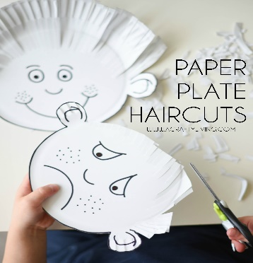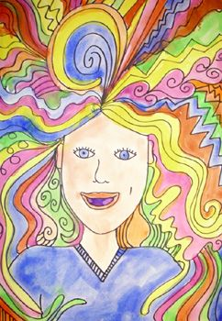
PE- Everyday, Get Active!
Joe Wicks PE lessons on Youtube Daily ay 9:00am.
Active Break’s https://www.gonoodle.com/
RTE Junior has ten minute exercise videos that the girls can follow https://rtejr.rte.ie/10at10/
Keep an eye on the active school section for some more ideas!
Music
Youtube: Music with Myleene Klass. 1pm each day on her channel.
Optional Projects: /Aistear/Fine Motor
You could set you your own beauty salon alongside your hair salon. You can practice painting nails on cardboard or paper like in the picture shown below. When you have practiced loads maybe Mam might let you paint her nails.
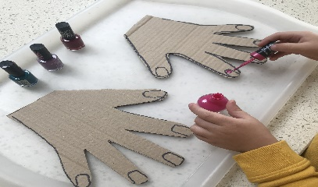

See the Aistear folder attached on the class page for some play ideas, key vocabulary and some other ideas you might like to use!
Don’t forget you can write your Aistear plan at home like you do in school each day before you play!
Today is ___________. I am going to the role play /playdough /small world /art /sand /construction /writing station. I will________ (write about what you plan to do during play, who you will play with, what you will make, etc).

