School Closure Work 11th-15th of May
Monday
Numeracy
- Continue to work on your counting activities. Please try spend around 15 minutes every day counting.
- Please find video of the days of the week used in school on the class page. Revise days of the week- Can you say all of the days in the week in order? How many days of the week are there? Which days are the weekdays? Which days are the considered the weekend? How many days are considered the weekend? • What day comes before ___? Which day comes after _____? Question with all days.
- Visit the topmarks.co.uk website and mangahigh for maths games and activities. Select your age and subject maths.

Literacy
- Raz Kidz: If you haven’t already joined Raz kids please do. It’s a great site with loads of books for you to read. You can listen to the story and then read it yourself and afterwards you can record yourself reading and listen back to yourself. There’s a few activities to complete too and you can collect lots of stars as prizes.
(email us for your password if you would like to use this site)
- Write 3-5 sentences of your news from the weekend and draw a picture to match. What did you play? What did you learn? What did you enjoy doing?

P.E
- Ball games- Can you play football/basketball/tennis in your garden? Try go noodle/ Joe wicks activity each day.

Aistear: The Airport (Don’t forget to send us in pictures of your Aistear time, we miss Aistear so much and its so lovely to see all of you still engaging in the Aistear themes.)
Tuesday
Numeracy
- 15 minutes counting activities
- Using a number line: Can you draw a number line to 20 outside (with chalk) or inside on paper? Practice hopping on the line to do some sums! E.g Start on 6, go on 1 more. Start on 2 go on 7 more. Maybe you could go up in your 2s and 5s and 10s when you’re feeling more confident. You can always make the number line longer eg up to 50 or shorter up to 10.

Literacy
- In school we briefly revise all letter sounds daily. I have attached a video with all of the letter sounds to the class page above.
- Listen to Ms Quigg reading A Quiet night in using the video on the class page. You can read along using your book.
- Revise all of your sounds. This week focus on digraphs:
    - Click on https://slp.cjfallon.ie/
    - Select book B
    - Unit 2- cl, cr . There are plenty of games for each sound.

Aistear

SESE: Oral report- talk about Elephants- what do you know about them? What do they look like? Have you seen one before? Ask a parent to help you find out more information about Elephants. You could also write some sentences about Elephants.

Wednesday
Numeracy
- 15 minutes counting activities.
- 2D Shapes: Go on an outside or inside 2D Shape hunt! Can you find squares, circles, rectangles and triangles? Draw a picture of each shape and write below an object that contains that shape. E.g Circle (football)

Aistear

Literacy
- Raz –kids: Continue to work on your reading fluency reading through some of the stories on this website.
- Play some tricky word games
- Continue to practise your handwriting by:
  - Revising lowercase letters in your ‘Handwriting Today’ book.
  - Use the following link to practise letter formations and writing 2 and 3 letter words. http://data.cjfallon.ie/resources/gwtf-handwriting/index.html#!/books
  - Practise writing your tricky words- Can you write them in a sentence?
SESE/Literacy
- Here is a link to Oral language activities based on ‘We are going to the Zoo”, follow the link. Complete as many activities as you can. If you found out any more information on Elephants, you can add them to your oral report. Maybe you could draw an elephant and label its parts.
https://rainbow.cjfallon.ie/#/units/senior/16
Thursday
Numeracy
- 15 minutes counting activities.
- 2D shape art: Can you draw a fun picture only using squares, circles, triangles and rectangles? What shape would the house be? What shape would the sun be?

Literacy
- Raz-kids: continue reading through the stories on this website.
- Summarise the whole story of A quiet night in using 5 sentences.
- Draw a picture of your favourite image from the story.(on a sheet of paper or on your whiteboard )
- Painting with water Tricky Words: Can you use a paintbrush and water to write your tricky words outside? How long does it take for the sun to dry them?

SESE / Literacy
- Look at the powerpoint on Day and Night. What do you know already? What are some of the things that we do at night time? What are some of the things what we do during the day? Do we eat breakfast at day time or night time? Do we brush our teeth during day time or night time? (both)
- Complete the worksheet on ‘Why we have day time and why we have night time’. Ask an adult to help you read the questions.

Aistear

Gaeilge: Practice talking as gaeilge everyday for 5 mins. E.g Dia Duit, Is mise Ms Quigg. Ce tusa? Cen aois thu? Ca bhfuil tu I do chonai?
Friday
Numeracy
- 15 minutes counting activities
- Paint with Primary Colours: Blue, Yellow and Red are the primary colours. What colour will you get if you mix blue and yellow? Yellow and red? Red and blue?

Literacy
- Raz-kids: Continue reading the stories on this website.
- Use your best handwriting to put 3 new tricky words into sentences: Saw, Put, Could, Should, Would, Right

Baking:
- If an adult has time to help you can make the following recipe or a recipe of your choice! Write the procedure you followed. Remember to include: your title, your ingredients, the steps you followed in the right order, and a comment about how they turned out. You can sketch a picture of your finished Banana Bread! Don’t forget to send me a picture if you bake them! This week’s baking activity is banana bread. Here is the recipe I followed if you would like to give it a go at home with someone. I added some chocolate chips to our recipe to make it even tastier
- Have fun and enjoy!
- https://www.kidspot.com.au/kitchen/recipes/easy-banana-bread-recipe/n1a0xd8s
- Remember, don’t be like the little red hen’s friends who wouldn’t help her bake her bread and only wanted to eat it. If you’re allowed to bake something at home you have to help prepare the ingredients, mix them altogether and do all the washing up after before you’re allowed to eat your yummy treats.
Choose the day you want to complete the below activities.
Gaeilge
Phrases to focus on:
We are giving you three phrases to work on. Try and use them as much as you can throughout the two week. For example, when you are having your breakfast you could say ‘Is maith liom tóasta’ Or if you are watching TV, you could say ‘Feicim Horid Henry’. Even if you don’t know what the word is in Irish you can still begin your sentence in Irish, for example ‘Is maith liom spaghetti bolognaise’
Don’t be afraid to make mistakes

Question: An maith leat? Do you like?
Answer: Is maith liom/Ní maith liom I like/I don’t like

Question: Cad a chuala tú? What did you hear?
Answer: Chuala mé….. I heard

Question: Cad a fheiceann tú? What do you see?
Answer: Feicim …….I see

Continue to enjoy watching some cartoons in Irish. Hopefully you might start to recognise a few more words this week.
You can click to have the subtitles so read along while listening to it in Irish.
Try and see how many Irish words your recognise and see if you can learn any new words too
This can be found on cúla4
https://www.cula4.com/en/shows/

Cúla4 scoil will be on again this week every morning at 10am.
Try your best and see how many words you understand.
Give it a go and enjoy it
https://www.cula4.com/en/shows/
Art
- Draw/Sketch an elephant in your free-Drawing copy.
- Use art hub to learn to draw an elephant. https://www.youtube.com/watch?v=A4CSVe8xg_g
- Art ideas: Elephants.
- 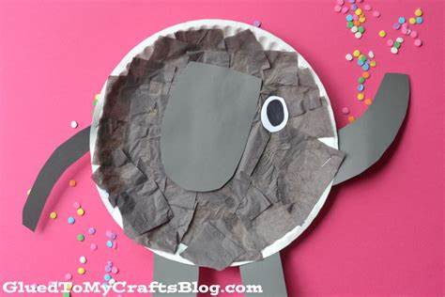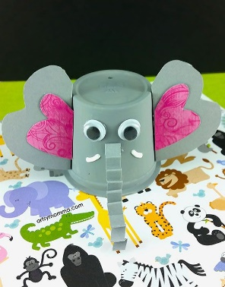

- 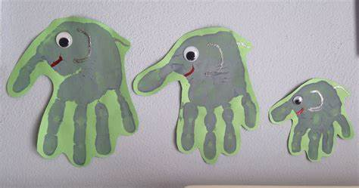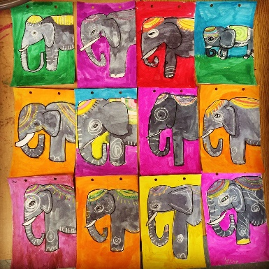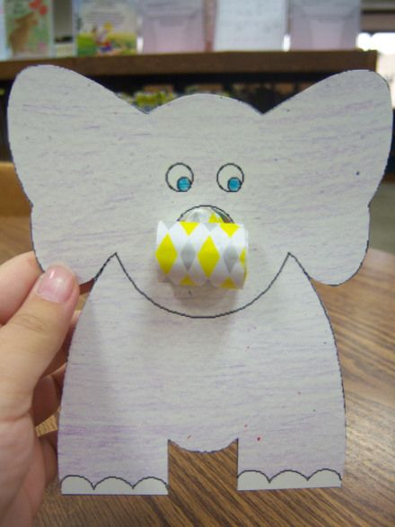
- 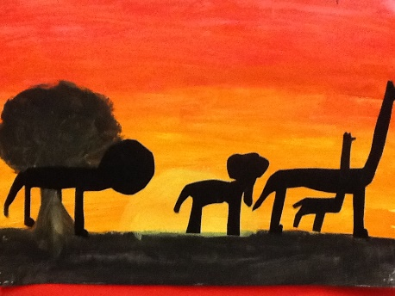

*** see art competition poster for details of a school art competition on our school page *** The final date for the competition is Wednesday 13th May so try get your entry sent to me by then
PE- Everyday, Get Active!
Joe Wicks PE lessons on Youtube Daily ay 9:00am.
Active Break’s https://www.gonoodle.com/
RTE Junior has ten minute exercise videos that the girls can follow https://rtejr.rte.ie/10at10/
Keep an eye on the active school section for some more ideas!
Music
Youtube: Music with Myleene Klass. 1pm each day on her channel.
Optional Projects: /Aistear/Fine Motor

See the Aistear folder attached on the class page for some play ideas, key vocabulary and some other ideas you might like to use!
Don’t forget you can write your Aistear plan at home like you do in school each day before you play!
Today is ___________. I am going to the role play /playdough /small world /art /sand /construction /writing station. I will________ (write about what you plan to do during play, who you will play with, what you will make, etc).

