School Closure Work 11th-15th of May
Monday
Numeracy
- Busy At maths interactive.
- Busy At maths page 151
- Using your white board add 22+ 76
- Mangahigh or Topmarks, maths games online.
Literacy
- Continue raz kids and spellings.
- Wolves, Trains and Dolphins page 24. Write your own book about popcorn using facts you learnt last week.
- Here is a link to Oral language activities based on animals in the garden, follow the link. Complete interactive vocabulary activity 3 today.
https://rainbow.cjfallon.ie/#/units/second/16
Novel: ‘Hundred Mile An Hour Dog’- read Chapter 4 page 35-41
- Describe Charlie Smugg in your own words.
- Look on a map (You can use google maps) to find a large open space where Streaker could run. Plan the route from your home and back.
- Charlie puts frog-spawn in the bath at the park. Can you create a poster that teaches people about the life cycle of a frog?
Tuesday
Numeracy
- Number of the day, write 5 facts about the number: 711
- Mangahigh or Topmarks, maths games online.
- List as many 2D shapes as you can. Remember they are FLAT shapes eg circle.

Literacy
- Continue raz kids and spellings.
- Here is a link to Oral language activities based on animals in the garden, follow the link. Complete jokes and slideshow today.
https://rainbow.cjfallon.ie/#/units/second/16
- Novel: ‘Hundred Mile An Hour Dog’- read chapter 5 page 42-52
Questions:
- Do you think Trevor’s idea about the phone was a good one? Why or why not?
- Trevor’s mum promises him thirty pounds if he walks Streaker every day in the holidays. Make a list of things that you could buy with thirty euro. How much change would you get?
- Create a set of instructions to teach people how to look after the hundred-mile-an-hour dog.

Wednesday
Numeracy
From today we are focusing on Angles.
When two straight lines meet they make an angle.
Rotate is another word for turning.

Watch these videos for more explanation
https://www.youtube.com/watch?v=2JSk0DC5q4g
https://www.youtube.com/watch?v=xzAGoErwAxg
https://www.youtube.com/watch?v=9RTM418qfdI

- Pretend you are a ballerina. Ask somebody at home to call out a turn/rotation. (1/4 turn, ½ turn, full turn)
- After watching the above videos explain angles in your own words.
- Complete counting activities every day, skip counting and counting forwards and backwards from a given number.
- Visit the topmarks.co.uk website and mangahigh for maths games and activities.
Literacy
- Continue raz-kids reading and spellings online. Email me if you have any questions or are finding the spellings tricky!
- Here is a link to Oral language activities based on looking after your body, follow the link. Complete interactive poster and vocabulary game 1 today.
https://rainbow.cjfallon.ie/#/units/second/5
- Handwriting Book- Page 37. Do your best and most careful work!
- Take a look at ‘Hundred Mile an Hour Dog’ by Jeremy Strong.
Last week we read up to chapter 5.
- Can you give a summary, in your own words, what has happened in the book so far?
- Today, are going to read chapter 6. (Remember if you want to read along with the audio version, refer to the link in last week’s work!)
- How do you think Streaker felt when he was being chased by the Alsatians?
- Write a diary entry from Streaker’s point of view.

Thursday
Numeracy
- Busy at maths interactive. https://my.cjfallon.ie/dashboard/student-resources follow this link and apply the filters to 2nd class busy at maths. Then find the page we are working on and complete the interactive activity and animations.
- Busy At maths page 122. You practised your turns yesterday. Imagine these turns as shower control turns/rotations when completing this page.
- Number of the day, write 5 facts about the number: 22
- Mangaigh

Literacy
- Continue Paired Reading and raz-kids.
- Wolves, Trains and Dolphins-page 73 is based on the novel we are reading.
Write the names of the characters and colour in their picture. Write one sentence about each, starting with Trevor.
- Here is a link to Oral language activities based on looking after our bodies, follow the link. Complete vocabulary game 2 today, what healthy lunchbox food am I?
https://rainbow.cjfallon.ie/#/units/second/5
- Free-writing- any topic you want. Example, write a recipe, story, recount, report, diary entry, shopping list. You can take a look at the writing prompts from last week for inspiration.
- Novel: ‘Hundred Mile An Hour Dog’- Read Chapter 7
- Think of another word with the same meaning as:
  - Large
  - Scream
- Write a letter from Trevor to his parents that explains what happened when he got locked inside the broom cupboard.

Friday
Numeracy
- Using, two pencils/ two straws or any two straight line items show a 90 degree right angle. Then show and bigger and smaller than a right angle.
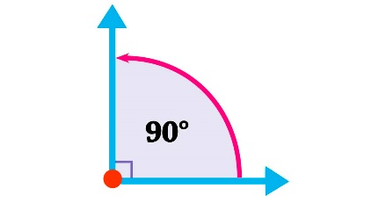
- Using your whiteboard add: 91+8
- Mangahigh or Topmarks, maths games online.
Literacy
- Continue raz-kids and spellings.
- Wolves, Trains and Dolphins- page 74, answer the questions based on the novel we are reading ‘100 Mile an hour dog’.
- Here is a link to Oral language activities based on taking care of our bodies, follow the link. Complete the poem and interactive activity 3 today.
https://rainbow.cjfallon.ie/#/units/second/5
- Novel: ‘Hundred Mile An Hour Dog’- Read Chapter 8
Draw a picture of any scene from this chapter. You can choose to create one picture or a comic strip.
Choose the day you want to complete the below activities.
Gaeilge
- Watch an episode of Tir na nog on RTE junior. Listen out for an Irish words you recognise. Oisín, Niamh and Fionn have fun through gaeilge.
https://www.rte.ie/player/series/tir-na-nog/SI0000006552?epguid=IP000064975
- Bua na Cainte page 79
Éadaí-clothes
Vardús- wardrobe
Cuirtíní- cutains
Cófra- press
Lampa-lamp
Fuinneog-window
Bréagáin-toys
Leabhar-book
Pictiúr-picture
Leaba- bed
In aice leis-beside
Ar an-on
Sa- in
Faoin-under
Art
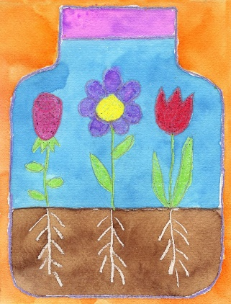
See steps to follow in the document attached on the 2nd class page.
You can integrate more art with your plant studies with this watercolour project.
PE- Everyday, Get Active!
Joe Wicks PE lessons on YouTube Daily at 9:00am (I will be following Joe Wicks too!)
Follow your active Homework journal.
Active Break’s https://www.gonoodle.com/
RTE Junior has ten minute exercise videos that the girls can follow https://rtejr.rte.ie/10at10/
Keep an eye on the active school section on the website, check out The Daily Mile Club!
Music
YouTube: Music with Myleene Klass. 1pm each day on her channel.
Here's a song from Bobby McFerrin with a really positive message. It was released in 1988.
Listen and practise singing along! I will link this under this work document too so you can click in quick!
https://www.youtube.com/watch?v=d-diB65scQU
RTE School Hub
You can tune in to watch RTE school hub on RTE TV at 11am each day.
This week’s topics:
Maths: Spatial Awareness
Gaeilge: Mo Bhréagáin
Drama: The Three Little Pigs
SPHE: Myself and My Opinions
History: Tom Crean
Optional Projects: SESE
Complete a project based on Plants your artwork will be nice to link with this project.
https://www.dkfindout.com/us/animals-and-nature/plants/
Take a look at this website and click on the icons to learn more!

