School Closure Work 27th of April to 1st of May
Here is some work for this week.
Like always, English (Literacy) and Maths (Numeracy) is broken up into days so that it is easier for you to follow.
You will find some more activities at the bottom of this page and you can choose when to do these.
Remember as always there is no pressure to get all of this done. You know I will understand if anything was tricky or confusing or you didn’t have time to complete it. Just try your best!
You can send me pictures of your completed work or any questions you have on my email:
msshaughnessysjog@gmail.com
Remember to exercise and keep safe and healthy.
Looking forward to seeing you all soon,
Ms Shaughnessy

Monday
Numeracy
This week we are focusing on Capacity

Capacity : The amount that something can hold.
Usually it means volume, such as millilitres (ml) or litres (l) in Metric.
There are 1000 ml in 1 Litre.

Watch these videos for more explanation
https://www.youtube.com/watch?v=GKCE8ohIBqE
https://www.youtube.com/watch?v=QMpkm4dAB4w
https://www.khanacademy.org/math/cc-third-grade-math/imp-measurement-and-data/imp-volume/v/liter-intuition

- https://www.scoilnet.ie/learning-path/ref/15778/
Capacity games to play each day this week.
- https://my.cjfallon.ie/dashboard/student-resources
Follow this link before completing each page in busy at maths. Complete the interactive activity before each page. Select, primary, 2nd class, maths, busy at maths, interactive, and then scroll to find the page number we are completing today and complete the activity first.
- Busy at maths: Page 144
- Complete counting activities every day, skip counting and counting forwards and backwards from a given number.
- Visit the topmarks.co.uk website and mangahigh for maths games and activities. Select your age and subject maths.
Literacy
- Continue Paired Reading and raz-kids. Email me if you haven’t asked for your password yet!
- I have set you all up with an online spellings programme. Send me an email and I will forward you your login details. On this website ignore the dictation for now. Just focus on the yellow spellings.
- Here is a link to Oral language activities based on transport, follow the link. Complete interactive poster and poem today.
https://rainbow.cjfallon.ie/#/units/second/12
- Handwriting Book- Page 33. Do your best and most careful work!
Tuesday
Numeracy
- Busy at maths interactive, follow steps listed yesterday.
- Busy At maths page 145
- Number of the day, write 5 facts about the number: 167
- Mangaigh

Literacy
- Continue Paired Reading and raz-kids.
- Wolves, Trains and Dolphins- Page 18. Label the spider and write 5 rules.
- Here is a link to Oral language activities based on transport, follow the link. Complete interactive activity 2 today.
https://rainbow.cjfallon.ie/#/units/second/12
- Free-writing- any topic you want. Example, write a recipe, story, recount, report, diary entry, shopping list.
Wednesday
Numeracy
- Busy At maths interactive.
- Busy At maths page 146
- Number of the day, write 5 facts about the number: 32
- Mangahigh or Topmarks, maths games online.
Literacy
- Continue Paired Reading and raz-kids.
- Wolves, Trains and Dolphins, Page 19, Popcorn.
- Here is a link to Oral language activities based on transport, follow the link. Complete interactive activity 3 today.
https://rainbow.cjfallon.ie/#/units/second/12
- Handwriting Book- Page 34. Do your best careful work!
Thursday
Numeracy
- Busy At maths interactive.
- Busy At maths page 147
- Number of the day, write 5 facts about the number: 189
- Mangahigh or Topmarks, maths games online.
Literacy
- Continue Paired Reading and raz kids.
- Wolves, Trains and Dolphins- https://kids.kiddle.co/Popcorn
Firstly, do some research about popcorn following the above link. Then answer the questions and finish the sentences on page 20
- Here is a link to Oral language activities based on transport, follow the link. Complete interactive activity 4 today.
https://rainbow.cjfallon.ie/#/units/second/12

Friday
Numeracy
- Use your white board to record some strategies for the following sums:
- 34+55
- 21+63
- 47+32
- Mangahigh or Topmarks, maths games online.
- Check some containers in your house to see how much liquid they hold (Check their capacity) Example: Milk carton, orange juice, mi-wadi, measuring jug etc.

Literacy
- Continue raz kids and spelling for me.
- Wolves, Trains and Dolphins complete page 21
- Here is a link to Oral language activities based on transport, follow the link. Complete slideshow today.
https://rainbow.cjfallon.ie/#/units/second/12
Choose the day you want to complete the below activities.
Gaeilge
- Watch an episode of Tir na nog on rte. junior. Listen out for an Irish words you recognise. Oisín, Niamh and Fionn have fun through gaeilge.
https://www.rte.ie/player/series/tir-na-nog/SI0000006552?epguid=IP000064975
- Bua na Cainte page 92. Colour by numbers and practise vocabulary.
Spéir- sky
An ghrian ag taitneamh- sun is shining
Crann-tree
Sa choill- the forest
Ina chodladh- sleeping
Carbhat- tie
Cóta- coat
An giorra- hare
Fear-grass
An toirtís- tortoise
Cloch-rock

Art
- Draw/Sketch a pond with water lilies in your new sketch book.
- Create a Claude Monet art project, try painting his water lilies using crayon and your watercolour paints from your new palette. The crayon and paint will create different textures.
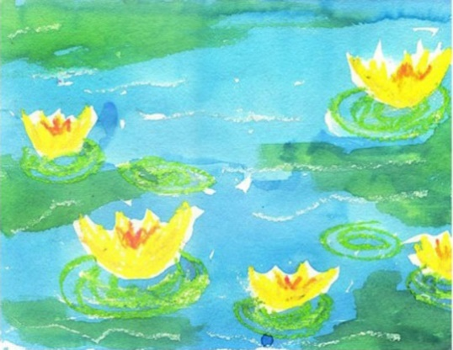
DIRECTIONS
- Draw and colour one large yellow lily (which is much the shape of a tulip) and then one medium and several small on a large piece of your sketch paper.
- Colour peach/yellow crayon on top of each flower, as a kind of shadow, and then pink for a centre.
- Draw light green ovals around the bottom of each lily. Lastly, add lots of squiggly lines with the white pastel to look like waves.
- Use liquid blue watercolour, and paint over everything except the flowers, which kept their pretty yellow colour. While the paint is still wet, add a bit of green watercolour in some areas. The bluish, greenish colour adds a lot of dimension to the painting.

PE- Everyday, Get Active!
This is ACTIVE HOME WEEK!!
Keep an eye on the active school section on the website for some active ideas!
Don’t forget to log your activities and email me some pictures of what you are up to!
Music
Youtube: Music with Myleene Klass. 1pm each day on her channel.
Rte School Hub
You can tune in to watch RTE school hub on RTE TV at 11am each day.
Optional Projects: SESE
Complete a project based on the water cycle.
Watch these clips for some inspiration.
https://www.youtube.com/watch?v=ncORPosDrjI
https://www.youtube.com/watch?v=TWb4KlM2vts
https://www.sciencekids.co.nz/sciencefacts/weather/thewatercycle.html

