Monday
Numeracy
This week we are focusing on Weight (Heavier/lighter/same/g/kg)
Weight
- How heavy something is.
- In everyday life, mass is often called weight but mass and weight are not the same,
mass is the quantity of matter in an object and doesn't change but the weight of an object changes according to gravity.
- A brick would be weightless in space, even though it still has the same mass as on earth.
- Weight is measured using scales.
- Weight is measured in grams/kilograms
- There are 1000 grams in one kilogram. "Kilo" actually means "one thousand". So half a kilo is 500 grams, and a quarter of a kilo is 250 grams.

Watch these videos for more explanation
https://www.youtube.com/watch?v=ivAD44nh0D0
https://www.youtube.com/watch?v=ZCd_-8r517Q

- https://my.cjfallon.ie/dashboard/student-resources
Follow this link before completing each page in busy at maths. It has an interactive activity to complete before each page. Select, primary, 2nd class, maths, busy at maths, interactive, and then scroll to find the page number we are completing today and complete the activity first.
- Busy at maths: Page 104
- Number of the day, write 5 facts about the number: 72
- Complete counting activities every day, skip counting and counting forwards and backwards from a given number.
- Visit the topmarks.co.uk website and mangahigh for maths games and activities. Select your age and subject maths.
Literacy
- Continue Paired Reading and raz kids. Email me if you havn’t asked for your password yet!
- I have set you all up with an online spellings programme called ‘Spellings for me’. Send me an email and I will forward you your login details. When you get your login details off me, ignore the dictation for now. Just focus on working your way through the yellow spellings!
- Listen to an Audio Book by David Walliams, After click on the Activities tab at the top of the web page and choose an activity to complete, your choice.
https://www.worldofdavidwalliams.com/
- Here is a link to Oral language activities based on Recycling, follow the link. Complete one activity of choice each day.
https://rainbow.cjfallon.ie/#/units/second/9
- Handwriting Book- Page 31. Do your best and most careful work!

Tuesday
Numeracy
- Busy at maths interactive, follow steps listed yesterday.
- Busy At maths page 105
- Number of the day, write 5 facts about the number: 36
- Using your whiteboard, use addition strategies for the sum: 41+36
- Mangaigh

Literacy
- Continue ‘raz-kids’ and ‘spellings for me’.
- Wolves, Trains and Dolphins- Page 13. Read the extract from the story ‘Washed Away’ Complete the activities on Page 13 and 14.
- Here is a link to Oral language activities based on Recycling, follow the link. Complete one activity of choice each day.
https://rainbow.cjfallon.ie/#/units/second/9
- Free-writing- any topic you want. Example, write a recipie, story, recount, report, diary entry, shopping list.
Wednesday
Numeracy
- Follow the learning path link below to find some ideas for exploring Weight
https://www.scoilnet.ie/learning-path/ref/15591/
- Busy At maths interactive.
- Busy At maths page 106
- Number of the day, write 5 facts about the number: 104
- Using your whiteboard, use addition strategies for the sum: 28+41
- Mangahigh or Topmarks, maths games online.
Literacy
- Continue ‘raz-kids’ and ‘spellings for me’.
- Wolves, Trains and Dolphins- Page 13. Read the extract from the story ‘Washed Away’ Complete the activities on Page 15
- Here is a link to Oral language activities based on Recycling, follow the link. Complete one activity of choice each day.
https://rainbow.cjfallon.ie/#/units/second/9
- Handwriting Book- Page 32. Do your best careful work!

Thursday
Numeracy
- Busy At maths interactive.
- Busy At maths page 107. Complete Q2 only if you have a weighing scale at home.
- Number of the day, write 5 facts about the number: 104
- Using your whiteboard, use addition strategies for the sum: 37+32
- Mangahigh or Topmarks, maths games online.
Literacy
- Continue ‘raz-kids’ and ‘spellings for me’.
- Wolves, Trains and Dolphins- Page 13. Read the extract from the story ‘Washed Away’ Complete the activities on Page 16.
- Here is a link to Oral language activities based on Recycling, follow the link. Complete one activity of choice each day.
https://rainbow.cjfallon.ie/#/units/second/9

Friday
Numeracy
- Number of the day, write 5 facts about the number: 212
- Mangahigh or Topmarks, maths games online.
- Use your kitchen scales to weigh different items that you find around the house. Experiment with different food items - tins, packets of sugar, fruit and vegetables. Notice how size is not always an indication of weight. Some items are very light, even though they take up a lot of space.
- Using your knowledge of weight, use a weighing scale to weigh ingredients you will use in a baking recipie.
If an adult has time to help you you can make the following recipie or a recipie of your choice, remember it’s your job to weigh the ingredients!
Give these cookies a try. Don’t forget to send me a picture if you bake them!
https://www.bbcgoodfood.com/user/896076/recipe/basic-cookies

Literacy
- Continue ‘raz-kids’ and ‘spellings for me’.
- Wolves, Trains and Dolphins- Page 13. Read the extract from the story ‘Washed Away’ Complete the activities on Page 17.
Rule for ‘to’ and ‘too’. Check out this link before you complete page 17.
https://www.grammar-monster.com/easily_confused/too_to.htm
- Here is a link to Oral language activities based on Recycling, follow the link. Complete one activity of choice each day.
https://rainbow.cjfallon.ie/#/units/second/9
- After your baking activity in maths, Write the procedure you followed. Remember to include: your title, your goal (What you hope to make), your ingredients, the steps you followed in the right order, and a comment about how they turned out. You can sketch a picture of your finished cookies!
Choose the day you want to complete the below activities.
Gaeilge
Watch an episode of Tir na nog on rte junior. Listen out for an irish words you recognise. Oisín, Niamh and Fionn have fun through gaeilge.
https://www.rte.ie/player/series/tir-na-nog/SI0000006552?epguid=IP000064975
Art
- Draw/Sketch an idea you have for creating art using recycled materials in your free-Drawing copy.
- Get creative and make something using recycled materials.
Here are some ideas to get you thinking:
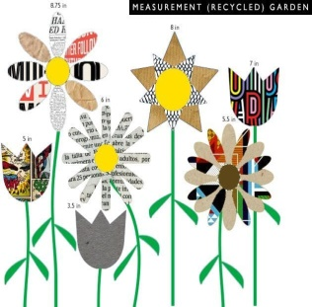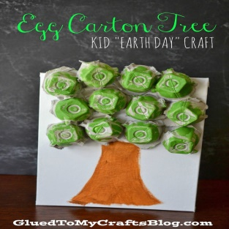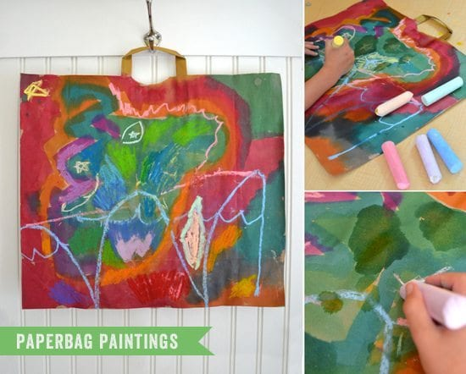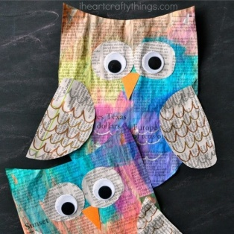

PE- Everyday, Get Active!
Joe Wicks PE lessons on Youtube Daily at 9:00am (I will be following Joe Wicks too!)
Follow your active Homework journal. This week starts on page 28
Active Break’s https://www.gonoodle.com/
RTE Junior has ten minute exercise videos that the girls can follow https://rtejr.rte.ie/10at10/
Keep an eye on the active school section on the website for some more active ideas!
Music
Youtube: Music with Myleene Klass. 1pm each day on her channel.
Rte School Hub
You can tune in to watch rte school hub on rte tv at 11am each day.
Optional Projects: SESE
Watch this short video about Recycling. Complete a project based on recycling. Remember to include the words reduce, reuse and recycle. You can complete you project using some recycled materials, get creative and try to include some of your own ideas!
https://www.youtube.com/watch?v=OasbYWF4_S8

