School Closure Work 30th-3rd March
Hi Girls,
I hope everyone is well and is staying safe at home. Here is some work to keep you busy for this week, before you tuck into your yummy Easter Eggs and take a break from schoolwork!
English and Maths is broken up into days so that it is easier for you to follow. You will find some more activities at the bottom of this page and you can choose when to do these.
Remember there is no pressure to get all of this done, think of it as a menu, you choose what suits you. You know I will understand if anything was tricky or confusing or you didn’t have time to complete it. Just try your best!
Remember to exercise and keep safe and healthy.
Looking forward to seeing you all soon,
Ms Shaughnessy

Monday
Numeracy
- Maths Homework Sheet- Week 3, complete first column (The Sheet we usually have for homework).
- Follow the link below to watch a video about odd and even numbers on Khan Academy.
https://www.khanacademy.org/math/cc-third-grade-math/arithmetic-patterns-and-problem-solving/imp-patterns-in-arithmetic/v/introduction-to-even-and-odd
- Busy at maths: Page 24
- Number of the day, write 5 facts about the number: 22
- Complete counting activities every day, skip counting and counting forwards and backwards from a given number.
- Visit the topmarks.co.uk website and mangahigh for maths games and activities. Select your age and subject maths.
Literacy
- Continue Paired Reading
- Listen to this Audio Book, by David Walliams, After click on the Activities tab at the top of the web page and choose an activity to complete, your choice.
https://www.worldofdavidwalliams.com/mr-stink-by-david-walliams-read-by-david-wallims-and-matt-lucas-audiobook-extract/
- Here is a link to Oral language activities based on Pets, follow the link. Complete one activity of choice each day.
https://rainbow.cjfallon.ie/#/units/second/1
- Handwriting Book- Page 29. Do your best and most careful work!

Tuesday
Numeracy
- Maths Homework Sheet- Week 3, complete 2nd day.
- Below is a link to some Activities based on Odd and Even numbers:
https://www.scoilnet.ie/learning-path/ref/15351/
- Busy At maths page 33
- Number of the day, write 5 facts about the number: 411
Literacy
- Continue Paired Reading
- Wolves, Trains and Dolphins- Page 7. Read the poem ‘My Foot Fell Asleep’. Complete the activities on Page 8.
- Oral language activities based on Pets, following this link. Complete one activity of choice daily
https://rainbow.cjfallon.ie/#/units/second/1
- Free-writing- any topic you want. Example, write a recipie, story, recount, report, diary entry, shopping list.

Wednesday
Numeracy
- Maths Homework Sheet- Week 3, complete 3rd day.
- Busy At maths page 34
- Number of the day, write 5 facts about the number: 209
- Mangahigh or Topmarks, maths games online.
Literacy
- Continue Paired Reading
- Wolves, Trains and Dolphins- Page 7. Read the poem ‘My Foot Fell Asleep’. Complete the activities on Page 9.
- Oral language activities based on Pets, following this link. Complete one activity of choice daily.
https://rainbow.cjfallon.ie/#/units/second/1
- Handwriting Book- Page 30. Do your best careful work!

Thursday
Numeracy
- Maths Homework Sheet- Week 3, complete 4th day.
- Busy At maths page 35
- Number of the day, write 5 facts about the number: 134
- Topmarks Website- choice of game
Literacy
- Continue Paired Reading
- Wolves, Trains and Dolphins- Page 7. Read the poem ‘My Foot Fell Asleep’. Complete the activities on Page 10.
- Oral language activities based on Pets, following this link. Complete one activity of choice daily.
https://rainbow.cjfallon.ie/#/units/second/1

Friday
Numeracy
- Number of the day, write 5 facts about the number: 372
- Game following this link
https://www.topmarks.co.uk/learning-to-count/blast-off
- Clock Diary-Write down what time you got up, ate your breakfast, had your dinner, went to bed, feel free to add more activities to your clock diary.
Literacy
- Continue Paired Reading
- Wolves, Trains and Dolphins: Remember Capital letters go at the beginning of each sentence. We use capital letters for names of people and places. Full stops belong at the end of each sentence. Complete the activities on Page 11.
- Summarise ‘The Diary of a killer Cat’ in your own words. Record yourself speaking on phone, talk to your reflection in the mirror or ask your mom, dad, brother, sister to listen to you retelling.

Choose the day you want to complete the below activities.
Gaeilge
Bua na cainte: pg 110
An Cháisc- Easter
Join the dots and practice Vocabulary.
Art
- Draw/Sketch an Easter Bunny in your free-Drawing copy.
- http://www.iamanartist.ie/drawing/ Watch relevant videos on this website and with attention to line draw your house or an imaginary house.
- Easter art ideas:
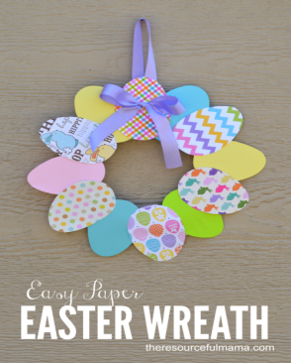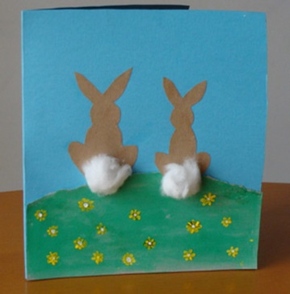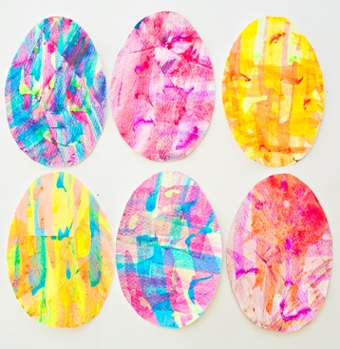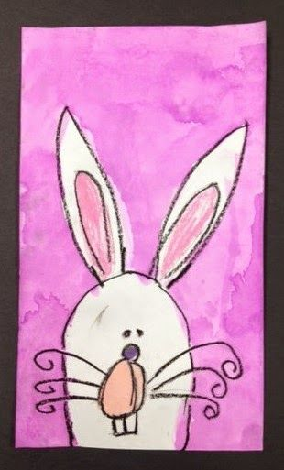

PE- Everyday, Get Active!
Joe Wicks PE lessons on Youtube Daily at 9:00am (I will be following Joe Wicks too!)
Follow your active Homework journal. This week starts on page 28
Active Break’s https://www.gonoodle.com/
RTE Junior has ten minute exercise videos that the girls can follow https://rtejr.rte.ie/10at10/
Keep an eye on the active school section on the website for some more active ideas!
Music
Youtube: Music with Myleene Klass. 1pm each day on her channel.
Optional Projects: SESE
Project/ Factfile on ‘Homes around the world’.
Watch this video and research some interesting facts. See how many interesting facts you can include.
https://www.teachertube.com/videos/little-human-planet-homes-around-the-world-386131

or

Design a ‘Spring’ Poster or Poem including as many facts about the season as you can recall/research. You can include pictures and Spring/Easter Vocabulary.
Some good free websites/free trials:
sir linkalot- Spelling Practice
Storytimefromspace.com- Story Time
The maths factor.com- Maths Lessons
Science kids.co.nz –Project section has some good activities
Nasa.gov – Kids Science section
National Geographic Kids –SESE Activities and Lessons
BBCgoodfood- has a kids baking section
Easter Baking Challenge
https://www.bbcgoodfood.com/recipes/shredded-wheat-nests
Try baking an Easter Recipie, if you don’t have any ideas try making easter nests like seen in the link above. Your parents might have another recipie idea you could follow.
Write the procedure you followed.
Remember to include: your title, your goal (What you hope to make), your ingredients, the steps you followed in the right order, and a comment about how they turned out.
If you like, take a picture or draw a picture of your yummy creation to show when we get back to school!

