School Closure Work 6th – 22nd May
Hi Girls,
I hope you all enjoyed your long weekend.
I have decided to give you work for the next two and a half weeks to work through today. We are focusing on the same topic in Maths, English, Irish and SESE for the next two and a half weeks so I thought it would be better to give all the work today. (so don’t be afraid when you see this document is 16 pages long )
English and Maths is broken up into days again so that it is easier for you to follow and then you can pick and choose whatever other work you want to do.
I have also included a HIT sessions for everyday as well for anyone who would like to continue to try keep their fitness levels up.
For your work over the next two and a half weeks I have created some worksheets and PowerPoints, you will find these on our school page, just underneath the link for this document.
Remember there is no pressure to get all of this done, do what you can and don’t be too worried about it. I am giving you quite a lot of work, I feel it’s better to give you more rather than less so please don’t feel under pressure at all to get this all complete. It’s only in case some people want more work to do to keep them busy. The main thing I would like you to be focusing on is doing some reading every day and practicing all your counting activities.
I have set a new challenge for you to take part in this week too, you have to try and beat my score again. It’s all a bit of fun, so enjoy it.
I have also uploaded a ‘Meaningful May’ poster. This poster gives you a small task to complete every day. These actions are for happiness, so enjoy completing them.
I am hoping to give you all a short phone call this week girls, just to see how you are getting and if you have any questions for me.

I hope you are all keeping well and helping out your parents at home as much as possible
Stay safe,
Missing you loads,
Ms Carr x
Wednesday
Numeracy
- Continue to work on your counting activities. Please try spend around 15 minutes every day counting.
- Time: This week we are going to look at the topic of Time. To begin please read through the powerpoint on time and watch the short video clip on time. This video focuses on o’clock and half past. Try and get familiar with this today before you start doing book work tomorrow.
https://www.youtube.com/watch?v=xUSvgVvBioE

- Here are three books that have the theme of time in them. Have a listen and get familiar with the different times and what you do at certain times of the day.
- Clock o’clock https://www.youtube.com/watch?v=lUhK42DYUjo
- What’s the time Mr Wolf : https://www.youtube.com/watch?v=0clHCBvjsNc
- The Grouchy ladybird: https://www.youtube.com/watch?v=M7fg0XxeSSQ

- It would be great if you all could make your own clock from a paper plate/cardboard. We will use this during the next two weeks when learning about time.

I have put a template of a clock on our page if you would like to use that either.
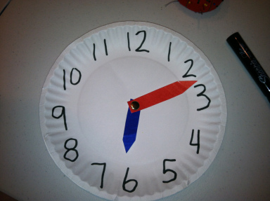

- Answer these questions if you can:
- What time did you get up at today?
- What time did you eat breakfast at?
- What time did you have lunch?
- What time did you have dinner?
- What time did you go to bed?

- Number of the day, write 5 facts about the number: 9 (use your new whiteboards)
- Visit the topmarks.co.uk website and mangahigh for maths games and activities. Select your age and subject maths.
Literacy
- Continue Paired Reading
- Raz Kidz: If you haven’t already joined Raz kids please do. It’s a great site with loads of books for you to read. You can listen to the story and then read it yourself and afterwards you can record yourself reading and listen back to yourself. There’s a few activities to complete too and you can collect lots of stars as prizes.
(email me for your password if you would like to use this site)
- Spellings: Move on to the next set of spellings pg 56 ‘ oy’ sound.
Take six spellings every night to focus on. Use our look, say , cover, write and check method when learning your spellings. Try put your spellings into a sentence. (either written or orally)
I know you have a short this week but try your best with the spellings. Challenge yourself, see if you can learn them all in two days
Complete exercise on page 56.
- The link below brings you to activities based on our spellings for the week. When you arrive at this site scroll down until you get to week 28, this is our spellings for this week. Here you will see a list of our spellings and you will also a button to press for games. Have a go at some of these activities, there are some games, word searches, fill in the missing letter and you can also complete a spelling test on this site too. Hopefully this site will make your spellings a bit more fun this week.
https://www.spellingcity.com/users/JollyGrammar
- Write your news from your long weekend. Try and write at least 5 sentences. Remember to use capital letters and full stops. Take your time with your handwriting, make sure your letters and on the line and you leave a finger space between all your words. Draw a nice picture to go along with it
- Handwriting Book- Page 55. Do your best and most careful work!
Active work
I’m going to leave up some HIT sessions for you to complete this week again as I really enjoyed doing them last week and they’re great for your fitness I hope you all enjoyed them as much as me. They only take 20 minutes so everyone should have plenty time to complete these during this lock down.

Again, as you know from last week this is hard work girls so have you bottle of water beside you!

- 30 seconds jumping jacks
- 30 seconds high knees
- 30 seconds tuck jumps
- 30 seconds burpees
*repeat 4 times

Thursday
Numeracy
- 15 minutes counting activities
- Time: Today I want you to use your homemade clock to make different times. Get used to making O’ clock times. Make 1 o’clock, 2o’clock, 3 o’clock, 4 o’clock, 5 o’clock, 6 o’clock, 7 o’clock, 8 o’clock, 9 o’clock, 10’ o clock, 11 o’clock and 12 o’clock.
When you have this complete get someone at home to make different times on your clock and you have to tell them what time it is.
- Make a big effort to try and read the time though out the day.
- Number of the day, write 5 facts about the number: 95
- Addition sum: Complete this sum using as many strategies as you can
43 + 22 =
Literacy
- Continue Paired Reading
- Continue reading your stories on Raz- kids
- Spellings: learn the next six spellings today and try put them into sentences.
Spelling exercises and games:
https://www.spellingcity.com/users/JollyGrammar
- Write your news from your long weekend. Try and write at least 5 sentences. Remember to use capital letters and full stops. Take your time with your handwriting, make sure your letters and on the line and you leave a finger space between all your words. Draw a nice picture to go along with it
- My Grammer book : Exercises on page 57

Active work
- 30 seconds sit ups
- 30 seconds press ups
- 30 seconds squats
- 30 seconds lunges
*repeat 4 times

Friday
Numeracy
- 15 minutes counting activities.
- Time: Busy at maths pg 81 exercise 1 ( write the time shown on the clock)
- On your homemade clock get someone at home to ask you to make times on your clock. ( O’clock times only)
- Keep trying to read the time during the day. Look at the clock when you wake up, having breakfast, having lunch, having dinner and going to bed. Make sure to ask someone at home to help you read the clock if you are stuck.
- Number of the day, write 5 facts about the number: 61
- Mangahigh or Topmarks, maths games online.
Literacy
- Continue Paired Reading
- Raz-kids: continue reading through the stories on this website.
- Spelling test: Ask someone at home to test you on your spellings or else complete the spelling test on spelling city website. Try your best
- Countryside: see how many small words you can find in the word countryside.
- David Walliams: Have a listen to David William’s free audio story today. Sit back, relax and enjoy having a story being read to you after you finish your spelling test
https://www.worldofdavidwalliams.com/elevenses/
- Riddle: The answer to last week’s riddle was a clock.
- Here is this week’s riddle
What word begins with E but only has one letter in it?

Active work
- 30 seconds high knees
- 30 seconds skips
- 30 seconds bunny hops
- 30 seconds jumping jacks
*repeat 4 times

Week 11th – 15th May
Monday
Numeracy
- Continue to work on your counting activities. Please try spend around 15 minutes every day counting.
- Time: We are looking at time again this week. Have a quick recap on what we did last week on time, looking at O’clock and half past. Have a look at the video on time again to help you remember where the big hand and small hand go.
https://www.youtube.com/watch?v=xUSvgVvBioE
- Get someone at home to call out times for you to create on your clock. Maybe today you could test someone at home too, you can ask them to make a time and you have to see if they are correct
- On your whiteboard I want you to draw a clock. When you have your clock drawn I want you to make these times on your clock. (When you have drawn the hands for the first time, get someone to check it and if it is correct rub it out and do the next time.)
- 5 o’clock
- 7 o’clock
- 11 o’clock
- 4 o’clock
- 12 o’clock
(if you want to do more work on this get someone at home to call out more times for you to create )
- Number of the day, write 5 facts about the number: 26
- Visit the topmarks.co.uk website and mangahigh for maths games and activities. Select your age and subject maths.
Literacy
- Continue Paired Reading and Raz kids.
(email me for your password if you would like to use this site)
- Spellings: Move on to the next set of spellings pg 58 ‘or’ sound.
Take three spellings every night to focus on. Use our look, say , cover, write and check method when learning your spellings. Try put your spellings into a sentence. (either written or orally)
Complete exercise on page 58.
- The link below brings you to activities based on our spellings for the week. When you arrive at this site scroll down until you get to week 29, this is our spellings for this week. Here you will see a list of our spellings and you will also a button to press for games. Have a go at some of these activities, there are some games, word searches, fill in the missing letter and you can also complete a spelling test on this site too. Hopefully this site will make your spellings a bit more fun this week.
https://www.spellingcity.com/users/JollyGrammar
- Handwriting Book- Page 57. Do your best and most careful work!
- Our News: Write a piece about your news today. I would like 5/6 sentences. Remember to use your capital letters and full stops. Take your time and do your best handwriting please
Active work

- 30 seconds jumping jacks
- 30 seconds high knees
- 30 seconds tuck jumps
- 30 seconds burpees
*repeat 4 times

Tuesday
Numeracy
- 15 minutes counting activities
- Time: Busy At maths page 81 exercise 2 ( draw the hands on the clock)
- Number of the day, write 5 facts about the number: 93
- Addition sum: Complete this sum using as many strategies as you can
47+ 12 =
Literacy
- Continue Paired Reading
- Continue reading your stories on Raz- kids
- Spellings: learn the next three spellings today and try put them into sentences.
Spelling exercises and games:
https://www.spellingcity.com/users/JollyGrammar
- Mr Large in charge
- Today we are going to start to look at our new book ‘Mr Large in charge’. As a lot of you might already have noticed, this is a follow on from our story ‘5 minutes peace’.
- To begin I want you to look at the front cover of our story. I want you to make a prediction about what you think this story is going to be about. Write 2 or 3 sentences and draw a picture to go along with it. (Try not to look through the book for help)
- When you have this complete, take a picture walk through the story and see if your prediction was correct.
- Read the first 10 pages, try your best to attempt to read it yourself, but if you need help ask someone at home. When you have these pages read I want you to tell the story in your own words to someone at home.

- Active work
- 30 seconds sit ups
- 30 seconds press ups
- 30 seconds squats
- 30 seconds lunges
*repeat 4 times

Wednesday
Numeracy
- 15 minutes counting activities.
- Time: Today we are going to look at half past. Take a quick look at the video again if you can’t remember where the big and small hand should be to show half past.
- Using your home made clock make these times:
- Half past 5
- Half past 8
- Half past 9
- Half past 12
- Half past 6
- When you have this complete ask someone at home to make times on your clock and you tell them what time they made.
- Busy at maths : complete exercise 1 and 2 on page 82
- Number of the day, write 5 facts about the number: 13
- Mangahigh or Topmarks, maths games online.
Literacy
- Continue Paired Reading
- Raz –kids: Continue to work on your reading fluency reading through some of the stories on this website.
- Spellings: Learn the next three spellings today. Try and put your spellings into sentences and do some exercise on spelling city.
https://www.spellingcity.com/users/JollyGrammar
- Mr Large in charge:
- To begin today recap on what you read yesterday. Tell the story in your own words again.
- Next I want you to read the next 10 pages. Again, try your best to read this by yourself.
- When you have it read, put the story into your own words again, summarise it. Write 4/5 sentences and draw a picture to go along with it.

- My Grammer book page 59 – complete the exercises.
Active work
- 30 seconds high knees
- 30 seconds skips
- 30 seconds bunny hops
- 30 seconds jumping jacks
*repeat 4 times

Thursday
Numeracy
- 15 minutes counting activities.
- Time: Today we are continuing to look at half past. Use your clock again to make some times and get someone at home to test you on them.
- Using your whiteboard draw a clock. On this clock I want you to make these times:
- Half past 11
- Half past 8
- Half past 3
- Half past 1
- Busy at maths: Complete exercise 3 and 4 on page 82.

- Number of the day, write 5 facts about the number: 80
- Topmarks/mangahigh Website- choice of game
Literacy
- Continue Paired Reading
- Raz-kids: continue reading through the stories on this website.
- Spellings: Revise all your spellings for a spelling test tomorrow. Use your look, say , cover, write and check method to help you learn them.
Games/activities on spelling city.
- Mr Large in charge
- Today I want you to finish reading the story.
- Summarise the whole story today using 5 sentences.
Draw a picture of your favourite image from the story.
(on a sheet of paper or on your whiteboard )
- Handwriting: Page 59. Do your best and most careful work!

Active work
- 30 seconds mario jumps
- 30 seconds jogging on the spot
- 30 seconds scissor jumps
- 30 seconds seconds marching on the spot
*repeat 4 times
Friday
Numeracy
- 15 minutes counting activities
- Number of the day, write 5 facts about the number: 17
- Problem solving Friday!! Today you can try some word problems on time. I have uploaded a worksheet onto our page, complete half of these word problems today, we will look at the rest of them next Friday. Have a go at them!
Literacy
- Continue Paired Reading
- Raz-kids: Continue reading the stories on this website.
- Spelling test: Ask someone at home to test you on your spellings or else complete the spelling test on spelling city website. Try your best
- David Walliams: Have a listen to David William’s free audio story today. Sit back, relax and enjoy having a story being read to you after you finish your work and spelling test
https://www.worldofdavidwalliams.com/elevenses/
- Riddle: The answer to last week’s riddle was An Envelope
- Here is this week’s riddle
What has to be broken before you use it?

Active work
- 30 seconds heel flicks
- 30 seconds jump squats
- 30 seconds high knees
- 30 seconds seconds fast feet
*repeat 4 times
Week 18th – 22nd May
Monday
Numeracy
- Continue to work on your counting activities. Please try spend around 15 minutes every day counting.
- Today have a talk about the different things you do at different times during the day. Focus on the words: morning, night, noon, afternoon, evening and midnight.
- Think of one thing you do at each of these times.
- Look at the PowerPoint names day or night. Take the quiz on this PowerPoint to see if you know what we do during the day and what we do at night.
- Number of the day, write 5 facts about the number: 38
- Visit the topmarks.co.uk website and mangahigh for maths games and activities. Select your age and subject maths.
Literacy
- Continue Paired Reading and Raz Kids.
- Spellings: Move on to the next set of spellings pg 60 ‘al’sound.
Take three spellings every night to focus on. Use our look, say , cover, write and check method when learning your spellings. Try put your spellings into a sentence. (either written or orally)
Complete exercise on page 60.
- The link below brings you to activities based on our spellings for the week. When you arrive at this site scroll down until you get to week 30, this is our spellings for this week. Here you will see a list of our spellings and you will also a button to press for games. Have a go at some of these activities, there are some games, word searches, fill in the missing letter and you can also complete a spelling test on this site too. Hopefully this site will make your spellings a bit more fun this week.
https://www.spellingcity.com/users/JollyGrammar
- My News: Today write a piece of news about your weekend. Write 6-7 sentences paying attention to capital letters and full stops. Do your best handwriting too please.
- Handwriting Book- Page 61. Do your best and most careful work!
Active work

- 30 seconds jumping jacks
- 30 seconds high knees
- 30 seconds tuck jumps
- 30 seconds burpees
*repeat 4 times

Tuesday
Numeracy
- 15 minutes counting activities
- Time: We are focusing on the words: morning, night, evening, noon, midnight and afternoon again today.
- To begin, think of a different thing you do at each of these times today.
- Busy at maths: complete exercise 1 and 2 on page 83.
- Number of the day, write 5 facts about the number: 94
- Addition sum: Complete this sum using as many strategies as you can
51 + 18 =
Literacy
- Continue Paired Reading
- Continue reading your stories on Raz- kids
- Spellings: learn the next three spellings today and try put them into sentences.
Spelling exercises and games:
https://www.spellingcity.com/users/JollyGrammar
- Mr Large in charge:
- Begin today by reading the story again. (You can listen to the YouTube clip too and read along)
- Next I would like you to summarise the story ‘Mr Large in charge’. Use your whiteboard and marker. Split it into 4 boxes. In each box draw/write the story in your own words/pictures. You only have four boxes so you need to pick the four most important things from the story that you think will tell the story.
- Worksheet: I have made a worksheet on ‘Mr Large in charge’. (I have it uploaded onto our page) Today I would like you to complete exercise 1 and 2. Use your book to help you if you’re stuck

Active work
- 30 seconds sit ups
- 30 seconds press ups
- 30 seconds squats
- 30 seconds lunges
*repeat 4 time

Wednesday
Numeracy
- 15 minutes counting activities.
- Time: Today we are going to look at the days of the week. Monday , Tuesday, Wednesday, Thursday, Friday, Saturday and Sunday.
- I want you to think of one thing you do on each of these days, For example we have PE on Tuesday, we have drama on Wednesday.
- Enjoy this song on days of the week to help you learn them
https://www.youtube.com/watch?v=mXMofxtDPUQ
- Busy at maths: complete exercise 1 on page 84
- Extra worksheets on days of the week (cut and stick activity) available on our page
- Number of the day, write 5 facts about the number: 6
- Mangahigh or Topmarks, maths games online.
Literacy
- Continue Paired Reading
- Raz –kids: Continue to work on your reading fluency reading through some of the stories on this website.
- Spellings: Learn the next three spellings today. Try and put your spellings into sentences and do some exercise on spelling city.
https://www.spellingcity.com/users/JollyGrammar
- Mr Large in charge
- Have a read through your favourite page on the book.
Worksheet: Today I would like you to complete exercise 3 and 4 on the worksheet.
- Handwriting Book- Page 63. Do your best careful work!
Active work
- 30 seconds high knees
- 30 seconds skips
- 30 seconds bunny hops
- 30 seconds jumping jacks
*repeat 4 times

Thursday
Numeracy
- 15 minutes counting activities.
- Time: See if you can say all the days of the week in the correct order today without looking at anything.
- Busy at maths: complete exercise 2 on page 84.
- Number of the day, write 5 facts about the number: 39
- Topmarks Website- choice of game
Literacy
- Continue Paired Reading
- Raz-kids: continue reading through the stories on this website.
- Spellings: Revise all your spellings for a spelling test tomorrow. Use your look, say , cover, write and check method to help you learn them.
Games/activities on spelling city.
- Mr Large in charge:
Worksheet: Complete exercise 5

Active work
- 30 seconds mario jumps
- 30 seconds jogging on the spot
- 30 seconds scissor jumps
- 30 seconds seconds marching on the spot
*repeat 4 times

Friday
Numeracy
- 15 minutes counting activities
- Number of the day, write 5 facts about the number: 45
- Addition sum: 63 + 15 =
- Problem solving Friday: Try your best to complete the rest of the word problems on time on the worksheet.

Literacy
- Continue Paired Reading
- Raz-kids: Continue reading the stories on this website.
- Spelling test: Ask someone at home to test you on your spellings or else complete the spelling test on spelling city website. Try your best
- holiday: see how many small words you can find in the word holiday.
- Mr Large in charge: Today I would like if you could complete a book report on the book. I have created a book report template that you can use. I have uploaded this onto our page.
- David Walliams: Have a listen to David William’s free audio story today. Sit back, relax and enjoy having a story being read to you after you finish your spelling test
https://www.worldofdavidwalliams.com/elevenses/
- Riddle: The answer to last week’s riddle was an egg.
- Here is this week’s riddle
Mary’s father has five daughters – Nana, Nene, Nini, Nono. What is the fifth daughter’s name?

Active work
- 30 seconds heel flicks
- 30 seconds jump squats
- 30 seconds high knees
- 30 seconds seconds fast feet
*repeat 4 times

Choose the days you want to complete the below activities.
Gaeilge
Bua na cainte: An teilifís pg 67 – 75
We are going to focus on the theme ‘an teilifís’ for the next two and a half weeks. Please try your best to work through the pages in your Bua na Cainte.

Phrases to focus on:

For these two weeks I am giving you three phrases to work on. Try and use them as much as you can throughout the two week. For example, when you are having your breakfast you could say ‘Is maith liom tóasta’ Or if you are watching TV, you could say ‘Feicim Horid Henry’.
Even if you don’t know what the word is in Irish you can still begin your sentence in Irish, for example ‘Is maith liom spaghetti bolognaise’
Don’t be afraid to make mistakes

Question: An maith leat? Do you like?
Answer: Is maith liom/Ní maith liom I like/I don’t like

Question: Cad a chuala tú? What did you hear?
Answer: Chuala mé….. I heard

Question: Cad a fheiceann tú? What do you see?
Answer: Feicim …….I see

Continue to enjoy watching some cartoons in Irish. Hopefully you might start to recognise a few more words this week.
You can click to have the subtitles so read along while listening to it in Irish.
Try and see how many Irish words your recognise and see if you can learn any new words too
This can be found on cúla4
https://www.cula4.com/en/shows/

Cúla4 scoil will be on again this week every morning at 10am.
Try your best and see how many words you understand.
Give it a go and enjoy it
https://www.cula4.com/en/shows/
Art
- Draw/Sketch an elephant in your free-Drawing copy.
- Use art hub to learn to draw some animals. https://www.artforkidshub.com/
- Drawing with Jarla Duffy : This is who I used to always watch when I was younger. I used to love following his steps to help me learn to draw new things. Why not give it a go. (he is great at drawing cartoon characters )
https://www.youtube.com/channel/UCvzhIRaDcS2Zm4Ji7_BLu-w
- Art ideas: Elephants. (Africa)
- 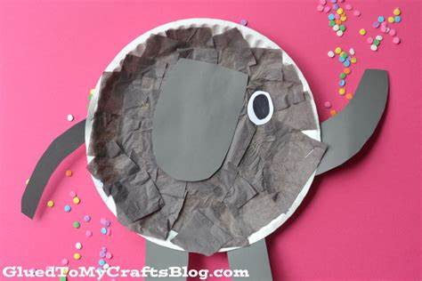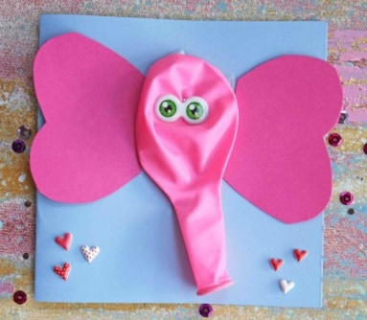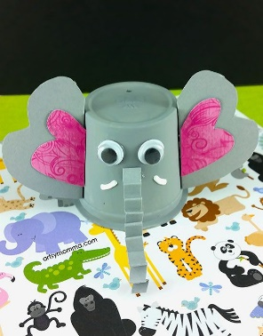
- 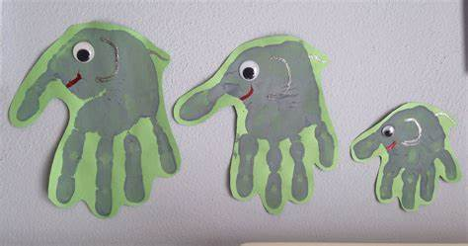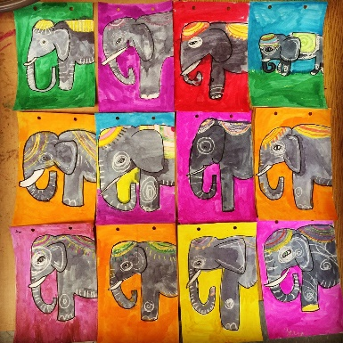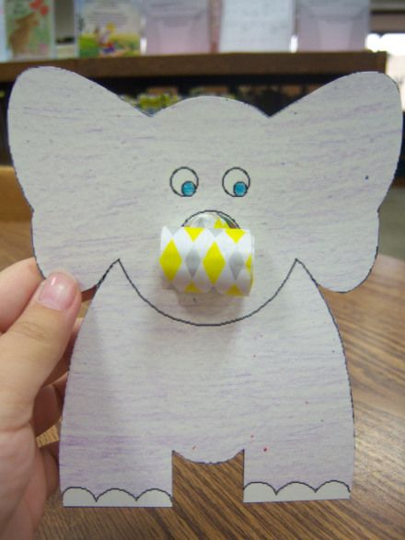
- 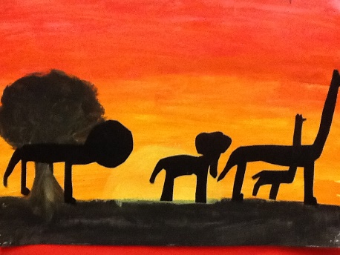

*** see art competition poster for details of a school art competition on our school page *** The final date for the competition is Wednesday 13th May so try get your entry sent to me by then
PE- Everyday, Get Active!

- Joe Wicks PE lessons on Youtube Daily ay 9:00am.
- Active Break’s https://www.gonoodle.com/
- RTE Junior has ten minute exercise videos that the girls can follow https://rtejr.rte.ie/10at10/
- Why not try some African dances on just dance.
https://www.youtube.com/watch?v=1vD7x5ncGNw
https://www.youtube.com/watch?v=QjCOU0_m9Xg
https://www.youtube.com/watch?v=aogNWORL_j0

- Look at the active school section of the school website to get some more ideas. Have a look at all the pictures from ‘Active home week’, see who you can spot from our class.

*** Challenge ***
Well done to everyone who took part in the challenge last you, you had some excellent scores.
This week I am going to set you a new challenge. I’ll give you the two and a half weeks to complete this challenge. Your challenge is to see how burpees you can do in 30 seconds.
My score is 18. Let’s see who can beat me.
Email me with your score and we’ll see who our winner is this week.
Have fun!!

Music
Youtube: Music with Myleene Klass. 1pm each day on her channel.
Have a listen to some traditional African music : https://www.youtube.com/watch?v=9b81mWYIyTo
Have a listen to ‘The Lion King’ soundtrack on youtube
Optional Projects: SESE
‘Africa’
We have started to look at ‘Mr Large in charge ‘ in English these weeks. The main characters in this book are elephants. Elephants are from Africa so I thought for the next two and a half weeks we will focus on Africa for SESE. We will look at where Africa is, different animals in Africa and focus on one part of Africa, Ethiopia. I have put together a PowerPoint on Africa, in this PowerPoint I have different tasks for you to do. I will have information provided on the task but it would be great if you could further research the topic too. See if you can find out more new interesting facts about Africa.
- Week 1: I would like you to do task 1.
- Week 2: try and complete task 2 and 3.
- Week 3: Try complete task 4 and if you want make a project on Africa with all the new information you have learned. You can do this on a big sheet of paper or make it into a book, it’s up to you. You can present this project to someone at home then. Show them how much you learned about Africa over the last two and a half weeks.
(Again there is no pressure to complete this but if you would like an extra challenge of making a project give it a go. I was hoping to start project work with you all this term, so give it a go and see how you get on yourself at home )

** Why not sit down some evening and watch ‘The Lion King’. This movie was set in Africa. Look at all the different animals and the scenery. You might get some ideas from this movie for an art lesson. ***

I hope you enjoy learning about Africa these two and a half weeks. Try your best with the tasks. Remember there is no pressure to complete this, it’s only if you want the extra work to do.

SPHE
Meaningful May poster
School Hub
Home school Hub will be on every day from 11am – 12pm on RTÉ 2, but you can catch it on RTÉ player afterwards! There will be extra activities available on http://www.rte.ie/learn/ to be done alongside the Home School Hub programme.
Baking:
This week’s baking activity is banana bread. Here is the recipe we followed if you would like to give it a go at home with someone. We added some chocolate chips to our recipe to make it even tastier
Have fun and enjoy!

https://www.kidspot.com.au/kitchen/recipes/easy-banana-bread-recipe/n1a0xd8s

Remember, don’t be like the little red hen’s friends who wouldn’t help her bake her bread and only wanted to eat it. If you’re allowed to bake something at home you have to help prepare the ingredients, mix them altogether and do all the washing up after before you’re allowed to eat your yummy treats.

Here is a picture of our banana bread!

