School Closure Work 27th – 1st May
Hi Girls,
I hope you all had a good week last week and enjoyed all the lovely sunshine. Looks like it’s going to be a lovely week again this week so remember to get outside and enjoy it
Here is some work to keep you busy for this week. English and Maths is broken up into days again so that it is easier for you to follow and then you can pick and choose whatever other work you want to do.
Remember there is no pressure to get all of this done, do what you can and don’t be too worried about it. The main thing I would like you to be focusing on is doing some reading every day and practicing all your counting activities.
I hope you all might have received another nice treat in the post last week, if not you should receive it someday this week.( I am still waiting for mine to arrive too so don’t worry if you don’t have them yet ) You all should receive three new books. We are going to use these books for English work starting from next week so try hold out from reading them just yet. We will all enjoy reading them and doing some activities on them next week.
This week is ‘Active home week’, so just like active schools’ week except you will be taking part in it at home with your family members.
You will see more information on this on our PE section of this page and there will also be more information and updates on the Active schools section of the school website. I have a HIT session for you to complete every day, this should take around 20 minutes. Get your family members to join in too, it’s a lot easier doing exercise with others than by yourself. Keeping active is so important, especially now when you are stuck at home every day.
I have set a challenge for you to take part in this week too, you have to try and beat my score in an activity. It’s all a bit of fun, so enjoy it.

I hope you are all keeping well and helping out your parents at home as much as possible
Looking forward to seeing you all soon,
Missing you loads,
Ms Carr :)
Monday
Numeracy
- Continue to work on your counting activities. Please try spend around 15 minutes every day counting.
- Weight: This week we are going to look at the topic of weight. To begin please read through the powerpoint on weight and watch the short video clip on weight, this is a recap on what you know from last year.
Video : https://www.youtube.com/watch?v=ybEU-6U7s8k
(The powerpoint will be available on our school class page)
We will be focusing on the terms heavier, lighter and the same as.
Here is a link to a simple game focusing on lighter/heavier
https://ie.ixl.com/math/jr-infants/light-and-heavy
- List 5 things that are heavier than an apple.

- Number of the day, write 5 facts about the number: 23 (use your new whiteboards)
- Visit the topmarks.co.uk website and mangahigh for maths games and activities. Select your age and subject maths.
Literacy
- Continue Paired Reading
- Raz Kidz: If you haven’t already joined Raz kids please do. It’s a great site with loads of books for you to read. You can listen to the story and then read it yourself and afterwards you can record yourself reading and listen back to yourself. There’s a few activities to complete too and you can collect lots of stars as prizes.
(email me for your password if you would like to use this site)
- Spellings: Move on to the next set of spellings pg 54 ‘oi’sound.
Take three spellings every night to focus on. Use our look, say , cover, write and check method when learning your spellings. Try put your spellings into a sentence. (either written or orally)
Complete exercise on page 52.
- The link below brings you to activities based on our spellings for the week. When you arrive at this site scroll down until you get to week 27, this is our spellings for this week. Here you will see a list of our spellings and you will also a button to press for games. Have a go at some of these activities, there are some games, word searches, fill in the missing letter and you can also complete a spelling test on this site too. Hopefully this site will make your spellings a bit more fun this week.
https://www.spellingcity.com/users/JollyGrammar
- Handwriting Book- Page 51. Do your best and most careful work!
Active work
We are going to try do a HIT session every day this week, so like we did in school some days for PE when we did 30 seconds of exercise and then took 30 seconds rest. The girls will all be familiar with this and are well able so I don’t want anyone saying they can’t do. Play some music in the background to help keep you going, I know I will be.
Every day there will be different exercises, so you do the first exercise then take 30 seconds break, do the next exercise take 30 seconds break until you have all four exercises done. When you have all exercises finished take a 1 minute break and then do it all over again.

This will be hard work girls so have you bottle of water beside you!

- 30 seconds jumping jacks
- 30 seconds high knees
- 30 seconds tuck jumps
- 30 seconds burpees
*repeat 4 times

Choose another active piece of work from our PE section or else go on to our active schools section on the school website and choose something.

Tuesday
Numeracy
- 15 minutes counting activities
- Weight: Busy at maths pg 121
- List 5 things that are lighter than your maths book.
- Number of the day, write 5 facts about the number: 90
- Addition sum: Complete this sum using as many strategies as you can
47 + 30 =
Literacy
- Continue Paired Reading
- Continue reading your stories on Raz- kids
- Spellings: learn the next three spellings today and try put them into sentences.
Spelling exercises and games:
https://www.spellingcity.com/users/JollyGrammar
- Please watch the short Video clip: Mouse for sale (link below)
- https://www.youtube.com/watch?v=OzYwE3Tst1Y
- When you have finished watching the video clip write a sequel for the story, What happens when the boy and the mouse go home? (Write 4/5 sentences and draw a nice picture to go along with it. Use your imagination and try and come up with some interesting things they do together )
Active work
- 20 sit ups
- 20 press ups
- 20 squats
- 20 lunges
*repeat 4 times

Choose another active piece of work from our PE section or else go on to our active schools section on the school website and choose something.

Wednesday
Numeracy
- 15 minutes counting activities.
- Weight: Busy At maths page 122
- List 5 things that are heavier than you.
- Number of the day, write 5 facts about the number: 66
- Mangahigh or Topmarks, maths games online.
Literacy
- Continue Paired Reading
- Raz –kids: Continue to work on your reading fluency reading through some of the stories on this website.
- Spellings: Learn the next three spellings today. Try and put your spellings into sentences and do some exercise on spelling city.
https://www.spellingcity.com/users/JollyGrammar
- ‘Mouse for sale’ – Discuss how to look after a pet and how different pets have different needs. For example you have to take a dog for a walk everyday but you don’t take your hamster for a walk every day.
Choose a pet of your choice and write 5 different things on how you would look after your pet.
- My Grammer book page 55 – complete the exercises.
- Handwriting Book- Page 53. Do your best careful work!
Active work
- 20 high knees
- 20 skips
- 20 bunny hops
- 20 jumping jacks
*repeat 4 times

Choose another active piece of work from our PE section or else go on to our active schools section on the school website and choose something.

Thursday
Numeracy
- 15 minutes counting activities.
- Weight: Busy At maths page 123
- You might not be able to complete all of exercise 1 and 2 on this page as they require the use of weighing scales/a balance, however, you will be able to answer the estimation part so please complete that. Remember an estimation is a guess, so have a guess of how many cubes would a pencil weigh/how many crayons would your lunchbox weight.
- List 5 things that are lighter than you.
- Number of the day, write 5 facts about the number: 100
- Topmarks Website- choice of game (maybe try some games on weight)
Literacy
- Continue Paired Reading
- Raz-kids: continue reading through the stories on this website.
- Spellings: Revise all your spellings for a spelling test tomorrow. Use your look, say , cover, write and check method to help you learn them.
Games/activities on spelling city.
- ‘Mouse for sale’ – re-watch the video clip of ‘Mouse for sale’ from Tuesday.
Today I want you to discuss if you think it is good or bad to have a pet. For example
- I think it is a good idea to have a pet because they will always keep you company and be your friends
- 2) I don’t think it is a good idea to have a pet because they cost a lot of money. (have to buy food for them)
- Try and come up with three of your own reasons why you think it is either good or bad to have a pet. Write them down and draw a picture to go along with it.

Active work
- 20 mario jumps
- 20 seconds jogging on the spot
- 20 scissor jumps
- 20 seconds marching on the spot
*repeat 4 times

Choose another active piece of work from our PE section or else go on to our active schools section on the school website and choose something.

Friday
Numeracy
- 15 minutes counting activities
- Number of the day, write 5 facts about the number: 11
- Weight: Busy at maths pg 124
- Again on this page you may not be able to complete all of exercise 2, however please try the ‘my estimate’ part of the exercise.
- List 5 things that are around the same weight as you maths book.
- Use your kitchen scales to weigh different items that you find around the house. Experiment with different food items - tins, packets of sugar, fruit and vegetables. Notice how size is not always an indication of weight. Some items are very light, even though they take up a lot of space.
- Using your knowledge of weight, use a weighing scale to weigh ingredients you will use in a baking recipe.
If an adult has time to help you, you can make the following recipe or a recipe of your choice, remember it’s your job to weigh the ingredients!
Give these cookies a try. Don’t forget to send me a picture if you bake them!
https://www.bbcgoodfood.com/user/896076/recipe/basic-cookies

- Clock Diary-Write down what time you got up, ate your breakfast, had your dinner, went to bed, feel free to add more activities to your clock diary.
Literacy
- Continue Paired Reading
- Raz-kids: Continue reading the stories on this website.
- Spelling test: Ask someone at home to test you on your spellings or else complete the spelling test on spelling city website. Try your best
- Teacher: see how many small words you can find in the word teacher.
- David Walliams: Have a listen to David William’s free audio story today. Sit back, relax and enjoy having a story being read to you after you finish your spelling test
https://www.worldofdavidwalliams.com/elevenses/
- Riddle: The answer to last week’s riddle was a cold.
- Here is this week’s riddle
What has a face and two hands but no arms or legs?

Active work
- 20 heel flicks
- 20 jump squats
- 20 high knees
- 20 seconds fast feet
*repeat 4 times

Choose another active piece of work from our PE section or else go on to our active schools section on the school website and choose something.

Enjoy your long weekend this weekend, I’ll be back with more work on Tuesday.
Choose the day you want to complete the below activities.
Gaeilge
Bua na cainte: Sa bhaile pg 55 – 66
Continue working through the topic ‘sa bhaile’ this week.

Vocab to focus on:
Tolg - couch,
leithris- toilet,
teilifís – T.V.,
scathán - mirror,
doirteal - sink,
bord - table,
sorn- oven,
doras- door,
stól - stool,
cathaoir - chair,
lampa- lamp,
leaba - bed.
Seomra Suí – sitting room,
seomra folctha- bathroom,
seomra leaba - bedroom,
cistin - kitchen.
Suas staighre – upstairs,
síos staighre – down stairs
Scian - knife,
forc - fork,
spúnóg - spoon,
pláta - plate,
cupán - cup,
cruiscín bainne – milk jug,
baghla siúcra – sugar bowl,
im - butter,
arán - bread.

Continue this week: This week continue to choose 2/3 words every day that you didn’t do last week to learn, make a label and put it on the object at home. E.g. make a label saying ‘doras’ and stick it on the door. Then every time you pass the door it will remind you of how to say it in Irish. Try and say the word every time you. It will help you remember it.

I hope some of you enjoyed watching some of your favourite shows in Irish last week. Why not watch some more this week, or continue watching Horrid Henry!
You can click to have the subtitles so read along while listening to it in Irish.
Try and see how many Irish words your recognise and see if you can learn any new words too
This can be found on cúla4
https://www.cula4.com/en/shows/

Cúla4 scoil will be on again this week every morning at 10am.
Try your best and see how many words you understand.
Give it a go and enjoy it
https://www.cula4.com/en/shows/
Art
- Draw/Sketch a pet of your choice in your free-Drawing copy.
- Use art hub to learn to draw some animals. https://www.artforkidshub.com/
- Art ideas: For our theme in English and SESE this week ‘Pets ’.
- 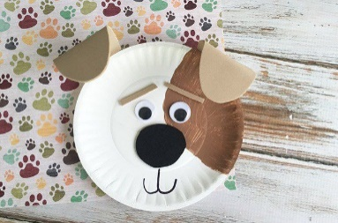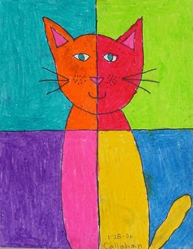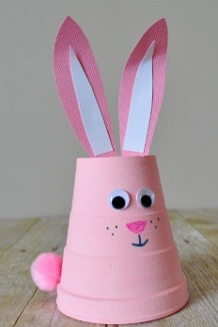
- 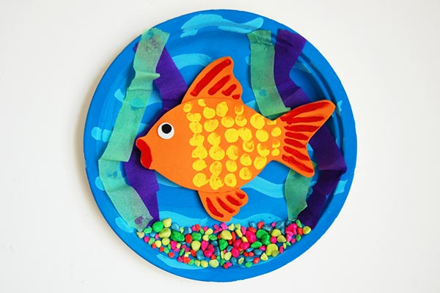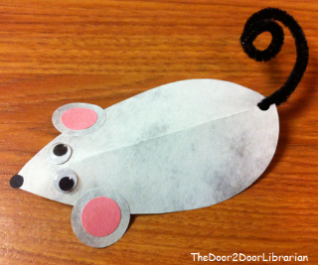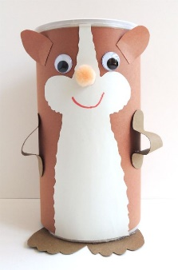

*** see art competition poster for details of a school art competition on our school page ***
PE- Everyday, Get Active!
This week is ‘active home week’!!
This week I would like you to get creative and be active in 4 different ways each day for a duration of 60 minutes or more. (I will be getting active this week too doing my 60 minutes of exercise everyday )
You will hopefully have received an Active home week chart that you can fill in everyday when you complete your 4 pieces of exercise.
Along with filling in this chart it would be great if you could take some pictures of you doing some exercise and send them on to me and we will upload these onto our Active school page on the website.
Remember to keep an eye on our active school section of the website for more updates on this and to get some more ideas on how to keep fit and active every day this week.
Colm will also be putting up some videos for us to have a watch and get practicing our GAA skills. Make sure to have a watch and give his tasks a go.

If you’re stuck for some ideas on how to stay active here is a list of things to do:
- Joe Wicks PE lessons on Youtube Daily ay 9:00am.
- Active Break’s https://www.gonoodle.com/
- RTE Junior has ten minute exercise videos that the girls can follow https://rtejr.rte.ie/10at10/
- Walking/running
- Brushing up on your Gaelic skills (practice your solo on both feet, hand passing using both hands, taking your 4 steps - then solo/bounce – 4 steps – solo/bounce)
- Dancing
- Gymnastics
- Skipping
- High knees/jumping jacks/scissor jumps
- Bear crawls/crab crawls/ bunny hops/frog jumps

*** Challenge no.1***
This week I am going to set you a challenge. All you need is a ball and a wall. I want you to see how many hand passes of a wall you can get in 60 seconds.
My score is 43 – let’s see if anyone can beat my score!!
It’s actually a lot harder than it sounds so get a few practice runs first and try build up your speed.
Email me with your score and we’ll see who our winner is this week.
Have fun!!

Music
Youtube: Music with Myleene Klass. 1pm each day on her channel.
Optional Projects: SESE
‘Mouse for sale’
- This week we are going to focus on our story from English for SESE. I will put up a few options of project /research work you can work through. (you don’t have to complete all these task, pick and choose which one(s) you would like to work on)
- Find out how human and animal ears work. Why do different animals have different kinds of ears?
https://www.youtube.com/watch?v=EowcFKQPYcI (animal ears)
https://www.youtube.com/watch?v=mptjEoHF2aI (How we hear)

- Make an information leaflet showing how to look after a pet. (PowerPoint on home page)

- Design a fun cage for the mouse to live in.

- Research the history of pets. How long have humans kept pets? Which pets were popular at different times? (If you’re giving your nan/granddad/aunt/uncle a call this week why not ask them if they had a pet when they were younger and what was it?)
What are the most popular pets?

- Research a pet of your choice and find out some interesting information about it.
https://www.activityvillage.co.uk/pet-animals
School Hub
Home school Hub will be on every day from 11am – 12pm on RTÉ 2, but you can catch it on RTÉ player afterwards! There will be extra activities available on http://www.rte.ie/learn/ to be done alongside the Home School Hub programme.
Baking:
This week’s baking activity is chocolate chip cookies. Here is the recipe we followed if you would like to give it a go at home with someone. (This links in with our maths topic this week ‘weight’.)
Have fun and enjoy!

https://www.bbcgoodfood.com/user/896076/recipe/basic-cookies

Remember, don’t be like the little red hen’s friends who wouldn’t help her bake her bread and only wanted to eat it. If you’re allowed to bake something at home you have to help prepare the ingredients, mix them altogether and do all the washing up after before you’re allowed to eat your yummy treats.

Here is a picture of our cookies!

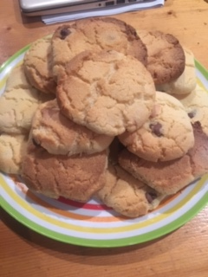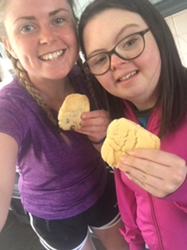

Some good free websites/free trials:
sir linkalot- Spelling Practice
Storytimefromspace.com- Story Time
The maths factor.com- Maths Lessons
Science kids.co.nz –Project section has some good activities
Nasa.gov – Kids Science section
National Geographic Kids –SESE Activities and Lessons
BBCgoodfood- has a kids baking section

