School Closure Work 20th – 25th April
Hi Girls,
I hope everyone enjoyed their Easter holidays and took a well-deserved break from all your school work. Thank you so much for all your lovely art pieces, I really enjoyed seeing them all, they were brilliant.
Here is some work to keep you busy for this week. English and Maths is broken up into days again so that it is easier for you to follow and then you can pick and choose whatever other work you want to do.
It looks like it’s going to be a lovely sunny week this week so go outside and enjoy the sun as much as possible while it’s here. Try and do some of your school work outside, it will make it more enjoyable rather than sitting at your desk all the time. I know I’ll be taking my reading book outside this week and enjoying reading while in the sun
Remember there is no pressure to get all of this done, think of it as a menu, you choose what suits you. You know I will understand if anything was tricky or confusing or you didn’t have time to complete it.
I hope you all enjoyed receiving your surprise in the post over the Easter break. You will have plenty colours and paints now to enjoy doing some art lessons I can’t wait to see more of your amazing work. If anyone didn’t receive their parcel please let me know and I will sort it out for you.
Looking forward to seeing you all soon,
Missing you loads,
Ms Carr :)
Monday
Numeracy
- Continue to work on your counting activities. Please try spend around 15 minutes every day counting.
- Money: this week will we work on money. Play shop: create your own shop in your house. Use different toys/books/clothes to sell in your shop. Give each item a price (20c or under).Pretend to be a customer and see how many items you can buy for 20c.
(if you don’t have any money to play with create your own money using paper 1c, 2c, 5c, 10, 20c)
- Number of the day, write 5 facts about the number: 34 (you can use your new whiteboard and marker today for this )
- Visit the topmarks.co.uk website and mangahigh for maths games and activities. Select your age and subject maths.
Literacy
- Continue Paired Reading
- Raz Kidz: If you haven’t already joined Raz kids please do. It’s a great site with loads of books for you to read. You can listen to the story and then read it yourself and afterwards you can record yourself reading and listen back to yourself. There’s a few activities to complete too and you can collect lots of stars as prizes.
(email me for your password if you would like to use this site)
- Spellings: Move on to the next set of spellings pg 52
Take three spellings every night to focus on. Use our look, say , cover, write and check method when learning your spellings. Try put your spellings into a sentence. (either written or orally)
Complete exercise on page 52.
- Handwriting Book- Page 47. Do your best and most careful work!

Tuesday
Numeracy
- 15 minutes counting activities
- Money: Have fun playing in your shop again.
Practice using coins up to 20c. How many ways can you make 20c? Do some coin rubbings. (Place a coin under a piece of paper and rub over it using a crayon, an image of the coin should appear)
- Number of the day, write 5 facts about the number: 62
- Addition sum: Complete this sum using as many strategies as you can
43 + 20 =
Literacy
- Continue Paired Reading
- Continue reading your stories on Raz- kids
- Spellings: learn the next three spellings today and try put them into sentences.
- My news: Today I would like you to write a piece on your news. You should have plenty news to write about from your Easter holiday. I would like you to write at least 5 sentences and you can finish it off with a nice picture.

Wednesday
Numeracy
- 15 minutes counting activities.
- Spend some time playing in your shop using coins up to 20c.
- Busy At maths page 71
- Number of the day, write 5 facts about the number: 55
- Mangahigh or Topmarks, maths games online.
Literacy
- Continue Paired Reading
- Raz –kids: Continue to work on your reading fluency reading through some of the stories on this website.
- Spellings: Learn the next three spellings today. Try and put your spellings into sentences.
- My Grammer book page 53 – complete the exercises.
- Handwriting Book- Page 49. Do your best careful work!

Thursday
Numeracy
- 15 minutes counting activities.
- Money: Spend some time again playing in your shop. See how many things you can buy for 20c.
- Busy At maths page 72
- Number of the day, write 5 facts about the number: 79
- Topmarks Website- choice of game
Literacy
- Continue Paired Reading
- Raz-kids: continue reading through the stories on this website.
- Spellings: Revise all your spellings for a spelling test tomorrow. Use your look, say , cover, write and check method to help you learn them.
- Listen to this Audio Book, ‘Theres a snake in my school’ by David Walliams. (Debbie started to read this story to us in the library before school ended, you can find out what happened in the end ) After click on the Activities tab at the top of the web page and choose an activity to complete, your choice.
https://www.worldofdavidwalliams.com/mr-stink-by-david-walliams-read-by-david-wallims-and-matt-lucas-audiobook-extract/ https://rainbow.cjfallon.ie/#/units/second/1

Friday
Numeracy
- 15 minutes counting activities
- Number of the day, write 5 facts about the number: 26
- Money: Enjoy playing in your shop again today. Ask your mum/dad/sibling to come and visit your shop and see what things you can buy.
- Busy at maths pg 73
- Clock Diary-Write down what time you got up, ate your breakfast, had your dinner, went to bed, feel free to add more activities to your clock diary.
Literacy
- Continue Paired Reading
- Raz-kids: Continue reading the stories on this website.
- Spelling test: Ask someone at home to test you on your spellings. Try your best
- Homework: see how many small words you can find in the word homework.

- Riddle: Enjoy trying to figure out this riddle. I will post a riddle for you every Friday and I will give you the answer to it the following Friday. Try your best to figure out the answer.
What can you catch but never throw?
Choose the day you want to complete the below activities.
Gaeilge
Bua na cainte: Sa bhaile pg 55 – 66
Try your best to work through the pages on this topic over the next two weeks. The exercises are all similar to the exercises in the previous topics so it shouldn’t be too confusing.

Vocab to focus on:
Tolg - couch,
leithris- toilet,
teilifís – T.V.,
scathán - mirror,
doirteal - sink,
bord - table,
sorn- oven,
doras- door,
stól - stool,
cathaoir - chair,
lampa- lamp,
leaba - bed.
Seomra Suí – sitting room,
seomra folctha- bathroom,
seomra leaba - bedroom,
cistin - kitchen.
Suas staighre – upstairs,
síos staighre – down stairs
Scian - knife,
forc - fork,
spúnóg - spoon,
pláta - plate,
cupán - cup,
cruiscín bainne – milk jug,
baghla siúcra – sugar bowl,
im - butter,
arán - bread.

Every day over the next two week choose 2/3 words every day to try and learn, make a label and put it on the object at home. E.g. make a label saying ‘doras’ and stick it on the door. Then every time you pass the door it will remind you of how to say it in Irish. Try and say the word every time you. It will help you remember it.

I know a lot of you love to watch Horrid Henry so why not give it a go watching Horrid Henry in Irish. You can click to have the subtitles so read along while listening to it in Irish.
Try and see how many Irish words your recognise and see if you can learn any new words too
This can be found on cúla4, Dónall Dána
https://www.cula4.com/en/shows/

If you want to challenge yourself even more and learn even more Irish Cúla4 school begins today, Monday 20th April at 10am. This will be an entertaining school programme covering different themes every week for 30 minutes. This week they are focusing on ‘Communication’.
Give it a go and enjoy it
https://www.cula4.com/en/shows/
Art
- Draw/Sketch your dream house in your free-Drawing copy.
- http://www.iamanartist.ie/drawing/ Watch relevant videos on this website and with attention to line draw your house or an imaginary house.
- art ideas: For our theme in SESE this week ‘Homes and buildings in my locailty’.
- 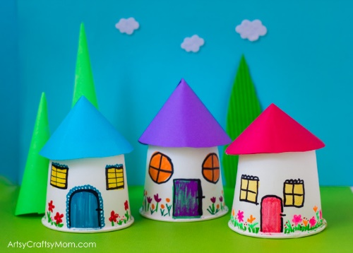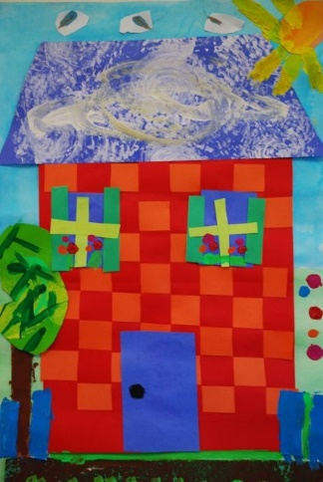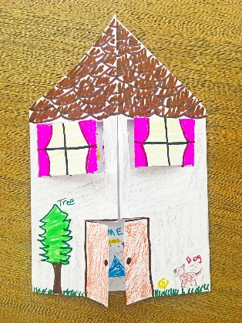
- 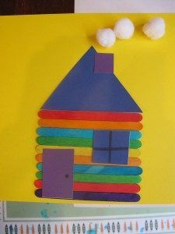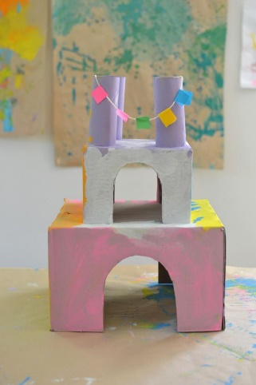

PE- Everyday, Get Active!
Joe Wicks PE lessons on Youtube Daily ay 9:00am.
Active Break’s https://www.gonoodle.com/
RTE Junior has ten minute exercise videos that the girls can follow https://rtejr.rte.ie/10at10/
Keep an eye on the active school section for some more ideas!
Music
Youtube: Music with Myleene Klass. 1pm each day on her channel.
Optional Projects: SESE
Homes/buildings in your locality
- Describe your home. Talk about what type of house it is (apartment, bungalow, two story etc.) How many rooms are in it, which room is your favourite and why?
- Draw a picture of your house and write a few sentences to go along with it. Try and use lots of adjectives (describing words) and make sure to use your capital letters and full stops.
- Construct a house using junk art and other materials in the home. (Paper, cardboard, empty toilet rolls, empty eater egg boxes…) Have fun doing this, you can construct your own house or else a house you would like to live in( use your imagination)
- Discuss the different buildings in our areas and what they are used for e.g. park, hospital, library etc.
- Discuss where we can go when we need different things in our community e.g. to send a letter, to get medicine, to get food etc.
- Draw a map of your local area. Draw your house and all the buildings and parks that are around you.
School Hub
Home school Hub will be on every day from 11am – 12pm on RTÉ 2, but you can catch it on RTÉ player afterwards! There will be extra activities available on http://www.rte.ie/learn/ to be done alongside the Home School Hub programme.
Baking:
Another fun activity that you might enjoy doing with someone at home every week is baking.
Every week I bake some nice treats with my little sister and she really enjoys it. Last week we made some chocolate chip muffins and they tasted great
Here is the recipe we followed if you would like to give it a go at home with someone.

https://www.cookingwithmykids.co.uk/chocolate-chip-muffins/

Remember, don’t be like the little red hen’s friends who wouldn’t help her bake her bread and only wanted to eat it. If you’re allowed to bake something at home you have to help prepare the ingredients, mix them altogether and do all the washing up after before you’re allowed to eat your yummy treats.

Some good free websites/free trials:
sir linkalot- Spelling Practice
Storytimefromspace.com- Story Time
The maths factor.com- Maths Lessons
Science kids.co.nz –Project section has some good activities
Nasa.gov – Kids Science section
National Geographic Kids –SESE Activities and Lessons
BBCgoodfood- has a kids baking section

