School Closure Work 7th – 18th June
Hi Girls,

I hope you are all keeping well and helping out your parents at home as much as possible We’re into our last month of school now, time is flying in. I am missing you all so much.
Here is work for the next two weeks. Do as much as you can and remember there is no pressure to get it all finished.
As always your English and maths is divided up into days and then you can choose what days you would like to do the other work. There will be PowerPoints and work sheets available on our website for you to use.
I know all of you should have collected your books from school by now, you can work through your fireworks book yourself at home. Maybe even use it if you’re playing school with your family or friends. When I was younger I used to love playing school with my sisters.
Girls I can’t get over how good some of you are doing in the daily mile challenge. We’re definitely the fittest class in the school. You have already won three vouchers for extra PE or extra yard time next year. It’s brilliant. Let’s see if we can get another few now before we get our summer holidays. If you haven’t already started to take part in this challenge it’s not to late to start. It’s simple, all you have to do is keep note of how much you walk/skip/run/cycle each day and then on Friday add them all up together and send you distance to me. Even if it’s only 1 or 2 KM that’s perfect. The more people who take part in the challenge the better we will do.
Ms Quigg is still running the baking/cooking competition every week. All you have to do is take a picture of something you bake/cook and send it to me by Friday. I will then email Ms Quigg the pictures and she will pick the winners. Give it a go
A big well done to Anna who won the baking competition for this week, the mars bar squares looked super tasty.
I am hoping to upload all your pictures and amazing work you have been completing onto our page this week. If you have any photos you want up on our page email them to me
If you have any questions or want me to see any of the amazing work you have been doing give me an email. I love hearing from you.
I will be giving you all a phone call this week to check in on you and see how you are getting on.
Missing you loads,
Ms Carr :)
Monday
Numeracy
- Continue to work on your counting activities. Please try spend around 15 minutes every day counting.
- Tens and ones: This week we are going to look at tens and ones up to 19 again. Before you begin you can have a quick look at these videos again to refresh your memory.
https://www.youtube.com/watch?v=1F3AycEDksY
https://www.youtube.com/watch?v=_dHu5TFxPtk
https://www.youtube.com/watch?v=eJOK5uwJ_Xw
- Busy at maths: Today we will be looking at page 74. Before you complete this page complete the activity in the link below.
http://data.cjfallon.ie/resources/19619/activity-74/index.html
- https://my.cjfallon.ie/dashboard/student-resources
Follow this link before completing each page in busy at maths. Complete the interactive activity before each page. Select, primary, 1st class, maths, busy at maths, interactive, and then scroll to find the page number we are completing today and complete the activity first.

- Number of the day, write 10 facts about the number: 74
(Here are some tips for you to make it up to 10 facts)
- Is it odd or even
- How many tens and ones are in it
- What number comes before it/after it
- Put it into the houses
- Put it on the abacus
- What family is it in? (thirty family/fifty family/eighty family….)
- Make some sums (70 + 4 = 74, 50 + 20+ 4 = 74…..)
- Visit the topmarks.co.uk website and mangahigh for maths games and activities. Select your age and subject maths.

- Literacy
- Continue Paired Reading and Raz kids. Email me if you haven’t got your password yet.
- Spellings: Move on to the next set of spellings pg 66 ‘ir’sound.
Take three spellings every night to focus on. Use our look, say , cover, write and check method when learning your spellings. Try put your spellings into a sentence. (either written or orally)
Complete exercise on page 66. (write an ‘ir’ word in each bird)
- The link below brings you to activities based on our spellings for the week. When you arrive at this site scroll down until you get to week 33, this is our spellings for this week. Here you will see a list of our spellings and you will also a button to press for games. Have a go at some of these activities, there are some games, word searches, fill in the missing letter and you can also complete a spelling test on this site too. Hopefully this site will make your spellings a bit more fun this week.
https://www.spellingcity.com/users/JollyGrammar
- My News: Write a piece of news from your weekend. Remember to use capital letters and full stops. Try and write at least 6 sentences.
Today I want you to try and use these three words in your news :
- sunshine
- beautiful
- active
- Handwriting Book- Continue onto the next page in your handwriting book. Take your time and be careful.
- Oral language activities: Choose an activity from the list of oral language activities I have uploaded onto our page.
Active work

- 30 seconds jumping jacks
- 30 seconds high knees
- 30 seconds tuck jumps
- 30 seconds burpees
*repeat 4 times

Tuesday
Numeracy
- 15 minutes counting activities
- Tens and ones:
- Busy at maths interactive, follow steps listed yesterday.
- http://data.cjfallon.ie/resources/19619/activity-75/index.html Before completing your page in busy at maths, complete this activity first to help you.
- Busy at maths pg 75.

- Number of the day, write 10 facts about the number: 75
- Addition sum: Complete this sum using as many strategies as you can
37 + 18 =

Literacy
- Continue Paired Reading and Raz-kids.
- Spellings: learn the next three spellings today and try put them into sentences.
Spelling exercises and games:
https://www.spellingcity.com/users/JollyGrammar
- Fireworks:
- ‘Jeremy James, elephants don’t sit on cars’. This week we are going to start looking at our new novel.
- The first thing I want you to do today is look at the front cover and the title of the story and read the blurb at the back of the book. I want you to make a prediction about what you think this novel is going to be about. Draw a picture about what you think is going to happen and then write a few sentences along with it.
(I have made a template you can use for this or else use your whiteboard or a piece of paper)
- Oral language activities
- Active work
- 30 seconds sit ups
- 30 seconds press ups
- 30 seconds squats
- 30 seconds lunges
*repeat 4 times

Wednesday
Numeracy
- 15 minutes counting activities.
- Tens and ones: Busy at maths interactive
- Busy at maths pg 76 – Number puzzle

- Number of the day, write 10 facts about the number: 76
- Addition: 51 + 36 =
- Mangahigh or Topmarks, maths games online.
Literacy
- Continue Paired Reading
- Raz –kids: Continue to work on your reading fluency reading through some of the stories on this website.
- Spellings: Learn the next three spellings today. Try and put your spellings into sentences and do some exercise on spelling city.
https://www.spellingcity.com/users/JollyGrammar
- ‘Jeremy James, Elephants don’t sit on cars’.
- Today we are going to look at chapter 1. I want you to try your best and read pages 1 -4. I have recorded myself reading the story for you so you can also listen to me read it.
- When you have read these four pages I want you to answer these questions.
- What was daddy doing?
- What did mammy use the sultanas for?
- What did mammy tell Jeremy to do?
- My Grammer book page 67– complete the exercises.
- Handwriting Book- complete the next page. Take your time
- Oral language activities

Active work
- 30 seconds high knees
- 30 seconds skips
- 30 seconds bunny hops
- 30 seconds jumping jacks
*repeat 4 times
Thursday
Numeracy
- 15 minutes counting activities.
- Tens and ones:
- Busy at maths interactive.
- Busy at maths page 77.

- Number of the day, write 10 facts about the number: 77
- Addition sum: 47 + 13 =
- Topmarks Website
Literacy
- Continue Paired Reading
- Raz-kids: continue reading through the stories on this website.
- Spellings: Revise all your spellings for a spelling test tomorrow. Use your look, say , cover, write and check method to help you learn them.
Games/activities on spelling city.
- ‘Jeremy James , elephants don’t sit in cars’.
- Today we are going to read pages 6 – 9. (you can also listen to my recording)
- When you have finished reading I want you to answer these questions:
- What does the word ‘Hmmph’ mean?
- What do you think ‘with his face as long as an elephant’s nose’ means?
- What was daddy going to do with the car?
- Oral language activities
Active work
- 30 seconds mario jumps
- 30 seconds jogging on the spot
- 30 seconds scissor jumps
- 30 seconds seconds marching on the spot
*repeat 4 times
Friday
Numeracy
- 15 minutes counting activities
- Tens and ones:
- Busy at maths interactive, follow steps listed yesterday.
- Busy at maths pg 78.

- Number of the day, write 10 facts about the number: 78
- Addition sum: Complete this sum using as many strategies as you can
39 + 26 =

Literacy
- Continue Paired Reading
- Raz-kids: Continue reading the stories on this website.
- Spelling test: Ask someone at home to test you on your spellings or else complete the spelling test on spelling city website. Try your best
- ‘Jeremy James, Elephants don’t sit on cars’
- Today I want you to read pages 10 – 12. (you can listen to my voice recording )
- When you have finished reading the pages, answer these questions.
- Why do you think ‘Daddy didn’t use any words’?
- What did daddy think happened his car?
- unhealthy: see how many small words you can find in the word unhealthy.
- David Walliams: Have a listen to David William’s free audio story today. Sit back, relax and enjoy having a story being read to you after you finish your spelling test
https://www.worldofdavidwalliams.com/elevenses/
- Riddle: The answer to last week’s riddle was your age.
- Here is this week’s riddle
What kind of room has no windows or doors?

Active work
- 30 seconds heel flicks
- 30 seconds jump squats
- 30 seconds high knees
- 30 seconds seconds fast feet
*repeat 4 times

Week 1st – 5th June
Monday
Numeracy
- Continue to work on your counting activities. Please try spend around 15 minutes every day counting.
- Tens and ones: This week we are going to look at tens and ones up to 49. It is the same as last week except we will be looking at numbers that go up as far as 50.
- Busy at maths: Today we will be looking at page 88.
- https://my.cjfallon.ie/dashboard/student-resources
Follow this link before completing each page in busy at maths. Complete the interactive activity before each page. Select, primary, 1st class, maths, busy at maths, interactive, and then scroll to find the page number we are completing today and complete the activity first.

- Number of the day, write 10 facts about the number: 88
- Visit the topmarks.co.uk website and mangahigh for maths games and activities. Select your age and subject maths.
Literacy
- Continue Paired Reading and Raz kids. Email me if you haven’t got your password yet.
- Spellings: Move on to the next set of spellings pg 68 ‘ur’sound.
Take three spellings every night to focus on. Use our look, say , cover, write and check method when learning your spellings. Try put your spellings into a sentence. (either written or orally)
Complete exercise on page 68.
- The link below brings you to activities based on our spellings for the week. When you arrive at this site scroll down until you get to week 32, this is our spellings for this week. Here you will see a list of our spellings and you will also a button to press for games. Have a go at some of these activities, there are some games, word searches, fill in the missing letter and you can also complete a spelling test on this site too. Hopefully this site will make your spellings a bit more fun this week.
https://www.spellingcity.com/users/JollyGrammar
- My News: Write a piece of news from your weekend. Remember to use capital letters and full stops. Try and write at least 6 sentences.
Today I want you to try and use these three words in your news :
- everyone
- happy
- home

- Handwriting Book- Continue onto the next page in your handwriting book. Take your time and be careful.
- Oral language activities

Active work

- 30 seconds jumping jacks
- 30 seconds high knees
- 30 seconds tuck jumps
- 30 seconds burpees
*repeat 4 times

Tuesday
Numeracy
- 15 minutes counting activities
- Tens and ones:
- Busy at maths interactive, follow steps listed yesterday.
- Busy at maths pg 89.

- Number of the day, write 10 facts about the number: 89
- Addition sum: Complete this sum using as many strategies as you can
61 + 15 =
Literacy
- Continue Paired Reading and Raz-kids.
- Spellings: learn the next three spellings today and try put them into sentences.
Spelling exercises and games:
https://www.spellingcity.com/users/JollyGrammar
- ‘Jeremy James, elephants don’t sit on cars’
- Today we are going to begin reading chapter 2. Please read pages 13 – 17. (You can also listen to my recording)
- When you have finished reading these pages please answer these questions:
- How did mammy and Jeremy get to the shops?
- What type of shops did mammy like?
- Name three things that were in the toy shop?
- Oral language activities
- Active work
- 30 seconds sit ups
- 30 seconds press ups
- 30 seconds squats
- 30 seconds lunges
*repeat 4 times

Wednesday
Numeracy
- 15 minutes counting activities.
- Tens and ones: Busy at maths interactive
- Busy at maths pg 90 + 91

- Number of the day, write 10 facts about the number: 90
- Mangahigh or Topmarks, maths games online.
Literacy
- Continue Paired Reading
- Raz –kids: Continue to work on your reading fluency reading through some of the stories on this website.
- Spellings: Learn the next three spellings today. Try and put your spellings into sentences and do some exercise on spelling city.
https://www.spellingcity.com/users/JollyGrammar
- ‘Jeremy James, elephants don’t sit on cars’.
- Today I want you to read pages 18 – 21. (listen to my voice recording )
- This chapter focuses on going shopping. Today I want you to write a piece about your favourite shop and explain why you like it. After you have finished your written piece draw a picture of your favourite shop.
- My Grammer book page 69– complete the exercises.
- Handwriting Book- complete the next page. Take your time
- Oral language activities

Active work
- 30 seconds high knees
- 30 seconds skips
- 30 seconds bunny hops
- 30 seconds jumping jacks
*repeat 4 times
Thursday
Numeracy
- 15 minutes counting activities.
- Tens and ones:
- Busy at maths interactive.
- Busy at maths page 92.

- Number of the day, write 10 facts about the number: 92
- Addition: 53 + 23 =
- Topmarks Website
Literacy
- Continue Paired Reading
- Raz-kids: continue reading through the stories on this website.
- Spellings: Revise all your spellings for a spelling test tomorrow. Use your look, say , cover, write and check method to help you learn them.
Games/activities on spelling city.
- ‘Jeremy James , elephants don’t sit on cars’
- Today I want you to read pages 22 – 26. (you can listen to my voice recording )
- When you have finished reading please answer these questions:
- What happened when Jeremy pulled out the tin of mandarin oranges?
- Describe the ‘shop man in a grey suit’. Tell me two things about him.
- Do you think mammy was angry with Jeremy? Why?
- Free writing: it’s all up to you, write about whatever you want.
- Oral language activities
Active work
- 30 seconds mario jumps
- 30 seconds jogging on the spot
- 30 seconds scissor jumps
- 30 seconds seconds marching on the spot
*repeat 4 times
Friday
Numeracy
- 15 minutes counting activities
- Number of the day, write 10 facts about the number: 93
- Addition : 37 + 27 =
- Tens and ones:
- Busy at maths interactive.
- Before you complete the page in Busy at maths, complete this exercise to help you. http://data.cjfallon.ie/resources/19619/activity-93/index.html
- Busy at maths page 93.

Literacy
- Continue Paired Reading
- Raz-kids: Continue reading the stories on this website.
- Spelling test: Ask someone at home to test you on your spellings or else complete the spelling test on spelling city website. Try your best
- ‘Jeremy James, elephants don’t sit on cars’.
- Today I want you to read all of chapter 2 again. Take your time and try working on your fluency. Pick your favourite page and practice reading it using some expression, read it to someone at home, you could even try put some actions to it?
- Supermarket: see how many small words you can find in the word Supermarket.
- David Walliams: Have a listen to David William’s free audio story today. Sit back, relax and enjoy having a story being read to you after you finish your spelling test
https://www.worldofdavidwalliams.com/elevenses/
- Riddle: The answer to last week’s riddle was a mushroom.
- Here is this week’s riddle
What belongs to you but others use it more than you?

Active work
- 30 seconds heel flicks
- 30 seconds jump squats
- 30 seconds high knees
- 30 seconds seconds fast feet
*repeat 4 times

Choose the day you want to complete the below activities.
Gaeilge
Bua na cainte: Ócáidí Speisialta – Lá breithe pg 91

We are going to focus on the theme ‘Lá breithe’ for the next two weeks. There is only one page in Bua na cainte to complete this week, pg 91.

I have uploaded a few worksheets for you to complete too. You will find these on our page.
I have uploaded a birthday card template for you if you would like to make some birthday cards for people in Irish. You can design your own cards either if you’d prefer.
I have also uploaded a PowerPoint on ‘ages’. Use this to help you learn the different ages. This PowerPoint will help you with your worksheets.

Phrases to focus on:

For these two weeks I am giving you one phrase to work on along with some new vacabulary. Try and use them as much as you can throughout the two week. Make some labels with the new vocabulary and find them objects in the house.
Don’t be afraid to make mistakes

Question: Cén aois thú? What age are you?
Answer: Tá mé …….. d’aois. I am ……. Years old.

Aon bhliain d’aois – One year old
Dhá bhliain d’aois – two years old
Trí bliana d’aois – three years old
Ceithre bliana d’aois – four years old
Cúig bliana d’aois – five years old
Sé bliana d’aois – six years old
Seacht mbliana d’aois – seven years old
Ocht mbliana d’aois – eight years old

New vocabulary:
Coinneal candle
Cárta card
Leitís lettuce
Cáca cake
Cairéad carrot
Bord table
Daideo grandad
Carbhat tie
Bronntanas presents
Coinín rabbit
Balún balloon
Hata hat
Féasta party

Watch an episode of Tir na nog on rte junior. Listen out for an irish words you recognise. Oisín, Niamh and Fionn have fun through gaeilge.
https://www.rte.ie/player/series/tir-na-nog/SI0000006552?epguid=IP000064973

Continue to enjoy watching some cartoons in Irish. Hopefully you might start to recognise a few more words this week.
You can click to have the subtitles so read along while listening to it in Irish.
Try and see how many Irish words your recognise and see if you can learn any new words too
This can be found on cúla4
https://www.cula4.com/en/shows/

Cúla4 scoil will be on again this week every morning at 10am.
Try your best and see how many words you understand.
Give it a go and enjoy it
https://www.cula4.com/en/shows/
Art
- Art ideas: Frogs (We willl look at frogs in art these two weeks too)
- Draw/Sketch a frog (Use art hub if you want)
Here are some ideas to get you thinking:

- 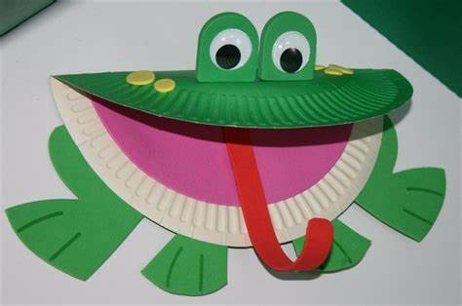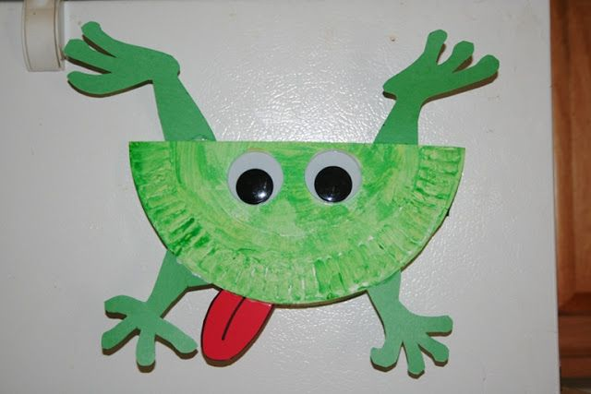
- 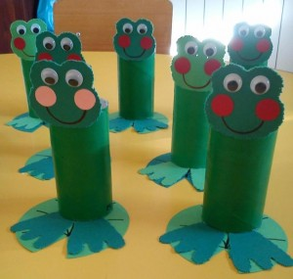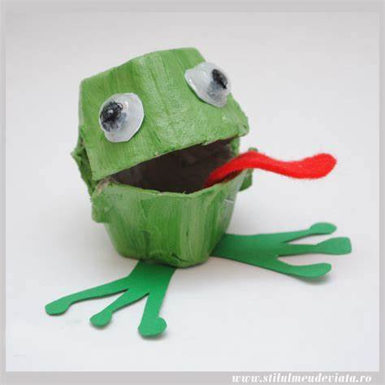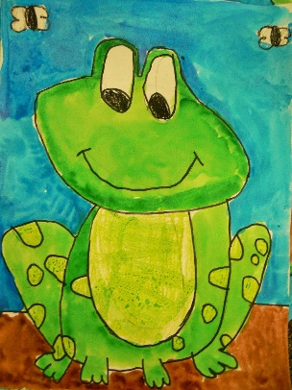

PE- Everyday, Get Active!

- Joe Wicks PE lessons on Youtube Daily ay 9:00am.
- Active Break’s https://www.gonoodle.com/
- RTE Junior has ten minute exercise videos that the girls can follow https://rtejr.rte.ie/10at10/
- Walking/running
- Brushing up on your Gaelic skills (practice your solo on both feet, hand passing using both hands, taking your 4 steps - then solo/bounce – 4 steps – solo/bounce)
- Dancing
- Gymnastics
- Skipping
- High knees/jumping jacks/scissor jumps
- Bear crawls/crab crawls/ bunny hops/frog jumps

FAI – soccer skills
I know a lot of you girls play soccer outside of schools so I thought you might like to brush up on some of your skills for when your training starts back up.
The FAI have put together some brilliant videos showing you how to do different skills and tricks. There are 38 different videos, you can pick and choose which skills you would like to brush up on.
If you have any videos of you doing some of these skills send them on to me, I’d love to see them.
Here is a link to the videos:
https://www.youtube.com/channel/UC_4CVGZ-aQH2V6cLGYmKMAg

*** THE DAILY MILE CLUB***
Please remember to send me your distance on Friday. We are doing so well with this challenge girls, I’m so proud of you, Keep it up! You are going to have loads of PE vouchers and extra yard vouchers next year. If you haven’t joined in in this challenge already, it’s not too late. Every week is a new week, let’s make the next two weeks even better!
Music
Youtube: Music with Myleene class. 1pm each day on her channel.
Optional Projects: SESE

- Children of Lír:
- Read through the PowerPoint of Children of Lír. (uploaded onto our page)
- Write the story in your own words and draw an image to go along with it.

- Life cycle of a frog
- This week will are going to look at the life cycle of a frog.
- Read through the PowerPoint on the life cycle of a frog.
- Complete the worksheets attached to our page:
Cut and paste Activity
Writing template
- Sit back and watch the short video clip on the life cycle of a frog.

- The Zoo
- Why not choose a different animal to focus on these two weeks. https://www.dublinzoo.ie/news/dublinzoofun/
- Why not spend some time researching some of your favourite animals in the zoo. There are load of excellent resources available on their page for all of us to use.
- Daily activity booklets are available on the website at 2pm each day.
- Six nature activity videos can be found on it.
- A visual tour is released each Monday giving you a front row glimpse of animals in action in their habitats.
- You can also tune into their webcam to see how animals at Dublin zoo spend their time while visitors are away. Why not join the elephant feed at 12.30 and snack with the penguins at 2.30pm?

School Hub
Home school Hub will be on every day from 11am – 12pm on RTÉ 2, but you can catch it on RTÉ player afterwards! There will be extra activities available on http://www.rte.ie/learn/ to be done alongside the Home School Hub programme.
Baking:
This week’s baking treat are donuts. Here is the recipe we followed. We followed a gluten free recipe for these doughnuts because my sister is a coeliac. You can change the flour to plain flour, it’s all the same.
I know a lot of you might not have donut trays, don’t worry because I didn’t either. You can make your own doughnut shapes from tin foil, it’s pretty simple.

https://www.glutenfreepalate.com/gluten-free-vanilla-birthday-cake-donuts/
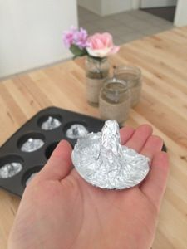
Have fun and I hope you enjoy them as much as we did!

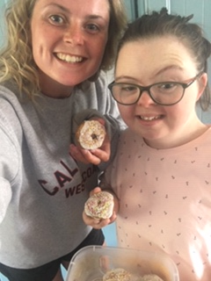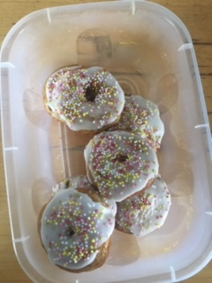
*** competition alert ***

Well done to Anna who won the baking competition last week!!
Let’s see who is going to win this week

Every week Ms Quigg is running a cooking competition. All you have to do is bake/cook something, whatever you want and take a picture of it and send it to me. I will then send the image onto Ms Quigg and she will pick a winner at the end of the week.
I know a lot of you have been enjoying cooking and baking in the last few weeks so why not see if your baking skills can win you a prize.

