School Closure Work 25th – 5th June
Hi Girls,

I hope you are all keeping well and helping out your parents at home as much as possible
Here is work for the next two weeks. Do as much as you can and remember there is no pressure to get it all finished.
For your work over the next two weeks I have some worksheets and PowerPoints again, you will find these on our school page, just underneath the link for this document.
Ms Quigg is starting a baking/cooking competition. All you have to do is take a picture of something you bake/cook and send it to me by Friday. I will then email Ms Quigg the pictures and she will pick the winners. Give it a go
The keep active competition is still running these two weeks too. Remember to track how much you walk/run/cycle/skip every day and send me your total on Friday. It doesn’t matter how much or how little you do, just remember to email me on Friday with your total distance. We’ve been doing super already but it would be great if some more of you could join in too please.
Next weekend is a bank holiday, so you can take next Monday off work too and relax. I have work prepared for Monday but as we were meant to be off school you do not have to do it if you don’t want.
I hope you are all enjoying the lovely weather you’re having in Dublin, I’m very jealous of it. Try and get outside and enjoy it as much as possible. Remember if the sun is shining, take a break from your work and get some vitamin D.
If you have any questions or want me to see any of the amazing work you have been doing give me an email. I love hearing from you.
Missing you loads,
Ms Carr :)
Monday
Numeracy
- Continue to work on your counting activities. Please try spend around 15 minutes every day counting.
- Capacity: This week we are moving onto the topic of capacity.
Capacity is how much a container can hold. We are going to focus mainly on the terms full, empty, half full, half empty, nearly full and nearly empty.
Have some fun this week playing with water. Use some cups, saucepans, bowls, jugs, whatever objects you have at home.
To begin have a look at the videos and PowerPoint on capacity.
The PowerPoint will be uploaded onto our page under math resources.
- https://www.youtube.com/watch?v=z_UswOa1WME
- https://my.cjfallon.ie/dashboard/student-resources
Follow this link before completing each page in busy at maths. Complete the interactive activity before each page. Select, primary, 1st class, maths, busy at maths, interactive, and then scroll to find the page number we are completing today and complete the activity first.
- Busy at maths p137 Question 1, 2, and 3.

- Number of the day, write 5 facts about the number: 18
- Visit the topmarks.co.uk website and mangahigh for maths games and activities. Select your age and subject maths.
Literacy
- Continue Paired Reading and Raz kids. Email me if you haven’t got your password yet.
- Spellings: Move on to the next set of spellings pg 62 ‘nk’sound.
Take three spellings every night to focus on. Use our look, say , cover, write and check method when learning your spellings. Try put your spellings into a sentence. (either written or orally)
Complete exercise on page 62.
- The link below brings you to activities based on our spellings for the week. When you arrive at this site scroll down until you get to week 31, this is our spellings for this week. Here you will see a list of our spellings and you will also a button to press for games. Have a go at some of these activities, there are some games, word searches, fill in the missing letter and you can also complete a spelling test on this site too. Hopefully this site will make your spellings a bit more fun this week.
https://www.spellingcity.com/users/JollyGrammar
- My News: Write a piece of news from your weekend. Remember to use capital letters and full stops. Try and write at least 6 sentences.
Today I want you to try and use these three words in your news :
- Yesterday
- Tomorrow
- Exciting
- Handwriting Book- Continue onto the next page in your handwriting book. Take your time and be careful.
Active work

- 30 seconds jumping jacks
- 30 seconds high knees
- 30 seconds tuck jumps
- 30 seconds burpees
*repeat 4 times

Tuesday
Numeracy
- 15 minutes counting activities
- Capacity: ‘Lets investigate’ Today we are going to do some more investigating with water. If it’s a nice day why not go outside and have some water play outside.
- Busy at maths interactive, follow steps listed yesterday.
- Busy at maths pg 138 Question 1, 2, 3. Give this page a go and have some fun! If you don’t have the equipment at home then only complete the ‘my estimate’ part of the question. Remember an estimate is a guess.

- Number of the day, write 5 facts about the number: 63
- Addition sum: Complete this sum using as many strategies as you can
38 + 30 =
Literacy
- Continue Paired Reading and Raz-kids.
- Spellings: learn the next three spellings today and try put them into sentences.
Spelling exercises and games:
https://www.spellingcity.com/users/JollyGrammar
- Alice in Wonderland: This week we are doing to start to read a new story ‘Alice in Wonderland, the mad hatter’s tea party’. Before you begin to read this book I want you to predict what you think is going to happen in this story. Look at the front cover to help you. Write down your prediction and draw an image to go along with it.
- When you have this complete take a picture walk through the book. Look at all the different pictures and see if your prediction was correct.
- Today I want you to read the blurb at the back. The ‘blurb’ is a summary of the story.
Active work
- 30 seconds sit ups
- 30 seconds press ups
- 30 seconds squats
- 30 seconds lunges
*repeat 4 times

Wednesday
Numeracy
- 15 minutes counting activities.
- Capacity: Busy at maths interactive
- Busy at maths pg 139

- Number of the day, write 5 facts about the number: 5
- Addition: 36 + 21 =
- Mangahigh or Topmarks, maths games online.
Literacy
- Continue Paired Reading
- Raz –kids: Continue to work on your reading fluency reading through some of the stories on this website.
- Spellings: Learn the next three spellings today. Try and put your spellings into sentences and do some exercise on spelling city.
https://www.spellingcity.com/users/JollyGrammar
- ‘Alice in Wonderland’ – Read the first half of the book. (there is a CD with the story on it inside your book cover, why not have a listen to the story too after you have read the story )
- My Grammer book page 63– complete the exercises.
- Handwriting Book- complete the next page. Take your time
Active work
- 30 seconds high knees
- 30 seconds skips
- 30 seconds bunny hops
- 30 seconds jumping jacks
*repeat 4 times
Thursday
Numeracy
- 15 minutes counting activities.
- Capacity: Today we are going to look at 1litre. There will be lots of things in your house that hold 1litre. Have a look around your house and see what things you can find.
I found a milk carton, a bottle of coke, a cartoon of orange juice a bottle of water. Go and see what you can find.
- Busy at maths interactive.
- Busy at maths page 140.

- Number of the day, write 5 facts about the number: 103
- Addition sum: 27 + 12 =
- Topmarks Website
Literacy
- Continue Paired Reading
- Raz-kids: continue reading through the stories on this website.
- Spellings: Revise all your spellings for a spelling test tomorrow. Use your look, say , cover, write and check method to help you learn them.
Games/activities on spelling city.
- ‘Alice in Wonderland’: Read the second half of the book.
- Wordsearch: complete the wordsearch on Alice in Wonderland, it’s uploaded on our page.

Active work
- 30 seconds mario jumps
- 30 seconds jogging on the spot
- 30 seconds scissor jumps
- 30 seconds seconds marching on the spot
*repeat 4 times
Friday
Numeracy
- 15 minutes counting activities
- Number of the day, write 5 facts about the number: 33
- Addition : 55 + 16 =
- Capacity: To end this week on capacity take the quiz on capacity. You will find this on our website under maths resources.
Literacy
- Continue Paired Reading
- Raz-kids: Continue reading the stories on this website.
- Spelling test: Ask someone at home to test you on your spellings or else complete the spelling test on spelling city website. Try your best
- Teacher: see how many small words you can find in the word teacher.
- David Walliams: Have a listen to David William’s free audio story today. Sit back, relax and enjoy having a story being read to you after you finish your spelling test
https://www.worldofdavidwalliams.com/elevenses/
- Riddle: The answer to last week’s riddle was Mary.
- Here is this week’s riddle
What has four legs but can’t walk?

Active work
- 30 seconds heel flicks
- 30 seconds jump squats
- 30 seconds high knees
- 30 seconds seconds fast feet
*repeat 4 times

Week 1st – 5th June
Monday
Numeracy
- Continue to work on your counting activities. Please try spend around 15 minutes every day counting.
- Tens and ones: This week we are going to look at tens and ones. You should all be familiar with our tens and ones. If you forget have a quick look at these videos on tens and ones.
https://www.youtube.com/watch?v=1F3AycEDksY
https://www.youtube.com/watch?v=_dHu5TFxPtk
https://www.youtube.com/watch?v=eJOK5uwJ_Xw
- Busy at maths: Today we will be looking at page 65. Before you complete this page complete the activity in the link below.
http://data.cjfallon.ie/resources/19619/activity-65/index.html
- https://my.cjfallon.ie/dashboard/student-resources
Follow this link before completing each page in busy at maths. Complete the interactive activity before each page. Select, primary, 1st class, maths, busy at maths, interactive, and then scroll to find the page number we are completing today and complete the activity first.

- Number of the day, write 8 facts about the number: 67 (One fact you should have this week is how many tens and how many ones are in your number)
- Visit the topmarks.co.uk website and mangahigh for maths games and activities. Select your age and subject maths.
Literacy
- Continue Paired Reading and Raz kids. Email me if you haven’t got your password yet.
- Spellings: Move on to the next set of spellings pg 64 ‘er’sound.
Take three spellings every night to focus on. Use our look, say , cover, write and check method when learning your spellings. Try put your spellings into a sentence. (either written or orally)
Complete exercise on page 64.
- The link below brings you to activities based on our spellings for the week. When you arrive at this site scroll down until you get to week 32, this is our spellings for this week. Here you will see a list of our spellings and you will also a button to press for games. Have a go at some of these activities, there are some games, word searches, fill in the missing letter and you can also complete a spelling test on this site too. Hopefully this site will make your spellings a bit more fun this week.
https://www.spellingcity.com/users/JollyGrammar
- My News: Write a piece of news from your weekend. Remember to use capital letters and full stops. Try and write at least 6 sentences.
Today I want you to try and use these three words in your news :
- Weekend
- Family
- school

- Handwriting Book- Continue onto the next page in your handwriting book. Take your time and be careful.
Active work

- 30 seconds jumping jacks
- 30 seconds high knees
- 30 seconds tuck jumps
- 30 seconds burpees
*repeat 4 times

Tuesday
Numeracy
- 15 minutes counting activities
- Tens and ones:
- Busy at maths interactive, follow steps listed yesterday.
- Busy at maths pg 66.

- Number of the day, write 8 facts about the number: 83
- Addition sum: Complete this sum using as many strategies as you can
42 + 27 =
Literacy
- Continue Paired Reading and Raz-kids.
- Spellings: learn the next three spellings today and try put them into sentences.
Spelling exercises and games:
https://www.spellingcity.com/users/JollyGrammar
- Alice in Wonderland: Listen to the CD of the story and read along with it.
- Today I want you to use your imagination! Imagine you are Alice and have just fallen down the rabbit hole. Where do you land?
Think about what you can see, hear, smell, feel and taste.
It can bring you anywhere in the whole world, it doesn’t have to be a real place either, for example it might bring you to a land made of sweets or to a fairy land.
Have fun and enjoy your adventure down the rabbit hole
Active work
- 30 seconds sit ups
- 30 seconds press ups
- 30 seconds squats
- 30 seconds lunges
*repeat 4 times

Wednesday
Numeracy
- 15 minutes counting activities.
- Tens and ones: Busy at maths interactive
- http://data.cjfallon.ie/resources/19619/activity-67/index.html
- Busy at maths pg 67

- Number of the day, write 8 facts about the number: 12
- Addition: 53 + 15 =
- Mangahigh or Topmarks, maths games online.
Literacy
- Continue Paired Reading
- Raz –kids: Continue to work on your reading fluency reading through some of the stories on this website.
- Spellings: Learn the next three spellings today. Try and put your spellings into sentences and do some exercise on spelling city.
https://www.spellingcity.com/users/JollyGrammar
- ‘Alice in Wonderland’ – Today I want you to write the story in your own words. You can use the worksheet I have uploaded for this or else use your own paper. Try and write at least 5 sentences.
If you want to use the comic strip to tell the story either that’s perfect. Draw four of the main parts of the story in each box. Write a short sentence to go with each.
I have uploaded a word map of words based on Alice in Wonderland. These words will help you write your piece.
- My Grammer book page 65– complete the exercises.
- Handwriting Book- complete the next page. Take your time
Active work
- 30 seconds high knees
- 30 seconds skips
- 30 seconds bunny hops
- 30 seconds jumping jacks
*repeat 4 times
Thursday
Numeracy
- 15 minutes counting activities.
- Tens and ones:
- http://data.cjfallon.ie/resources/19619/activity-68/index.html
- Busy at maths interactive.
- Busy at maths page 68 + 69.

- Number of the day, write 8 facts about the number: 99
- Topmarks Website
Literacy
- Continue Paired Reading
- Raz-kids: continue reading through the stories on this website.
- Spellings: Revise all your spellings for a spelling test tomorrow. Use your look, say , cover, write and check method to help you learn them.
Games/activities on spelling city.
- ‘Alice in Wonderland’: Today you are going to use your imagination and come up with your own magic potion. When Alice drank the magic potion she grew very big. Today you are going to decide what might happen to me if I was to drink your magic potion. Describe you potion and how it works and after draw an image of what happens once you drink it.
- Worksheet uploaded on our page for this.

Active work
- 30 seconds mario jumps
- 30 seconds jogging on the spot
- 30 seconds scissor jumps
- 30 seconds seconds marching on the spot
*repeat 4 times
Friday
Numeracy
- 15 minutes counting activities
- Number of the day, write 8 facts about the number: 81
- Addition : 57 + 25 =
- Tens and ones:
- Busy at maths interactive.
- Busy at maths page 70.

Literacy
- Continue Paired Reading
- Raz-kids: Continue reading the stories on this website.
- Spelling test: Ask someone at home to test you on your spellings or else complete the spelling test on spelling city website. Try your best
- ‘Alice in Wonderland’ – Book review: Today I want you to complete a book review on ‘Alice in Wonderland’. I have uploaded a template for you to use for this.
- Maybe this weekend you could have a ‘Mad Hatters tea party’ with your family. Make some crazy hats to wear to your tea party.
- Wonderland: see how many small words you can find in the word Wonderland.
- David Walliams: Have a listen to David William’s free audio story today. Sit back, relax and enjoy having a story being read to you after you finish your spelling test
https://www.worldofdavidwalliams.com/elevenses/
- Riddle: The answer to last week’s riddle was a table.
- Here is this week’s riddle
What goes up but never comes down?

Active work
- 30 seconds heel flicks
- 30 seconds jump squats
- 30 seconds high knees
- 30 seconds seconds fast feet
*repeat 4 times

Choose the day you want to complete the below activities.
Gaeilge
Bua na cainte: Siopadóireacht pg76 – 83

We are going to focus on the theme ‘Siopadóireacht’ for the next two weeks. Please try your best to work through the pages in your Bua na Cainte.

Phrases to focus on:

For these two weeks I am giving you four phrases to work on. Try and use them as much as you can throughout the two week. You could play shop again but this time focus on your Irish rather than your maths skills. Put some labels on toys and ask these questions.
Don’t be afraid to make mistakes

Question: An maith leat? Do you like?
Answer: Is brae liom I love

Question: Cén bréagan is fearr leat? What toy do you prefer?
Answer: Is fearr liom ….. I prefer the ….

Question: Cé mhéad atá air? How much is …?
Answer:
Euro amháin – one euro
Dhá euro – two euro
Trí euro – three euro
Ceithre euro – four euro
Cúig euro – five euro
Sé euro – six euro
Seacht euro – seven euro
Ocht euro – eight euro
Naoi euro – nine euro
Deich euro – ten euro
Aon euro déag – eleven euro
Dhá euro déag – twelve euro
Trí euro déag – thirteen euro
Ceithre euro déag – fourteen euro
Cúig euro déag – fifteen euro
Sé euro déag – sixteen euro
Seacht euro déag – seventeen euro
Ocht euro déag – eighteen euro
Naoi euro déag – nineteen euro
Fiche euro – twenty euro.

Phrase 4: Cheannaigh mé ….. – I bought

Liathróid – ball
An téád – teddy
An róbó – robot
An bhábóg – baby
An capall – horse
An ríomhaire – computer
An cluiche – game
An tarracóir – tractor

Watch an episode of Tir na nog on rte junior. Listen out for an irish words you recognise. Oisín, Niamh and Fionn have fun through gaeilge.
https://www.rte.ie/player/series/tir-na-nog/SI0000006552?epguid=IP000064973

Continue to enjoy watching some cartoons in Irish. Hopefully you might start to recognise a few more words this week.
You can click to have the subtitles so read along while listening to it in Irish.
Try and see how many Irish words your recognise and see if you can learn any new words too
This can be found on cúla4
https://www.cula4.com/en/shows/

Cúla4 scoil will be on again this week every morning at 10am.
Try your best and see how many words you understand.
Give it a go and enjoy it
https://www.cula4.com/en/shows/
Art
- Art ideas: Try and create a ‘Mad hat’ for the ‘Mad hatter’s’ tea party.

- Draw/Sketch an idea you have for creating art using recycled materials in your free-Drawing copy.
- Get creative and make something using recycled materials.
Here are some ideas to get you thinking:
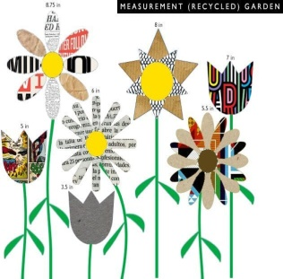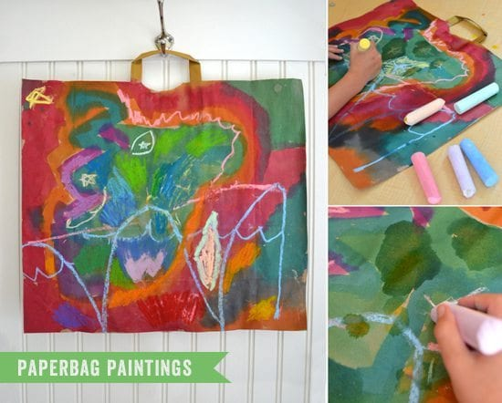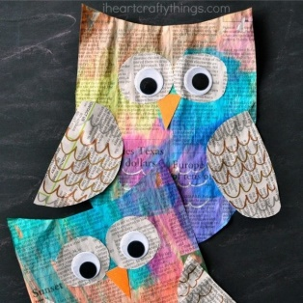
- 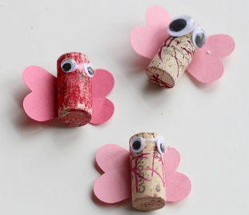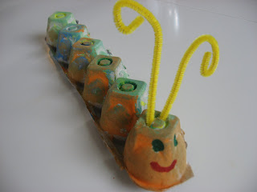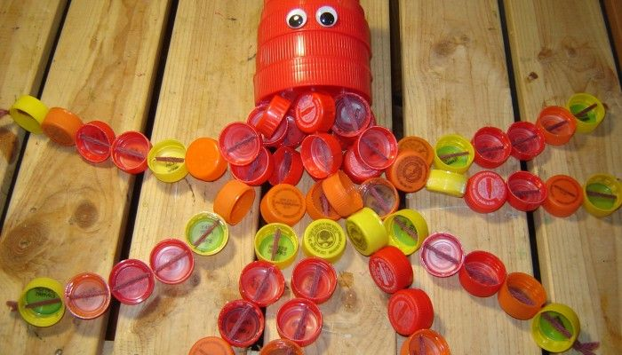

PE- Everyday, Get Active!

- Joe Wicks PE lessons on Youtube Daily ay 9:00am.
- Active Break’s https://www.gonoodle.com/
- RTE Junior has ten minute exercise videos that the girls can follow https://rtejr.rte.ie/10at10/
- Walking/running
- Brushing up on your Gaelic skills (practice your solo on both feet, hand passing using both hands, taking your 4 steps - then solo/bounce – 4 steps – solo/bounce)
- Dancing
- Gymnastics
- Skipping
- High knees/jumping jacks/scissor jumps
- Bear crawls/crab crawls/ bunny hops/frog jumps

*** THE DAILY MILE CLUB***
Please remember to send me your distance on Friday. It would be great to win a few more vouchers for the class next year. I’m running my miles every day, the more people that join in the better.

Music
Youtube: Music with Myleene Klass. 1pm each day on her channel.
Optional Projects: SESE

- Fionn and the salmon of knowledge:
- Read through the PowerPoint of Fionn and the Salmon of Knowledge. (uploaded onto our page)
- Write the story in your own words and draw an image to go along with it.

- Recycling
- Watch this short video about Recycling. Complete a project based on recycling. Remember to include the words reduce, reuse and recycle. You can complete you project using some recycled materials, get creative and try to include some of your own ideas!
https://www.youtube.com/watch?v=OasbYWF4_S8
- Have a look at the PowerPoint on recycling for some more information.

- The Zoo

https://www.dublinzoo.ie/news/dublinzoofun/
- Why not spend some time researching some of your favourite animals in the zoo. There are load of excellent resources available on their page for all of us to use.
- Daily activity booklets are available on the website at 2pm each day.
- Six nature activity videos can be found on it.
- A visual tour is released each Monday giving you a front row glimpse of animals in action in their habitats.
- You can also tune into their webcam to see how animals at Dublin zoo spend their time while visitors are away. Why not join the elephant feed at 12.30 and snack with the penguins at 2.30pm?

School Hub
Home school Hub will be on every day from 11am – 12pm on RTÉ 2, but you can catch it on RTÉ player afterwards! There will be extra activities available on http://www.rte.ie/learn/ to be done alongside the Home School Hub programme.
Baking:
This week’s baking treat is mars bar squares. Here is the recipe we followed.
Have fun and I hope you enjoy them as much as we did!
Sorry we ate all our mars bar squares before we got around to taking a picture this week!!

https://www.bakingmad.com/recipes/traybakes/cake-traybakes/mars-bar-slice

*** competition alert ***
Every week Ms Quigg is running a cooking competition. All you have to do is bake/cook something, whatever you want and take a picture of it and send it to me. I will then send the image onto Ms Quigg and she will pick a winner at the end of the week.
I know a lot of you have been enjoying cooking and baking in the last few weeks so why not see if your baking skills can win you a prize.

