School Closure Work 22nd – 26th June
Hi Girls,
I can’t believe that we are into our last week of school. I have missed you all so much over the last few weeks and I am really disappointed I didn’t get to see you all before we finish up for summer.
This week I am going to organise a zoom call with you all. You will be split into different groups as there is too many to have in the one zoom call. This will take place on Thursday, I would be very grateful if you could let me know if you would be interested in joining the zoom call so I can organise it. I will then email you out the zoom call details along with the joining password. I would love to see you all there.

I have uploaded some work for you to complete this week, again there is no pressure to complete any of it, only do what you can.
As we missed out on our school tour this year I have posted a link every day for a virtual school tour. Some days we are staying in Dublin but other days you might need to pack you bags aw we will be off on some excellent adventures. I really hope you enjoy.
Missing you loads,
Hope to see you all on Thursday,
Ms Carr :)
Monday
Numeracy
- Continue to work on your counting activities. Please try spend around 15 minutes every day counting.

- Number of the day, write 10 facts about the number: 43
- Visit the topmarks.co.uk website and mangahigh for maths games and activities. Select your age and subject maths.

- Literacy
- Continue Paired Reading and Raz kids.
- My News: Write a piece of news from your weekend. Remember to use capital letters and full stops. Try and write at least 6 sentences.
- Continue reading ‘Jeremy James, elephants don’t sit on cars’.
- Oral language activities: Choose an activity from the list of oral language activities I have uploaded onto our page.

The national aquarium:
Today we are going to go on a virtual school trip to the national aquarium. Have a look at all the different sea animals in the aquarium. If one animal takes your interest, why not do some extra research on it. Enjoy
http://samuraivirtualtours.com/example/nab/index.html
Tuesday
Numeracy
- 15 minutes counting activities
- Number of the day, write 10 facts about the number: 68
- Addition sum: Complete this sum using as many strategies as you can
46 + 18 =

Literacy
- Continue Paired Reading and Raz-kids.
- Continue reading ‘Jeremy James, elephants don’t sit on cars’.
- Write three things you would like to do this summer.
- Oral language activities

San Diego Zoo
Today we are flying all the way to San Diego zoo. Here you can look at all the different animals on a live web cam. There are apes, elephants, pandas, giraffes along with so many other amazing animals. Choose a few animals you would like to watch or if you want why not a quick look at them all have.
https://animals.sandiegozoo.org/live-cams
Wednesday
Numeracy
- 15 minutes counting activities.
- Number of the day, write 10 facts about the number: 95
- Mangahigh or Topmarks, maths games online.
Literacy
- Continue Paired Reading
- Raz –kids: Continue to work on your reading fluency reading through some of the stories on this website.
- Continue reading ‘Jeremy James, Elephants don’t sit on cars’.
- Write a short poem about summer and draw a picture to go with it.

A visit to a farm
Today you are going to get a chance to visit a farm. You can look at all the different animals on the farm along with looking at how milk and cheese are made. Have fun and enjoy
https://www.farmfood360.ca/
Thursday
Numeracy
- 15 minutes counting activities.

- Number of the day, write 10 facts about the number: 24
- Topmarks Website
Literacy
- Continue Paired Reading
- Raz-kids: continue reading through the stories on this website.
- Continue reading ‘Jeremy James , elephants don’t sit in cars’.
- Oral language activities
- Make up a song about summer and add some dance moves to it.

National Gallery of Ireland
Today you are going to go on a tour of the National Gallery of Ireland. Take a look at all the amazing art work. After your visit why not take some time to create your own art piece.

https://www.virtualvisittours.com/national-gallery-of-ireland/

Friday
Numeracy
- 15 minutes counting activities
- Number of the day, write 10 facts about the number: 26

Literacy
- Continue Paired Reading
- Raz-kids: Continue reading the stories on this website.
- Continue reading ‘Jeremy James, Elephants don’t sit on cars’
- David Walliams: Have a listen to David William’s free audio story today. Sit back, relax and enjoy having a story being read to you after you finish your spelling test
https://www.worldofdavidwalliams.com/elevenses/

Planet Mars
To end your week of virtual tours we are going to go into Space. We are going to go on a tour of the planet mars.
Get ready for take off
3
2
1
BLAST OFF !!!
https://accessmars.withgoogle.com/
Choose the day you want to complete the below activities.
Gaeilge

Watch an episode of Tir na nog on rte junior. Listen out for an irish words you recognise. Oisín, Niamh and Fionn have fun through gaeilge.
https://www.rte.ie/player/series/tir-na-nog/SI0000006552?epguid=IP000064973

Continue to enjoy watching some cartoons in Irish. Hopefully you might start to recognise a few more words this week.
You can click to have the subtitles so read along while listening to it in Irish.
Try and see how many Irish words your recognise and see if you can learn any new words too
This can be found on cúla4
https://www.cula4.com/en/shows/

Cúla4 scoil will be on again this week every morning at 10am.
Try your best and see how many words you understand.
Give it a go and enjoy it
https://www.cula4.com/en/shows/
Art
- Art ideas: Summer
Here are some ideas to get you thinking:

- 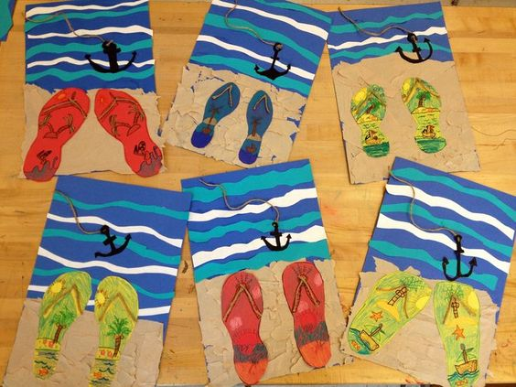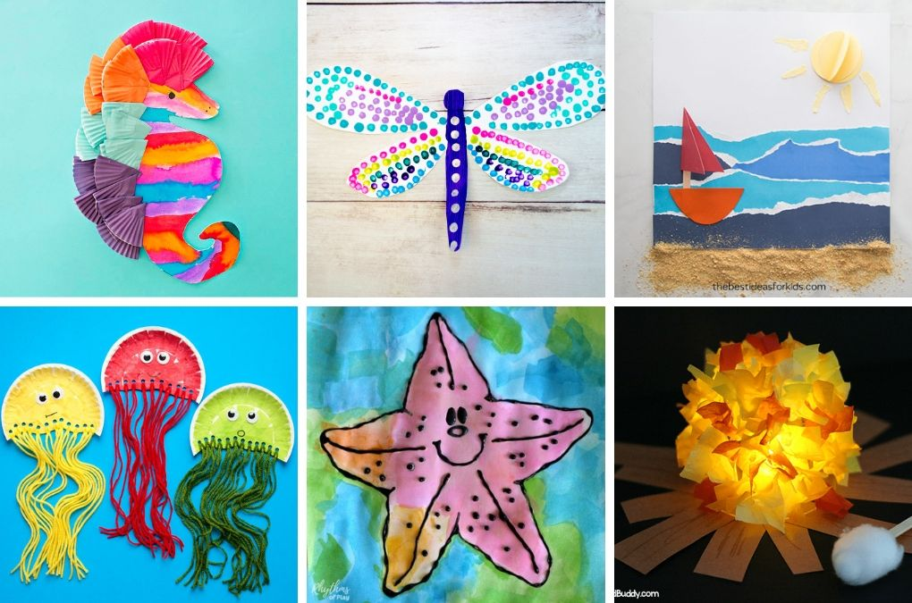

Here is a link for some more nice summer arts and crafts ideas, have a look:
https://www.easypeasyandfun.com/summer-crafts/

PE- Everyday, Get Active!

- Joe Wicks PE lessons on Youtube Daily ay 9:00am.
- Active Break’s https://www.gonoodle.com/
- RTE Junior has ten minute exercise videos that the girls can follow https://rtejr.rte.ie/10at10/
- Walking/running
- Brushing up on your Gaelic skills (practice your solo on both feet, hand passing using both hands, taking your 4 steps - then solo/bounce – 4 steps – solo/bounce)
- Dancing
- Gymnastics
- Skipping
- High knees/jumping jacks/scissor jumps
- Bear crawls/crab crawls/ bunny hops/frog jumps

FAI – soccer skills
I know a lot of you girls play soccer outside of schools so I thought you might like to brush up on some of your skills for when your training starts back up.
The FAI have put together some brilliant videos showing you how to do different skills and tricks. There are 38 different videos, you can pick and choose which skills you would like to brush up on.
If you have any videos of you doing some of these skills send them on to me, I’d love to see them.
Here is a link to the videos:
https://www.youtube.com/channel/UC_4CVGZ-aQH2V6cLGYmKMAg

Music
Youtube: Music with Myleene class. 1pm each day on her channel.
Optional Projects: SESE

SUMMER
- Read through the two PowerPoints on summer and safety during summer uploaded onto our page.
- Draw two detailed and interesting pictures of Summer on an A4 white page. Summer at the beach/Summer all around us etc. Label using as many words as possible – sun, beach, seaside, ice cream etc.
- Stick the finished picture in a card/cardboard. Use the pictures to make 2 jigsaws. Cut the pictures into 16/32 pieces and place into freezer bags (sip lock if possible to keep all the pieces safe).

Baking:
This week we might change it up a bit, why not try making a healthy summer fruit smoothie. Smoothie’s are so easy to make and are full of lots of great vitamins.
Have a look at the PowerPoint on our page, it will show you all you need to know about your summer smoothie.

Remember to take part in Ms Quigg’s baking competition this week too. All details will be available on the cooking section of the website.

