School Closure Work 1st – 5th of June
Daily Activities
- Aistear- Fairytales
- Counting activities
- Sounds, tricky words and handwriting
- PE- try to do 60 minutes each day- there are lots of ideas on the Active Home School Page. Why not try out the new Daily Mile (Home Edition) challenge this week?
- Reading- Raz kids, paired reading books, or a book from home
- Gaeilge- https://www.cula4.com/en/shows/
Monday & Tuesday
As we were due to be off school this Monday and Tuesday because of the bank holiday, we have included a list of some fun activities that you can try out at home on these days. We are also aware of the lovely sunshine that we are due to have, so many of these activities can be completed outside!! Don’t forget to send us on some photos of you having lots of fun!

- Nature Portrait art- go on a nature walk around your home and collect some items such as leaves, stones, feathers. Use this to create a portrait like the photo below!
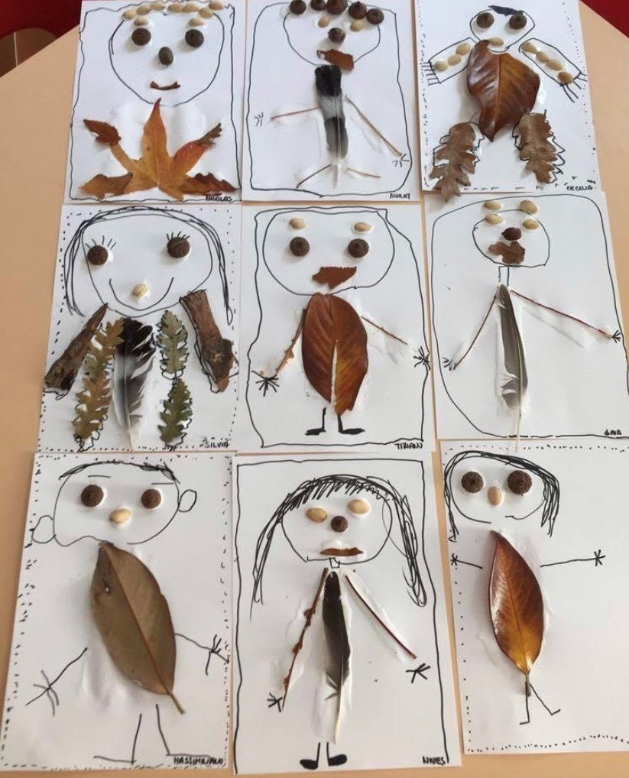
- Role play- Use the fairytale storyboard on the class page to create your own fairytale. Act out your fairytale with some of your family members. You can also act out a well-known fairytale such as Cinderella, Rapunzel, The Three Little Pigs, etc.
- PE- Try out the challenge below at home.
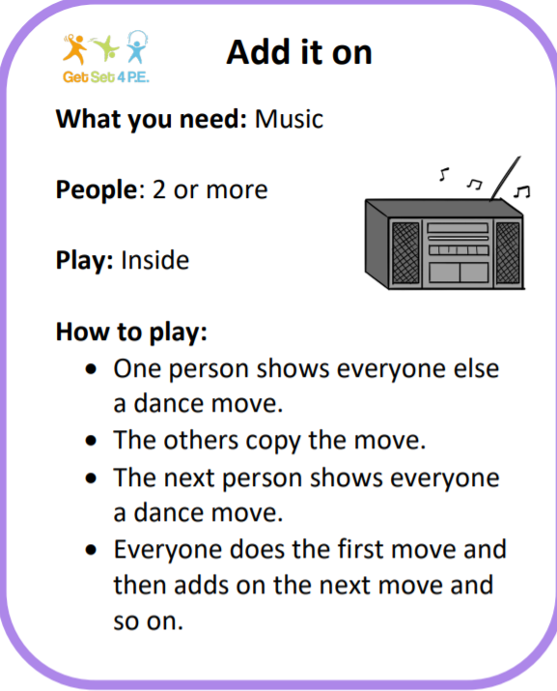
- Maths- Continue on with Capacity from last week- Fill up a basin of water and gather some containers of different sizes such as cups, bowls, jugs, pots, etc. Engage in free play by filling and emptying different sized and different shaped containers. Use maths language such as full, empty, level, hold more, holds less, most, least, the same, etc.
- Create your own bug hotel outside. Check every few days to see if any bugs have stayed in your hotel.
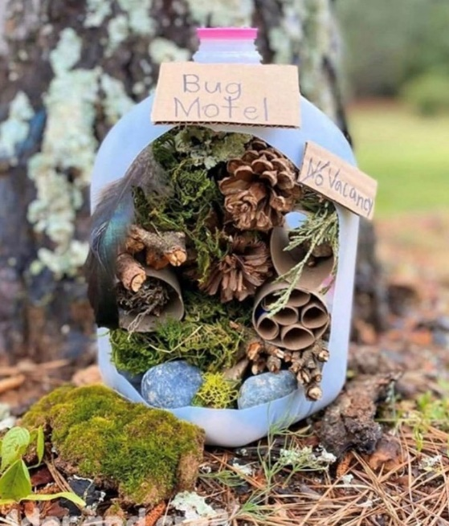
- SESE- Bouncing egg challenge. Place an egg into a jug/bowl of vinegar and leave it there overnight. The following day check if the egg shell has dissolved. If not, leave it in the video a bit longer. When the egg shell has dissolved, take it out of the vinegar and rinse with cold water. Can you lightly bounce the egg from a low level without it cracking? Have a look at the video on the class page.

Wednesday
Maths
- Counting:
  - Count forwards from 0-50 and backwards from 50-0.
  - Skip count in 10s up to 100
  - Skip count in 5s up to 50
- Capacity- Can you solve these mental problems?
  - If a jug holds 4 cups of water, how many cups will I need to fill 2 jugs?
  - A glass holds 6 eggcups of water altogether. If I poured 4 eggcups of water into the glass, how many more would I need to fill it completely?
  - If a bowl holds 6 mugs of water and I pour in 4 mugs, will the bowl be nearly full or nearly empty? How many more mugs of water are needed to fill the bowl completely?

Literacy
- Write 3-5 sentences of your news from the long weekend and draw a picture to match. What did you play? What did you learn? What did you enjoy doing? Did you make a bug hotel? Did you create a nature portrait?
- This week we want you to revise all of your tricky works. Play some tricky word games to help you revise them all.
- Practise 1 new cursive letter using the videos on the class page.
Make sure you do lots of practise of writing the letter and send us on some photos so we can see how you are all getting on. You can practise on a page, whiteboard, using playdough, sand, etc- it’s up to you Remember these are your first time trying these letters so they will be tricky at first. Just try your best

SESE: Children of Lir. Use the following link to listen to the story and to answer some true/false questions. You will need to log into Folensonline.
https://content.folensonline.ie/programmes/Explorers/ExplorersSI/resources/demonstrations/EX_SI_DEMO_CH01_016/index.html

Thursday
Maths
- Use your basin of water and containers to determine which containers can hold more. Estimate (guess) first and then measure.
- Planet maths books page 122

Literacy
- Use the fairytale storyboard on the class page to write your own fairytale or you can make up your own. Remember to plan your fairytale first- think about the following:
  - Setting- where will the fairytale take place? (A castle, a cottage, a small village, a tower, etc.)
  - The characters ( will there be good and bad characters? )
  - What happens in your fairytale?
  - Do you need any props? (a magic wand, a potion, gold, etc. )
- We look forward to reading your stories and sharing them with the class. You can send us on a photo of your story or you could send us on a video of you reading your story! (We really miss hearing all of your wonderful stories in school)

- Handwriting: use the handwriting video on the class page to learn 1 cursive capital letter and revise your letter from yesterday.

PE
Try out some fun PE activities such as :
- Egg and spoon race
- Sprinting
- Throwing
- Use chalk to make your own hopscotch
- Get creative and send us on some photos!
Friday
Maths
- Capacity- Use your basin and containers to see how many cups of water you need to fill other containers such as a pot, a jug, a bowl, etc. Estimate first and then measure.
- Planet maths books- page 123

Literacy
- Listen to the Rapunzel story on the class page.
- Write about your favourite part of the story.
- Practise 1 new cursive capital letter and revise all of the letters so far- S, A, T, I, P, N

Gaeilge
Bua na Cainte book page 41

Art
Can you make a tower for Rapunzel? Here are some ideas below, or you can create your own!
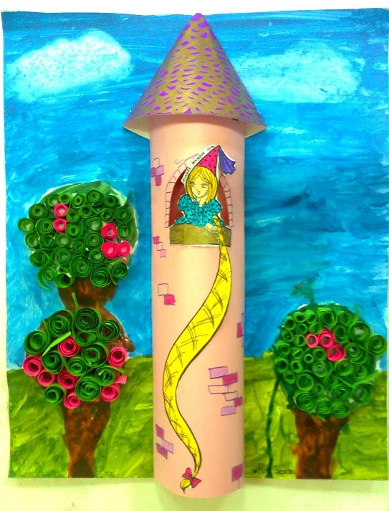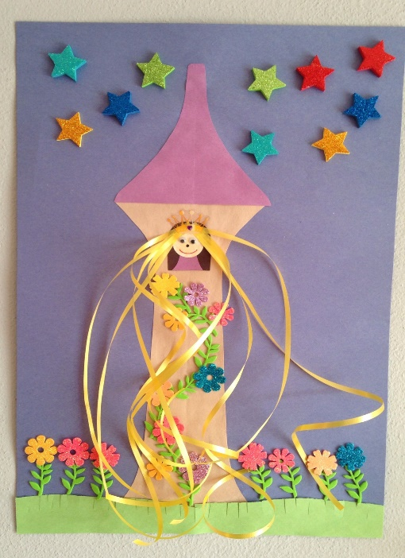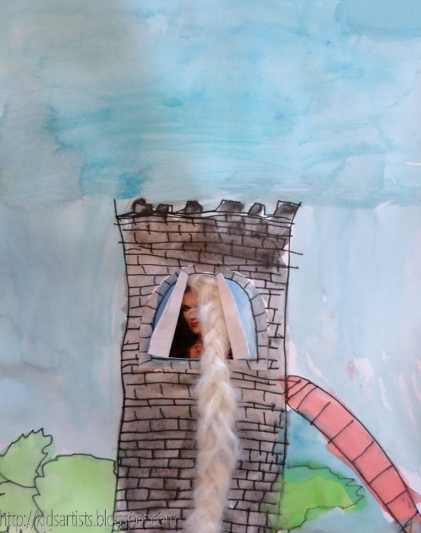

You could also use art for kids hub on Youtube to draw Rapunzel.

