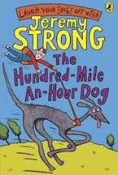

When your novels arrive in the post you can take a look at the first novel we are going to read together:

‘Hundred Mile an Hour Dog’ by Jeremy Strong.

- Read the blurb and take a look at the title and front cover.

- Make a prediction about what you think the story will be about.

- The blurb describes streaker as ‘a rocket on four legs’. Can you like of another saying (simile/metaphor) for a fast animal?

- Read the information about the author on the inside cover and think of some questions you would like to ask him. Can you find out some more information about the author and write 5 facts about him.

- Read Chapter 1 page 7-25

