Mr Large in Charge

- Find the word missing from each sentence.

Not | Cakes | Rest | Garden
Large | Children | Hard | Everyone

- The __________ had started on the breakfast.
- Mrs Large was _______ feeling well.
- Back to bed went Mrs large for a _______.
- There was lots of noise with _______ cleaning.
- Mrs Large was finding it _______ to sleep.
- In the _______ Mr Large tripped over the rake.
- Everyone came in with tea and _______.
- Mrs _______ sat up and everyone got on the bed.

- Write down all the small words you can find in these big words.
Football
Bedclothes
Everything
Upstairs
Breakfast
Weekend
Sandwiches
Backwards

- True or False
Circle the correct answer.
- Mrs Large didn’t feel good. True/false
- Mrs Large was going to take the children to the swimming pool. True/false
- Lester did the hovering. True/false
- The Large family had cheese sandwiches for lunch. True/false
- The children played basketball with their dad outside. True/false
- Dad tripped over the rake. True/false
- The bandages are on top of the bathroom cabinet. True/false
- Mr Large brought tea and biscuits to Mrs Large. True/false
- There are 5 children in the Large family. True/false
- Mrs Large had a hot water bottle in bed. True/false

- Compound words
A compound word is a word made up of two smaller words. We have done loads of work on these already this year so everyone should be familiar with them.

e.g Football – foot + ball
Homework – home + work

Use the words in the box below to make to make compound words. Write the compound words in the box below.
Room | Body | No | Bed | One
Only | Both | Thing | Every | Some

- Read the passage below and answer the questions.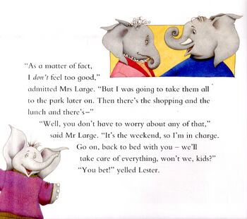

- How did Mrs Large feel?
____________________________________________
- Where was Mrs Large going to take the children?
____________________________________________
- What did Mr Large tell Mrs Large she didn’t have to worry about?
____________________________________________
- Who was in charge this weekend?
____________________________________________

