May 4th -8th
Daily Activities
Try your best to do the following each day/ every second day:
- Aistear
- Counting
- Sounds and tricky words
- Handwriting
- PE- try to do 60 minutes of exercise each day

Monday
As it is a bank holiday, here is a list of some fun activities that you could do at home:
Aistear The Airport
Art
Choose between the following:
- Airport colouring pictures (attached in the Aistear folder on the class page)
- Junk art- Can you make an aeroplane or airport using cardboard boxes, egg cartons, scraps of paper, etc?
Music
Listen to the Che Che Koolay song. Try your best to join in and sing the words
https://www.youtube.com/watch?v=hIdp_Nj0tgk

SESE
Float and sink. Use the following link on folensonline to learn all about floating and sinking.
https://content.folensonline.ie/programmes/Explorers/ExplorersSI/resources/demonstrations/EX_SI_DEMO_CH03_003/index.html
Can you set up your own floating and sinking station at home/in the garden? Don’t forget to predict what objects you think will float or sink first before testing them out.

Tuesday
Literacy
- Listen to Ms Sherwin reading Hippospotamus using the video on the class page. You can read along using your book.
- Write 3-5 sentences of your news from the weekend and draw a picture to match. We can’t wait to hear all of your news soon.

Maths
- Continue practising your counting each day. Revise counting forward from 0-50 and backwards from 45-0.
- Match number words to the corresponding amount of dots eg ‘Two’ would match with the card containing two dots. We have attached a word document on the class page that you could print out for this activity- or you can make your own!

PE
- Practise your sprinting in your garden or a nearby field. Time yourself- can you beat your previous time?

Wednesday
Literacy
- Play some of the tricky word games attached on the class page.
- Sounds like phonics- Click on https://slp.cjfallon.ie/
        - Select book B
        - Unit 2 bl/br
- Oral report- talk about Hippos- what do you know about them? What do they look like? Have you seen one before? Ask a parent to help you find out more information about Hippos. You could also write some sentences about Hippos.

Maths
- Length PowerPoint

Gaeilge
- Listen to the Gaeilge Video
- to learn some new words.

Thursday
Literacy
- Phonics sheet on the class page. Pick 4 sentences and write them in your green handwriting copy/lined paper. Don’t forget to use cursive writing.
Maths
- Length PowerPoint
- Practise skip counting in 10s up to 100. 10,20,30,40,50,60,70,80,90,100
- Practise skip counting in 5s up to 25.
PE
Reaction sprints
- lie on the ground, when someone says ‘GO’- hop up and sprint.
- Face backwards, when someone says ‘GO’- turn around and sprint

Religion
- May is the Month of Mary. Use the Mary PowerPoint to talk about Mary with a parent/older sibling.

Friday
Literacy
- Sounds like phonics- Click on https://slp.cjfallon.ie/
        - Select book B
        - Unit 2 cl/cr
- Poem: May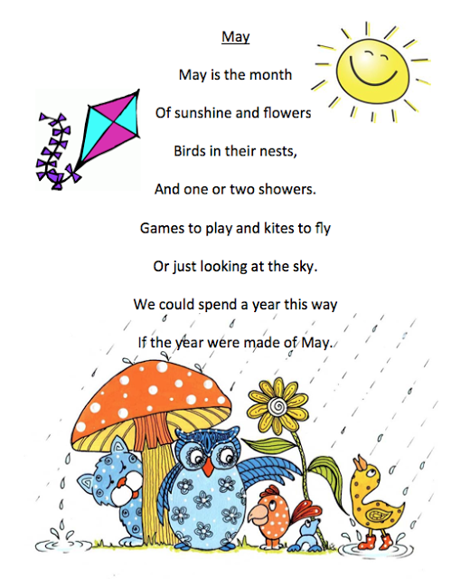
Maths
- Length PowerPoint
- Practise writing numbers 1-10 using the correct formation
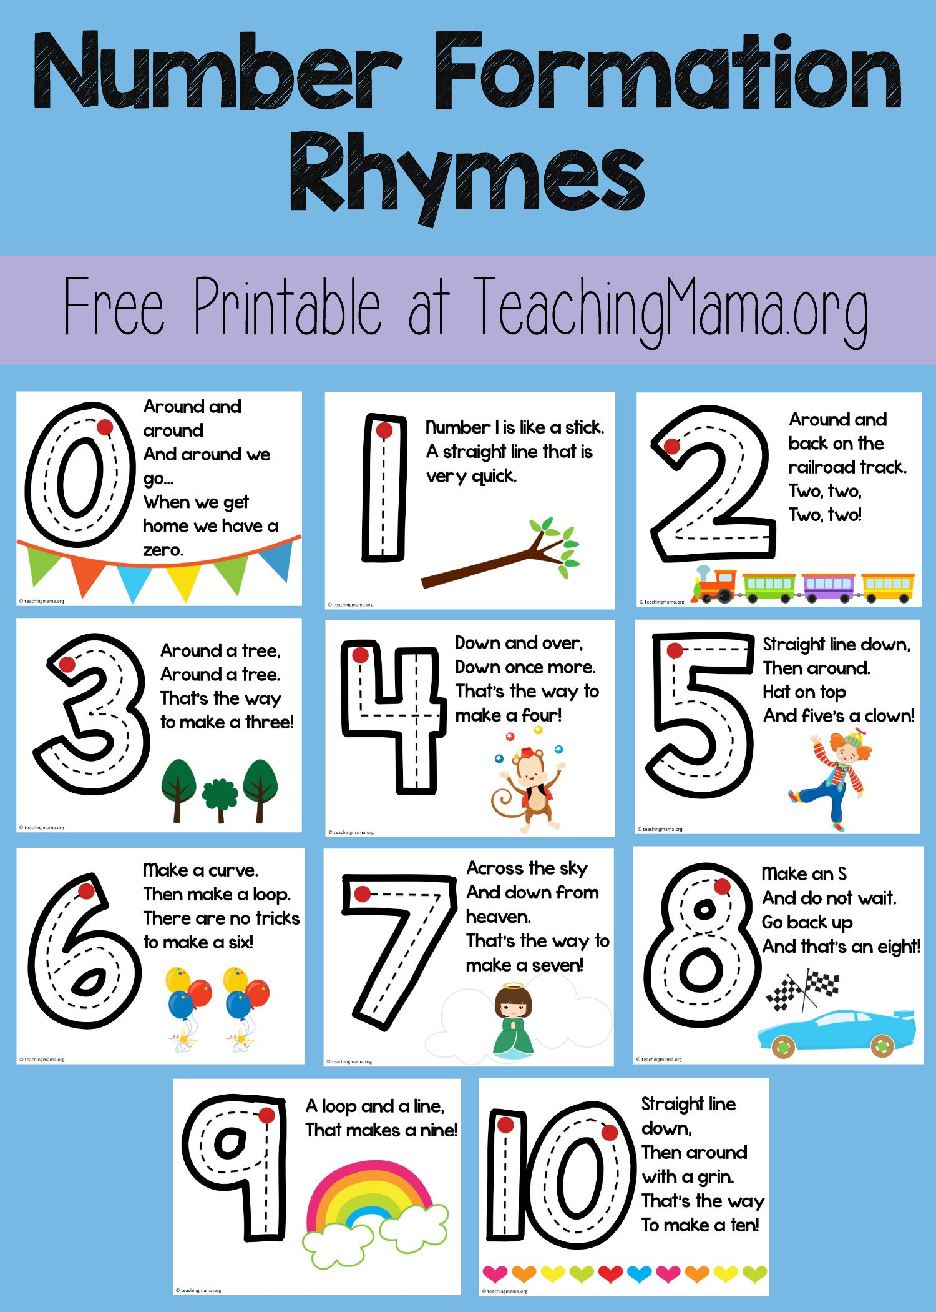

SESE
Summer- Use the following link to learn about summer and play some games. Some of you may already have a folensonline account- if you don’t select to register as a teacher, fill in a username, email address and password. For ‘Roll Number’, use the code Prim20 5. Click ‘Register’. You will then be sent an email to activate your account.
https://content.folensonline.ie/programmes/Explorers/ExplorersSI/resources/demonstrations/EX_SI_DEMO_001/index.html
Go on a summer walk over the weekend- can you identify any signs of summer?

