Magic Potion
In Alice in Wonderland, Alice drinks a potion from a bottle labelled ‘drink me’. Can you decorate the label on this bottle? What will the contents of the bottle look like?
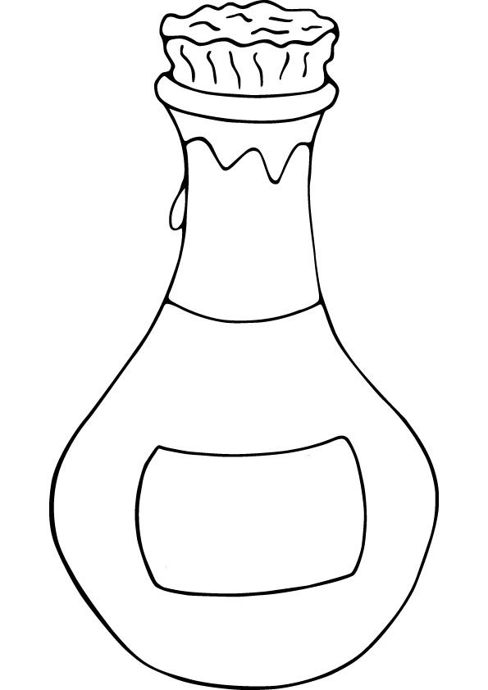
In Alice in Wonderland, when Alice drinks the potion she shrinks very small and then grows very big. If I was to drink your potion what will happen to me?
Use your imagination to think of something crazy that might happen.

_______________________________________________________________________________________________________________________________________________________________________________________________________________________________________________________________________________________________

Draw a picture of me after I drink your magic potion.

