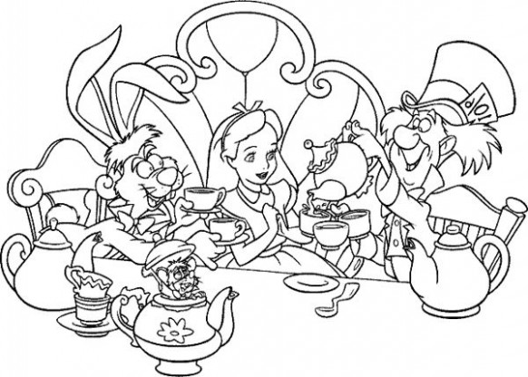

Mad Hatters tea party!

______________________________________________________________________________________________________________________________________________________________________________________________________________________________________________________________________________________________________________________________________________________________________________________________________________________________________________________________________________________________________________________________________________________________________

