Fun Language Games

The Yes/No Game

Rules
The Yes Or No game rules are nice and simple. You ask a child a long series of questions that would normally require that they answer “Yes” or “No”; however, the child isn’t allowed to say either of these words. They’re also not allowed to nod or shake their head.
For example, you might ask the child “Do you have any brothers or sisters?” Their natural inclination would be to answer “No” or “Yes”, but instead they’d need to say something like “I have two – one brother and one sister”.
Your next question could then be “Did you say you had three siblings?” This will hopefully trick them into saying something like “No, I have two”, in which case they’re out. Ask the questions in quick succession so that they have less time to think about their answer.
You could keep playing for as long as it takes for the youth to say “Yes” or “No”, or instead set a time limit of 1 or 2 minutes – if they manage to go that long without saying either of these words, they win (or the next person gets a chance to play).

Winner: The person who lasts the longest without saying either of the two words.

Yes Or No Game Questions
Don’t just ask closed-ended questions – throw in some open-ended questions to try to catch them off guard. For instance, you could try the following series of Yes Or No game questions (those in bold are yes/no questions):
- Do you have any brothers or sisters?
- Did you say three?
- What are their names?
- So how do you spell your brother’s name?
- Was that ……… (repeat how the brother’s name was spelled)
- Are you older than him?
- How old is he?
- Do you get on well?
- What’s his favourite sport?
- Do you ever play that with him?
- Are you better than him at the sport?
- When’s his birthday?
- What present did you get him for his birthday?
- Did he like it?

Play 20 Questions
20 questions is designed to improve your little one's problem-solving skills and help develop language skills simultaneously. This game will also help to build your child’s memory and recall skills, challenging them to think beyond what they can see in their immediate surroundings.
Think of an object (something), a person (someone) or a place (somewhere). Tell your little one which of these three categories the item falls into.
Tell your child they can ask only 20 questions to get clues for what the item could be. But you can only answer ‘yes’ or ’no’.
For example: Adult: "I am thinking of something we use everyday."
Child: "Is it in this house?"
Adult: "Yes."
Child: "Is it in this room?"
Adult: "No it is in another room."
Child: "Is it in the bathroom?"
Adult: "Yes."
Child: "Is it the bath tub?"
Adult: "No - but you are very close."
Child: "Is it the bathroom sink?"
Adult: "Yes."
Child: "Is it the plug?"
Adult: "Yes! Well done, let's try another one."
As your little one gets better at this game they could eventually be the one thinking of the person, place or thing.

‘How Many’ Game
Ask your child these types of questions to get them thinking and talking.
- How many animals can you name that hatch from eggs as babies?
- How many animals can you name that have patterns on their bodies?
- How many animals can you name that eat leaves?
- How many insects can you name that have six legs?
- How many vehicles can you name with four wheels?
- How many things can you name that are cone shaped?

I Went to Market:
- The aim of this game is to remember as many of the items in the shopping basket as possible. The first player begins by saying, “I went to market and bought a ___,” adding an item they would buy. For example, “I went to market and bought a bag of potatoes.” The next player in line continues with, “I went to market and bought (insert the name of the first player’s item) and a ___ (adding a new item purchased).” For example, “I went to market and bought a bag of potatoes and a candy bar.”
- Player three adds to the chain of shopping items, “I went to market and bought a bag of potatoes, a candy bar and a newspaper.” Players continue to take turns. Any player who makes a mistake is eliminated until only one winner is left.

What’s better?
- This fast paced game simply asks kids about their preferences between two things –
- “What’s better – banana or apple?”
“Banana”
“What’s better – banana or cheese?”
“Cheese”
“What’s better – cheese or chocolate?”
“Chocolate”
“What’s better – chocolate or ice cream?”

Odd One Out
Begin by naming three items – two that are connected in some way and one that is not (you can make this as easy or as hard as you wish, depending upon the age and interests of your children) and ask your children to choose the odd one out. For example with “train, bus, hair” it is easy to identify the odd one out. “Platypus, cobra, horse” is more challenging. “Chop, chicken, ship” focuses the game on identifying different sounds. “2, 4, 9”, or “21, 22, 45” turns it into a math challenge.

Tongue twisters:
Make up your own funny tongue twisters by choosing a letter or sound and working together to make a sentence with as many words beginning with the chosen sound as possible.

Alphabet chain
Choose a category and take turns naming an item that fits the category following the sequence oaf letters of the alphabet. So the first person chooses a word starting with a, the second person a word beginning with b, the third person with c, etc. The category can be anything at all – animals, countries, names, superpowers, etc.

Games That You Might Have or Get at Home
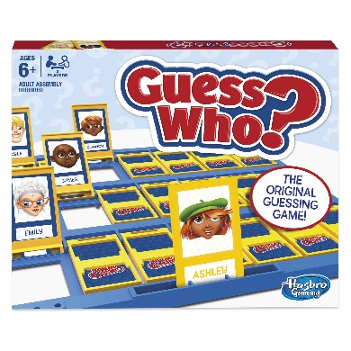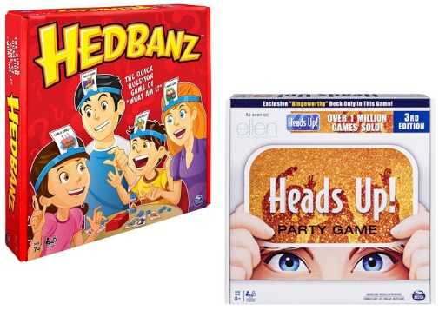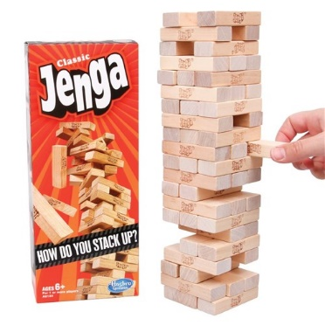
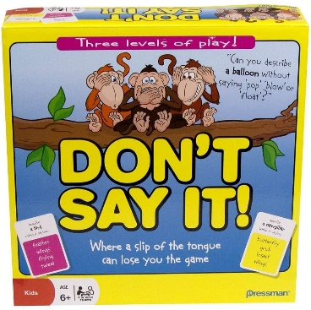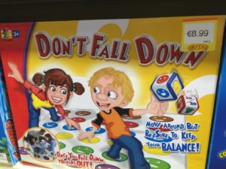

Playing Card Games
Go to the website below for a full list of playing card games and the rules of how to play them.
https://wehavekids.com/parenting/Card-Games-For-Kids

- Snap
- Pairs
- Go Fish
- Cheat
- Old Maid (Donkey)
- Beggar My Neighbour
- Switch
- Memory

