Fun Easter Activities
Hi, everybody
I’ve put together a few ideas of things you could do over Easter if you wish. These might help occupy some time as the days can be long staying indoors. I hope you enjoy and have a safe Easter.

- Over the Easter break, be sure to keep reading. Choose some of your own novels at home or use Raz-kids to complete reading everyday.
(if you want to sign up to Raz-kids give me an email and I will send you on your password )

- Make some delicious treats over the Easter break.
- Chocolate Easter nests – Can you make a recipe for making this yummy treat? I will give you the ingredients and equipment but I want you to try create the steps to follow. Step 1: _____ Step 2: ____. Remember we looked at writing out steps when creating our witches spells!!
Equipment you will need: bowl, wooden spoon, bun cases, bun case tray, hob, and fridge.
Ingredients you will need: cooking chocolate/ any chocolate, rice krispies and mini chocolate eggs.

- Make your own homemade pizza
1. Using some naan bread, baguettes, wraps or whatever you can find in the house.
2. Spread some Bolognese sauce, pasta sauce or pesto on your base.
3. Then add what you like to have on your own pizza – ham, peppers, mushrooms, sweetcorn, pepperoni etc. (cut up nice and small).
4. Finally add some grated cheese.
5. Place on a baking tray and put into oven until cheese has melted. (5-6 mins)
6. Enjoy your homemade pizza.

- There are loads of recipes for baking and cooking online which are easy to follow. You choose what you would like to make and look it up online or check any cookery books at home.

- Enjoy an Easter Egg Hunt in your garden or in your house. Ask somebody at home to hide eggs of different sizes around the garden or indoors. When this is done, see who can find the most eggs or if you are playing on your own why not set a timer? Check how long it takes you to find them all, are you up for the challenge?

- Create your own obstacle course in the garden or inside. It can be big or small, use your imagination. You can create it for yourself to complete or make one for your family members. You could even make it into a competition. See who can complete it the fastest!

- Have a dance party. Put on your favourite songs and dance along with everyone who is at home with you. Show of your best dance moves. Maybe you could even create an Easter dance to your favourite song.

- Easter cards – make some Easter cards for family and friends. Some colouring pencils, crayons or markers, paper and scissors is all you need.

- Play some board games or card games at home. These are sure to keep you busy for hours.

- Create your own treasure hunt. You could make this for somebody at home or maybe they can make one for you. At the end, be sure to have your special prize.

- Try to make some different Easter art crafts using different materials you have at home. Here are a few examples:

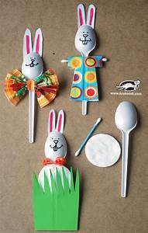 | 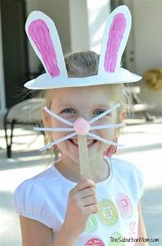
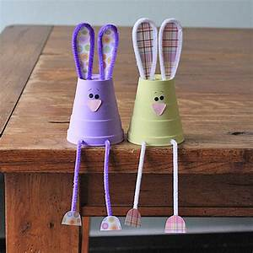 | 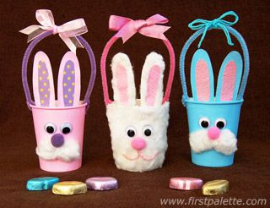
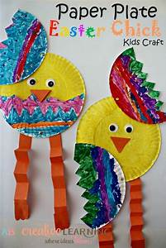 | 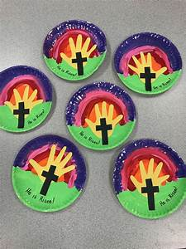

Keeping fit
Remember to try and do an hour exercise every day. This could be playing outside with your siblings, doing a go noodle or one of Joe Wicks exercise classes on YouTube.
You can also practice some yoga or mindfulness daily for 10 minutes. Lots of yoga and mindfulness activities can be found on Go noodle.

Gaeilge
The girls can watch something on cúla4. There are different kids shows in Irish on that the girls might enjoy to watch. Sponge-Bob is at 4.25 Monday – Friday if they want to give that a watch.

Helping out at home
Please try and help out as much as possible at home with some chores. I will leave a list of chores that you can choose from. You can choose one job to do every day.
(If your parents have other jobs they want you to do, they can adapt the list)

- Make your bed
- Set the table for dinner
- Stack the dishwasher/empty the dishwasher
- Wash the dishes/dry the dishes
- Tidy up all your toys
- Brush the floor (I know every girl in the class is brilliant at this job)
- Clean the table
- Tidy your bedroom
- Put the clothes away after they are washed.

