Active Home Week
This week we will all be taking part in Active Home Week as part of our Active Schools Flag. All you have to do is get active in 4 different ways each day in order to reach your goal of being active for 60 minutes every day.
Keep an eye on the post as Ms. Shaughnessy and Ms. Sherwin have sent each girl an Active Home Week poster for you to fill in over the course of the week. Check out the Active School section of the website for some ideas on how to get creative while getting active this week. You can also have a look at the Teacher Section to see how all of the teachers have been staying active at home!
Don’t forget to email me all of the creative ways that you have been getting active. You can email pictures of your completed Active Home Week poster and pictures of you and your family staying active!

Art Competition
Ms. Gerrard has organized an art competition for every class. You will soon receive a poster in the post for this competition. You can draw or paint anything that you interest you. When you have finished, take a picture of your poster and email it to me by Tuesday 12th May.
Best of luck!!!

RTÉ Home School Hub will continue every weekday at 11am on RTÉ 2.

As always, all of the work can completed in your copies and you can use the worksheets as a guide for your copy work.

Charlie and the Chocolate Factory (Chapters 1 – 6)
Hopefully you will all have received your lovely books in the post by now. As not all of you had the books for the entire week I am going to leave last week’s activities up for this week.
I will add some new activities for anyone who has already completed the first five chapters of Charlie and the Chocolate Factory. This week I would like everyone to try and read as far as Chapter 6 if you can. Hopefully next week we will all be on the same chapter and will get to progress through the book together.
(Activities April 27th – May 1st)
- In Chapter 4 ‘The Secret Workers’ Grandpa Joe tells Charlie about the spies working in Mr. Wonka’s chocolate factory. Imagine you are one of the spies working in the factory. Write an account of your time there.
Some things to think about:
- What is the factory like?
- Is Mr. Wonka a good boss?
- Does anything interesting happen in the factory?
- What secrets are you trying to steal?
- In Chapter 6 we are introduced to ‘The First Two Finders’. Please complete a character profile for each of these ticket holders. Use these character profiles to help you to create a comparison Venn diagram.
Remember: When comparing, we look at the similarities and differences.
Sample Venn Diagram
Character 1 Both Character 2

(Activities April 20th – 24th)
- Before reading each chapter, try to make a prediction. Revisit your prediction to see if you were correct.
- Can you make any connections or comparisons with the characters, places or events in the chapter?
- Summary: When you have read all 5 chapters, write a summary about all you have read. Remember that summaries are short and to the point. Try to write a summary in less than 100 words.
- Character Profile: Charlie. Draw a picture of what you think this character might look like. Write as many words as you can think of that you would use to describe this character.

Maths – 2D Shapes (Triangles)
Busy at Maths Pg. 67
- Have a look at each of the triangles in Question 1. Can you say the name of each of these? Have someone at home help you to check if you are correct.

- Equilateral triangle: all of the sides are the same length.
Isosceles triangle: two of the sides are the same length and one is different.
Scalene triangle: all of the sides are different lengths.
Can you think of a rhyme that could help you to remember these triangle facts?

- Triangle hunt: How many equilateral, isosceles and scalene triangles can you find in your home?
(Example: I found four equilateral triangles on the volume buttons on the remote control.)

- Complete page. 67 questions 1 - 5

Gaeilge – An Deireadh Seachtaine
- Bua na Cainte lch. 114 Bí ag léamh ‘An Deireadh Seachtaine’.
(Page. 114 Read ‘An Deireadh Seachtaine’)
- Bua na Cainte lch 114 Bí ag scríóbh. Líon na bearnaí ag baint úsáid as na bpictiúir.
(Complete the writing activities on page 114. Fill in the blanks using the pictures)
- Déan líosta den caitheamh aimsire.
(Write a list of hobbies. If you need some help check page 108.)
- Inis dom faoi do dheireadh seachtaine.
(In your Gaeilge copy, write a short account of your weekend. Use page 114 to help you.)
Science: The Eye
Watch this video about the Eye before completing your worksheet.
THE HUMAN EYE VIDEO LINK
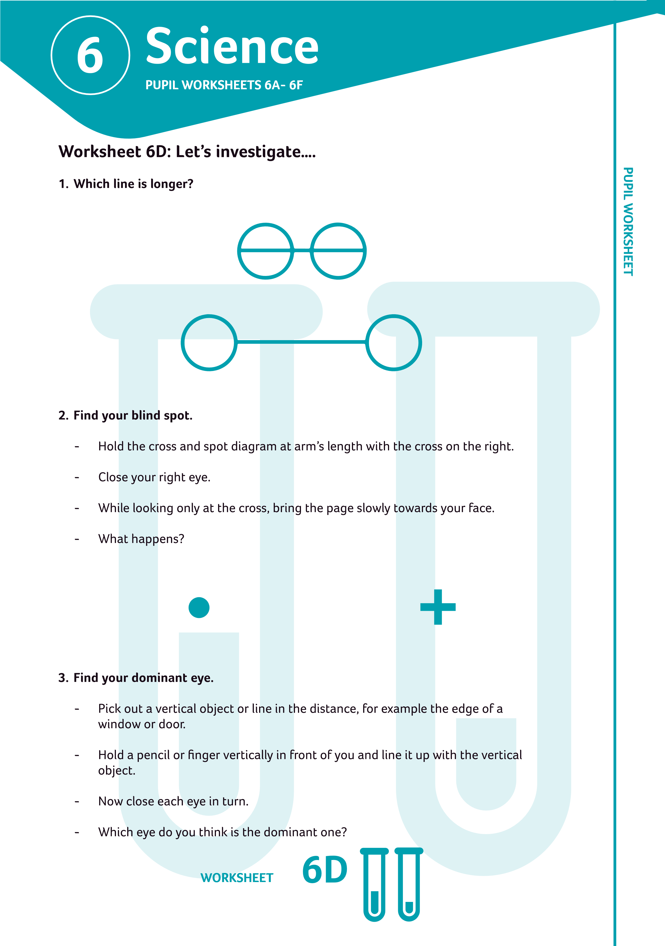
Games and Pastimes
I hope you have all been enjoying learning about Irish games and pastimes. Hopefully you can see that some of the games from the past aren’t so different to what we still enjoy today.
Last week you were asked to complete worksheet 4D as part of your history lesson. This week you can choose any of the other worksheets that you would like to complete yourself.
https://learning.gaa.ie/sites/default/files/9,12,13,21.pdf

