Aistear- The Hairdressers
See the Aistear folder attached on the class page for some play ideas, key vocabulary and some other ideas you might like to use!
Don’t forget you can write your Aistear plan at home like you do in school each day before you play!
Today is ___________. I am going to the role play /playdough /small world /art /sand /construction /writing station. I will________ (write about what you plan to do during play, who you will play with, what you will make, etc).

Maths
- Mangahigh assignments
- Counting- Practise counting forwards and backwards. You can use the Jack Hartmann Youtube videos to count and be active at the same time!
- Play the following games on ixl maths:
https://ie.ixl.com/math/sr-infants/count-on-ten-frames-up-to-20
https://ie.ixl.com/math/sr-infants/show-numbers-on-ten-frames-up-to-20
- Time PowerPoint on the class page.
- Planet maths- page 35 and 36.

Literacy
- Continue to practise your handwriting by:
  - Revising lowercase letters in your ‘Handwriting Today’ book.
  - Use the following link to practise letter formations and writing 2 and 3 letter words. http://data.cjfallon.ie/resources/gwtf-handwriting/index.html#!/books
  - Practise writing your tricky words- Can you write them in a sentence?
- Revise all of your sounds. This week focus on digraphs:
    - Click on https://slp.cjfallon.ie/
    - Select book B
    - Unit 1 Revise- sh, ch, th, ai, ea. There are plenty of games for each sound.
- Paired reading books/Razz-kids (online website for reading- email your teacher if you would like to be signed up)
- Hokey-Pokey Poem
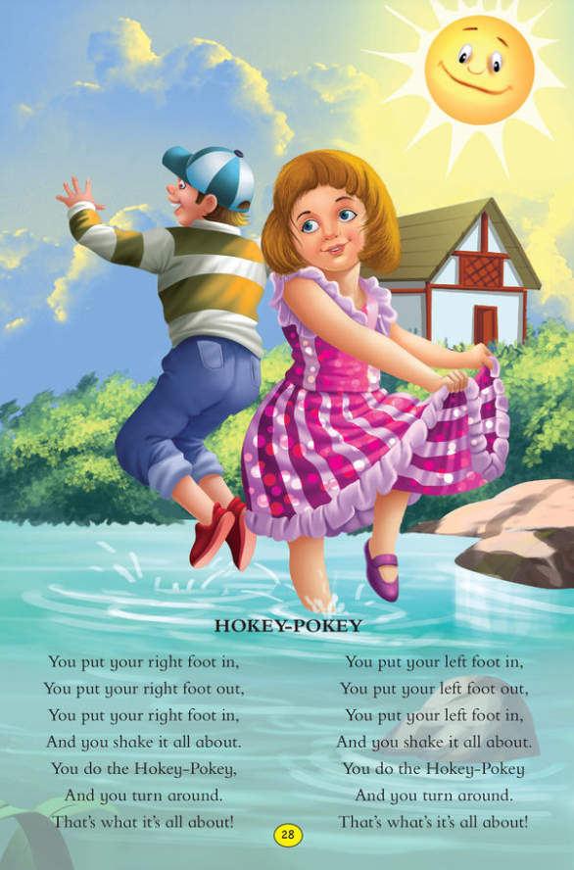
- Fireworks: page 58 and 65- remember to use your cursive writing.
Gaeilge
Please try to watch one program a day on TG4/ Cúla4 to ensure the girls are listening to Irish daily
SESE
For the next few weeks we will be learning all about water. This week use the following link to explore the pond. Create a free account as a student on folensonline.ie to access the resources.
https://content.folensonline.ie/programmes/Explorers/ExplorersSI/resources/demonstrations/EX_SI_DEMO_CH02_003/index.html

Art
Design your own hairstyle- you can use the template in the aistear folder on the class page or you could draw from scratch!
Art for kids hub (Youtube)- how to draw health heroes.
Get creative- make your own artwork

PE
Remember to try and keep active at home. Here some ideas:
- Go for a walk/cycle/scoot (within 2km of your home)
- Use GoNoodle, Cosmic Yoga (Youtube), 10@10 (RTE Junior)
- Check out the Active School page on the school website for some great ideas!

