Alice in Wonderland book review
In your own words, what was the book about?
________________________________________________________________________________________________________________________________________________________________________________________________________________________________________________________________________________________

Who was the main character? What was he/she like?
________________________________________________________________________________________________________________________________________________________________________________________________________________________________________________________________________________________

Who was your favourite character? Why?
________________________________________________________________________________________________________________________________________________________________________________________________________________________________________________________________________________________

Did you like this book? Why?
________________________________________________________________________________________________________________________________________________________________________________________________________________________________________________________________________________________
What was your favourite part of the book? Why?
________________________________________________________________________________________________________________________________________________________________________________________________________________________________________________________________________________________
Draw a picture of your favourite part from the story.

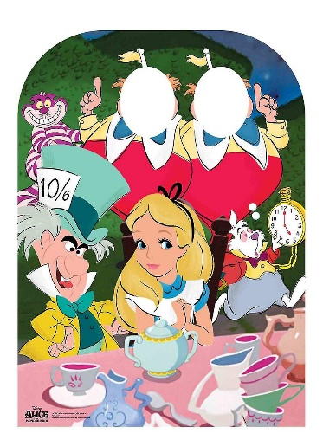 By _______________

