Monday
Maths
This week we’re looking at area.
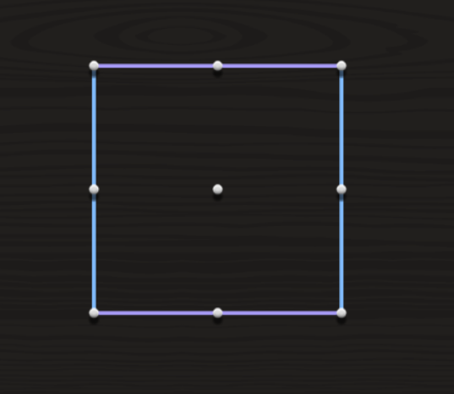
To find the area of this square, we create little squares in it.

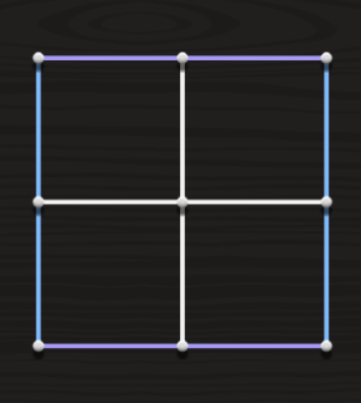
This box has 2 squares on top, 2 on the bottom. So the area is 4 squares. 2x2 = 4

- Introduction video: https://www.youtube.com/watch?v=_uKKl8R1xBM
- A great video to explain how to find the area (Starts at 1min)
https://www.youtube.com/watch?v=8cz_IB65pZM
- Interactive resource: http://data.cjfallon.ie/resources/20684/BAM3_Tutorial_100/lessons/BAM3_Tutorial_100/index.html
- Busy at Maths p161
- Optional: Link to a geoboard so you can create your own square/rectangles and work out the area. https://apps.mathlearningcenter.org/geoboard/
English
- Read George’s Marvellous Medicine ‘Grandma gets the medicine’.
- Create a list of interesting words.
Gaeilge
- Bua na Cainte p107 ‘os comhair an tí’ (in front of the house).
- Bua na Cainte p107 ‘os comhair ___’ Tá mamaí os comhair Daidí.
‘Os mo chomhair’ = in front of me.
Music
For the next few weeks, we’ll be looking at music from different parts of the world. This week we’re going to be introduced to some countries and their instruments.
- A musical Journey https://www.youtube.com/watch?v=iNv6XvRJQS4
- Musical Instruments https://www.youtube.com/watch?v=XBs9UCetgog
- Write a little piece/do a mind map about any music from around the world that you know of or musical instruments.

Tuesday
Maths
- Interactive http://data.cjfallon.ie/resources/20684/BAM3_Tutorial_101/lessons/BAM3_Tutorial_101/index.html
- Busy at Maths p162
- Can you complete this Sudoku?
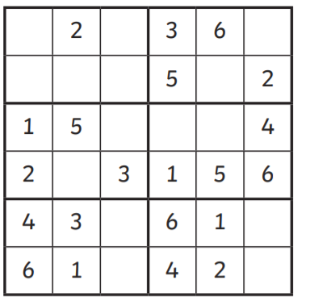
English
- Read George’s Marvellous Medicine ‘The Brown Hen’
- Summarise the chapter using exactly 15 words.
Gaeilge
- Bua na Cainte p111 Answer the questions
- Draw a seomra folchta i do chóipleadbhar agus label the items.
SESE
- History Quest p43 Read about The Maoris
- Activity A and B p46
- Optional information: PowerPoint on the website.

Wednesday
Maths
- Interactive http://www.sheppardsoftware.com/mathgames/geometry/shapeshoot/AreaShapesShoot.htm
- Busy at Maths p163
- Maths at home: Cut up a piece of paper into a square (or use an item that is a square in your house) – find the area of things in your house using the square. (Example, you could measure your fridge, your room, your table etc).
English
- Read George’s Marvellous Medicine ‘The pig, the Bullocks, the sheep…’
- Write a definition for these words ‘cackled, googled, gaped, colossal’
Gaeilge
- Bua na Cainte p114 Read the story and fill in the blanks.
Mindfulness/Calm time
- Do some breathing exercises (file on website)
- Listen to some music, do some colouring or go outside, close your eyes and sit quietly. What can you hear? What can you smell? What can you feel?
- Finish the Doodle (File on website, or just take inspiration and draw one yourself).

Thursday
Maths
- Interactive: http://data.cjfallon.ie/resources/20684/BAM3_Tutorial_102/lessons/BAM3_Tutorial_102/index.html
- Busy at Maths p164
- Create your own dream house/garden layout – just like the one on p164.
English
- Read George’s Marvellous Medicine ‘A crane for Grandma’
- Edit this excerpt and then correct it using your book (p59).
the crain arrived wun hour latr it waz on wheels, ans their were two man inside it. The crain men climbed up ontwo the ruf and put ropes undere grandmas arms. then she was lift ryt up through de roof in a way the medicine had dun Grandma gud
Gaeilge
- Bua na Cainte p118 Read and answer questions about ‘An Cistin’
- Draw ‘an cistin’ i do chóipleadbhar agus label the items.
PE
- Paper PE – all you need is 5 pieces of paper https://www.youtube.com/watch?v=T9XIGs_lu4g

Friday
Maths
- Busy at Maths p160
- Create an area picture – you could make an animal or your name (draw it in your maths copy & figure out the area of your picture).
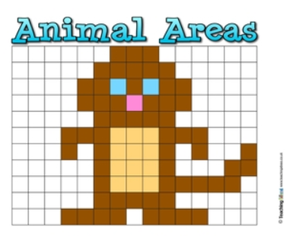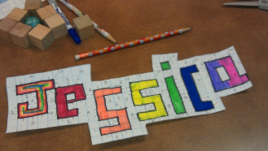
English
- Read George’s Marvellous Medicine ‘Mr. Kranky’s Great Idea’
- Write a letter to one of the characters in the story OR write a letter to a friend/family member.
Gaeilge
- Bua na cainte p119. Our story is about Nana who is minding the kids. While Nana and the kids clean up, someone is eating all the sweets!
- Answer the questions.
Art
- Koru Design (file on website – if no printer, just draw your own and then follow the instructions )

Other things you can do (Optional)
English | Can you create a podcast about something you’re interested in, you could record this or write a piece about it.
Podcast | But Why? A Podcast for curious kids (Different topic each episode)
Maths | I have assigned an area game on Mangahigh.
Poetry | Write a funny Limerick Poem.  (File on website about Limerick Poem).

