At your own pace, finish the last four chapters of George’s Marvellous Medicine this week.
Wednesday
Maths
This week we are looking at Fractions.
- Instructional video on YouTube: https://www.youtube.com/watch?v=p33BYf1NDAE (video start at 1.16)
- Busy at Maths Interactive resource: http://data.cjfallon.ie/resources/20684/BAM3_Tutorial_057/lessons/BAM3_Tutorial_057/index.html
- Busy at Maths p102 + p103
P102 Q4 e-h ½ of the circle is red, so the other ½ is blue. How else can you write half?
2/4 and 4/8 – just like pizza… if you cut the pizza into 8 slices and you eat half the pizza – you’ve eaten 4 slices! (4/8). But if you cut them into bigger pieces and only have 4 slices.. you eat half – 2 slices. (2/4)
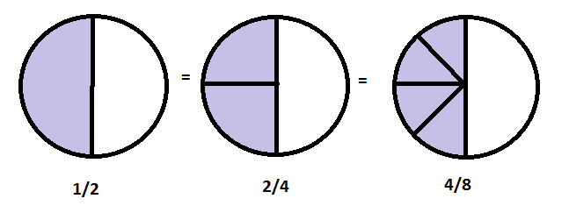
English
- My Spelling workbook Unit 15 one activity
- Read Fireworks p132: Mark’s Fingers.
- Complete the worksheet about Mark’s Fingers (on website. You don’t have to print, can write work into copybook).
Gaeilge
This week we are looking at ‘Caitheamh Aimsire’, these are hobbies.
- Bua na Cainte p76 Write the answers in your copy.
‘Cad atá ar siúl ag na paistí?’ = What are the children doing?
- Bua na Cainte p77
‘An maith leat bheith ____’ = Do you like. Is maith liom Ní maith liom
Geography
- Research Mexico using:
National geographic kids: https://kids.nationalgeographic.com/explore/countries/mexico/
Kids word travel guide: https://www.kids-world-travel-guide.com/mexico-facts.html
Fun facts for kids (YouTube): https://www.youtube.com/watch?v=SsP2QbDPbxY
- Create a travel brochure for Mexico.

Thursday
Maths
- Busy at Maths p104
- Interactive Resource: http://data.cjfallon.ie/resources/20684/BAM3_Tutorial_058/lessons/BAM3_Tutorial_058/index.html
Q5 3 halves is 3/2 or 1 ½ (Because you have one full orange and a half leftover).
Same for Q6. Q7 20/4 -> how many times can 4 go into 20? Count up in 4s -> 4,8,12,16,20. Four fits into 20 five times.
English
- My Spelling workbook Unit 15 one activity
This week we are looking at debates. Debates are discussions about a topic that have two sides: for and against. If the debate was – ‘there should be no homework’ straight away you have ideas for (positive aspects about homework) or against (negative aspects of homework). Today, I want us to just think about these ideas.
- Learn about debates: https://www.youtube.com/watch?v=yi6Im-Sb6Vw
- Pick your side on this debate: Dogs are better than cats.
- Write a brainstorm with at least four reasons for your side of the debate.
- Read the sample debate (file on website) and find any useful language/phrases that you could use in your own debate.
- Have a oral debate about ‘Dogs are better than cats’ with someone at home – tell them your opinions and see if you can find out if they agree.
Gaeilge
- Bua na Cainte p78
‘An bhfuil cead agam ___ a fháil?’ = May I have permission to take a ___?
In Scríobh na hAbairtí you have to choose the correct verb tense. Just like in English, yesterday I ate a cake. Right now I am eating vegetables. Look at the balloons – which verb do you use for: inné = yesterday. Gach lá = everyday. Amárach = tomorrow.
Science
With the nice weather, let’s try a science experiment to make your own ice-cream!
- The method is on the website. (You need milk, salt, ice, vanilla essence and ziplock bags).
If you do not have these supplies you could try make your own ice-lollies or even freeze petit filous with a stick. Try something at home

Friday
Maths
- Busy at Maths p105 + p106
- Interactive Resource: http://data.cjfallon.ie/resources/20684/BAM3_Tutorial_060/lessons/BAM3_Tutorial_060/index.html
Q5 seems tricky, but you’re well able for it. 1/10 of 40 same as yesterday.. how many times does 10 go into 40? 10,20,30,40 – The answer is 4.
English
- My Spelling workbook Unit 15 one activity
- Free writing: Write your own debate speech about any topic you’d like.
Sample ideas, All students should be required to take a cooking class, Teachers should be replaced by computers, there should be eight days in a week, the Irish flag should be silver and sparkly etc.
Gaeilge
- Bua na Cainte p80
In Irish, we use words for how many people there are not just the number. Ochtar = eight people whereas ocht is eight.
Art
- Origami time!
Jumping Frog https://www.youtube.com/watch?v=1kZjq8f8Mpo
Paper Heart https://www.youtube.com/watch?v=O9WV4Mm0En8
DIY notebooks https://www.youtube.com/watch?v=yy6T9r2MJM8
Cats https://www.youtube.com/watch?v=MnZjNQWY_VU
- If you don’t have coloured paper, that’s fine! Do the same with blank paper and design it yourself.

