Daily:
8 times tables: https://www.timestables.com/8-times-table.html
My Spelling Workbook Unit 14 – do one activity per day.
Monday
Maths
Today we’re looking at horizontal, vertical and diagonal lines.
- The Line Song: https://www.youtube.com/watch?v=DQEVllmeWH4
- Interactive resource: http://data.cjfallon.ie/resources/20684/BAM3_Tutorial_075/lessons/BAM3_Tutorial_075/index.html
- P128 Busy at Maths
- Can you find 3 vertical, 3 horizontal and 3 diagonal lines in your house or outside? You could take a picture of them or draw them in your copy.
English
- Fireworks p124-128: The Lion Club
- Answer Q2, Q6, Q7, Q8, Q9
- Q13 write about an animal you would take home with you.
Gaeilge
Today we are reading a story about a boy getting ready for school but being late!
Then you will write the verb from the story in the sentences and then chose the right ‘orm, ort, air, uirthi’. Chuir mé mo chota orm – means I put my coat on me.
- P100 Bua na Cainte
History
- Read Transport through the ages p60 History Quest
- Activity B p65
- Draw a picture/diagram of what you think a type of transport will be like in the future.

Tuesday
Maths
Today we are learning about parallel lines. They are lines that never meet. 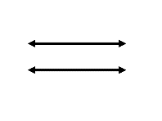
These two lines don’t touch = parallel
- Explanation http://data.cjfallon.ie/resources/20684/BAM3_Tutorial_077/lessons/BAM3_Tutorial_077/index.html
- P129 Busy at Maths
English
Today we are looking at another word trap: There/Their/They’re
- Watch the explanation video and do the quiz at the end: https://www.youtube.com/watch?v=GEgtjrAcRIo
- Use a book at home or George’s Marvellous Medicine and try find sentences with their/there/they’re in it.
- Write your own sentence for each word and then try write a sentence with the 3 words in it.
Gaeilge
Today you are reading a poem about a rooster and then drawing the pictures in your copy.
- P101 Bua na Cainte
Music
- Write about your favourite song. Who is the artist? What type of music is it? What instruments are in it? What’s the temp? (Fast/slow). Are there any other aspects of music you can think about your song?

Wednesday
Maths
Today we are looking at right angles.
- Explanation: https://www.youtube.com/watch?v=9PakNIwDin4
- Interactive resource: http://data.cjfallon.ie/resources/20684/BAM3_Tutorial_078/lessons/BAM3_Tutorial_078/index.html
- P130 Busy at Maths
English
- Read George’s Marvellous Medicine p27-31 (Chapter 1,2,3)
- Write an alternative (different) chapter ending.
Ideas – the medicine didn’t work, the medicine has a different effect, George’s parents came home – write at least 10 sentences.
Gaeilge
Today we are reading a story about Niamh getting ready for school and pretending to pour a glass of water to wake her brother up.
‘Ar nigh’ = Did ___ wash? ‘Ar bhain’ = Did ___ take off? ‘Ar chuir’ = Did ___ put on?
- P102 Bua na Cainte
STEM
- Create your own constellation cup (Explanation on website)

Thursday
Maths
Today we are looking at angles that are greater than or less than a right angle.
- Interactive resource: http://data.cjfallon.ie/resources/20684/BAM3_Tutorial_076/lessons/BAM3_Tutorial_076/index.html
- P131 Busy at maths
English
Reports are written to describe or classify the way things are. They organise and record information. Reports are organised by; classification, description and summarising comment.
Classification means what it is. Description means what it looks like etc. Summarising is to finish the report.
- Read sample of Report Writing.
- Look at the PowerPoint about report writing for more information.
- What is its classification? What description did it give? How did they end the report?
- Choose one of the topics for your own report:
Your favourite toy. Your favourite hobby.
A country. A food.
A book you’ve read. A movie you watched.
- Create a mind-map about your topic.
Gaeilge
Today we are looking at the verb ‘Bain’. I took my coat off. ‘Bhain mé mo chotá díom’ (díom is like ‘off me’). Remember in Líon na Bearnaí, if it’s a boy’s name you use ‘de’ (off him) and if it’s a girl’s name you use di (off her).
- P103 Bua na Cainte
Art
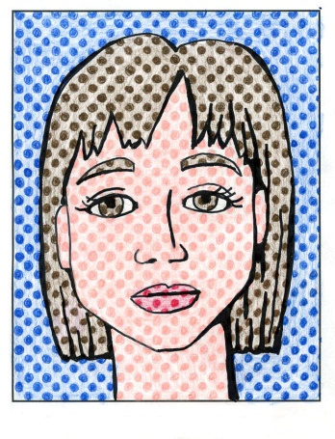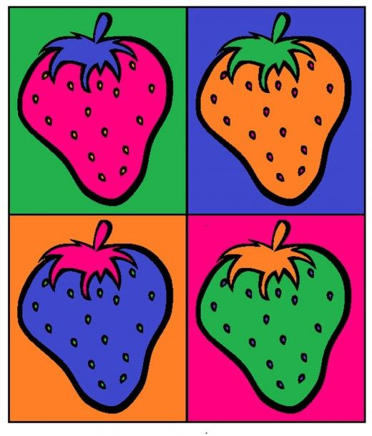
- What is PopArt? https://www.youtube.com/watch?v=DhEyoDCTSDQ
- How to: https://www.youtube.com/watch?v=7iKUZrQhR7U
- Create a PopArt picture of your name, sign for a room, a word/phrase, draw an object and add dots and lots of colour – anything you want!
- OR do a PopArt donut picture https://www.youtube.com/watch?v=3HqMbNCcHIo

Friday
Maths
Looking for angles at home/outside.
- Making a right angle at home: https://www.youtube.com/watch?time_continue=72&v=N_Kl7gFFJiY&feature=emb_title
Take a picture or draw them in your copy.
- Can you find right angles at home?
- Can you find any angles in your house that are greater than a right angle? (bigger)
- Can you find any angles that are less than a right angle?
English
- Look at your mind-map.
- Write a report about your topic.
Your report should have: A title, a brief introduction of what your report is about, 2 aspects of the topic, factual language (this means your information has to be fact. ‘I think tigers are the best animal’ isn’t a fact so wouldn’t go in a report)
Gaeilge
- P105 Draw the picture in your copy and label the words.
PE
- This week I want you to create your own PE game! Pick a topic area (or more than one) and then create your rules, things you need and then teach it to your family over the weekend.
- Write the name of your game, what you need, how to play and any other information and send it to ms.handly.stjohnofgodartane@gmail.com and we can have a collection of games to play at home!
Topics: Throwing, catching, running, jumping, walking, skipping, dodging, side step or balancing.

Other things you can do (Optional)
English | Story of the week: A teacher who becomes a movie star.
Music | Out of the Ark Music  https://www.outoftheark.co.uk/ootam-at-home/?utm_source=homepage&utm_campaign=ootamathome2&utm_medium=banner
Drama | Create a short play about a girl who has lost her teddy.
Project | Complete a project about stars!  - https://www.youtube.com/watch?v=ZrS3Ye8p61Y  - https://www.ducksters.com/science/star.php  - https://www.sciencekids.co.nz/sciencefacts/space/stars.html  - https://www.esa.int/kids/en/learn/Our_Universe/Stars_and_galaxies/Stars

